Gulfjobseeker CV No: 1342320
To interview this candidate call 971505905010
Or email us back filled up Vacancy Form
http://www.gulfjobseeker.com/Free_Job_Posting_Form.doc

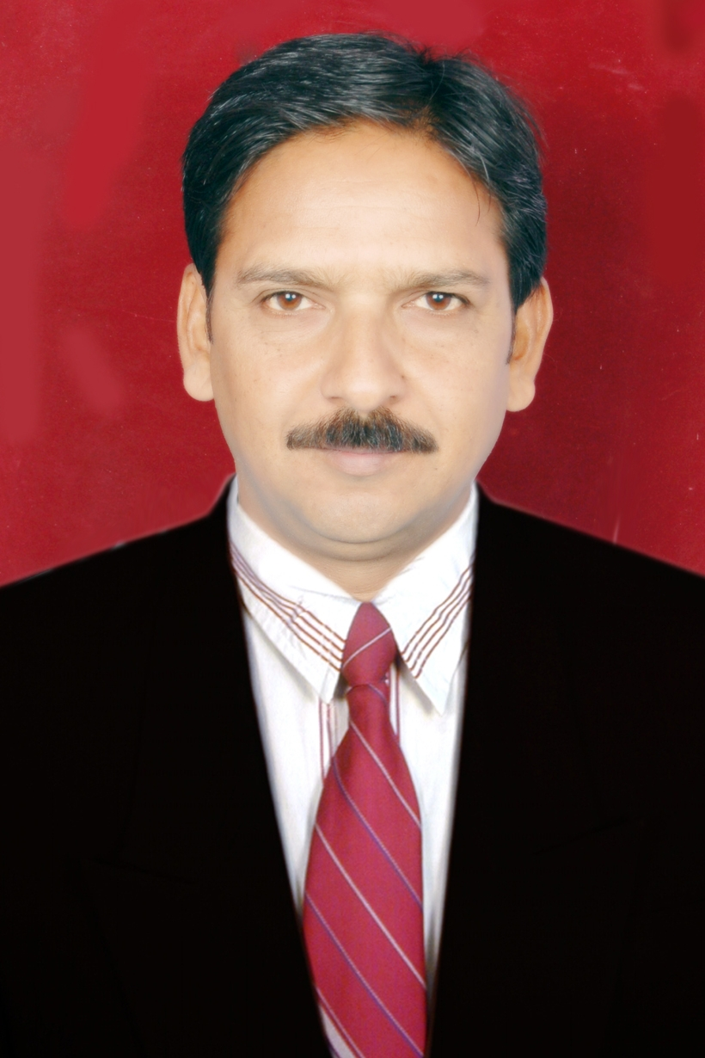
Accountant with 10+ years of exp.

Residing Country India
Key Skills Accountant, Computer literate and good command on Tally package and very good knowledge of MS word and MS excel.

Education :
Education level Specialization Inst./University year

1. B.Com Commerce University of Ajmer 1988
2. M.Com Commerce University of Rajasthan 1992

Technical Skill :

1. P.G.D.C.A. Computerized Accountancy Comp Ed and Pro 1996

Employment Details

Years of experience 10 years+

Previous Employer Const.Corp. Abu Dhabi

Functional Area Accounts/Administration

Current Designation Accounts Officer (site)

Current Industry Construction / Engineering

Personal Particulars

Nationality Indian

Marital status Married

Language Known English,Urdu,Arabic,Hindi

Resume Details

A devoted and determined Post Graduate in Commerce with Managerial Accountancy, Having 10+years experience of Accounts in Various Construction & Engineering Companies, Computer literate, Gulf experience of Eight years, skilled to manage AR/AP, inventories, control expenses, verifying and reconciling of invoices and handling daily general accounts procedure.

Looking to join with well managed esteemed organization engaged in Construction/ Engineering and Marketing Industries.

Employment Record

Name of Company Period Position

1. Const.Corp.
Kukje Plant Co. Apr-11 to Aug-2014 Accountant & Admin
Assistant
(Gen.Affair)

2.Supermax RMC Pvt Ltd May-10 to Apr-11 Sr.Accountant

3. Aziz & Associates ( I ) Pvt Ltd Aug 2006 to Apr-10 Accounts Officer
& Cashier.

4. NIC Construction India Pvt Ltd June 2003 to July 2006 Accounts Officer

5. Cercon General Contraction Comp.
Jeddah (Saudi Arabia) Nov 1997 to Feb 2003 Accountant & Store
Manager.

6. Ackon Engineering Comp. Bombay July 1994 to July 1996 Accountant.

Work Abroad:

1. GS Engineering & Construction Corp., RRE-2, SMP-1, (Kukje Plant Co.Ltd.) Apr-2011 to Aug-2014.

I designated here in this company in Apr-2011. I am working on post of Accounts Officer & Administration Assistant. Handling accounts of vendors, billing records, manages Debtors and Creditors accounts, maintain accounting ledger, posting accounting transaction and verifying them, preparing monthly payment schedule of payment, verifying vendors accounts and monthly statement and report to Managers, Petty Cash handling and Administrative work, such as keeping records of employees, visa status, and expenses related to visa processing, consult with recruiting agencies and other correspondence related to Administration section. Keep arranging workers accommodation and camp management, manages updated mandates records, making invoice, and co-coordinating with Camp and Catering Service Providers.

2.Cercon General Contracting Co. Jeddah (KSA) Nov 1997 to Feb 2003

A Company indulging in the business of Civil Construction, Road and Infrastructure
development. I was working in this company from Nov-1997 to Feb-2003. My responsibilities there were as:

(a) Keeping all the accounts of Vendors, maintaining ledger, reconciliation of AR/AP, invoices and vouchers verifying and posting proper accounts, Preparing salaries of staff and wages sheet for other employees.

(b) Handling Employees Personal Files, updating Visa Status and and other administrative job
works.
(c) I was handling the accounts of a Gas Station (petrol station) which owned by this company.
(d) For more than one year company appoint me as a Store Manager, where I was keeping all
the inventories, purchasing and coordinate supply between the project and store.

Work in India:

1. Ackon Engineering Comp. Bombay July 1994 to July 1996

It is a Partnership firm, where I was keeping all its general accounts, Partners Accounts and accounts of vendors. My service was there from July 1994 to July 1996.

2. NIC Construction India Pvt Ltd. Bhopal (M.P.) June 2003 to July 2006

A very reputed name in the field of Construction industry of Madhya Pradesh. It is engaging in the field of Civil Construction, Waterproofing and Ready-mix Concrete. I was worked here in this firm from June-2003 to July-2006.

(a) This firm engaged me on the Post of Accounts and General Manager, Where I was handling
Total accounts work, Purchasing and dealing with vendors.
(b) Weekly monitoring of sites, taking inventories of store, preparing salaries of staff and labour
wages sheets.
(c) Maintaining Accounts of Its Ready-mix division. Audit and finalization of accounts.

3. Aziz & Associates ( I ) Pvt Ltd. Hyderabad (A.P.) Aug 2006 to Mar-2010

A goodwill holder name in the field of Civil and Industrial Construction in Bombay from last 15 years with a well managed administration. Recently I am working in this company with its branch of Hyderabad from Aug-06 to Apr-2010.
(a) Here I am working on the post of Site Accounts Officer and Store Manager.
(b) Preparing all general accounts (using Tally 7.2 from last four years, handling Cash, Bank transaction).
(c) Purchasing and dealing with vendors, Manages Store with Kardex system.
d) Making budget of monthly expenses, wages, salaries and other payments details.
4. Supermax RMC Pvt. Ltd, Bhopal (M.P.) May-2010 to Apr-2011.

After completion of Hyderabad project I joined with this firm. Supermax RMC is one of most respected and leading RMC supplier of Bhopal and nearby areas. Supermax RMC having two batching plants and giving a large quantum of business, where I designated as a Senior Accountant and looking after all the accounting work doing by the juniors and manages all the daily activities related to accounts, using tally9 and tally7 packages. Supervision of receipts and payments, monitoring advance payments and their recovery and adjustments, managing vendor’s accounts and handling correspondence related to accounts dept.

Expected Salary : Negotiable

