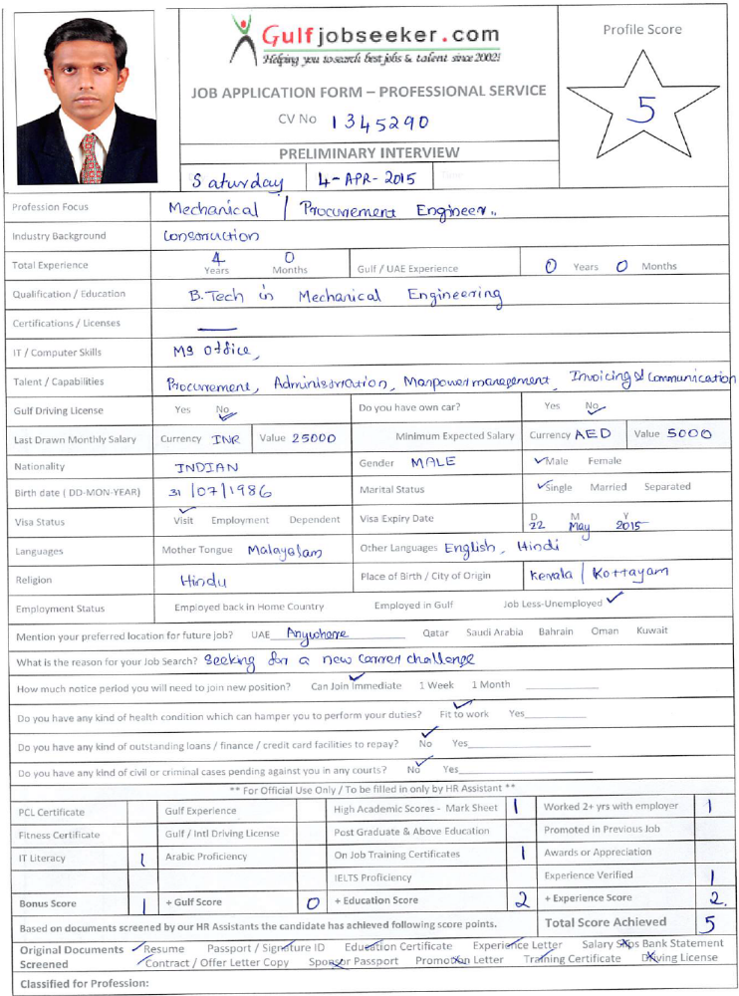

- Gulfjobseeker CV No 1345290
To get contact details of this candidate call +9971505797566
Or leave message on following link
http://www.gulfjobseeker.com/feedback/submit_fb.php
OBJECTIVE
To find an exciting opportunity to learn and contribute to the development of the company, profession of engineering and the overall development of the country.

EXPERIENCE&SKILLS

Company Name : LARSEN&TOUBRO(4-July-2011 To 31-July-2014).
Project : Setting up of the new plant for ONGC Mangalore Petrochemicals Limited(OMPL)
Project Value : 1205844902.33 AED (US$ 340,000,000)
Position : Procurement &Invoicing In-charge (Project Management& Planning).
Duties:
- Responsible for the Project Materials needs which includes managing purchasing Controlling inventory.

- Cost Control by Analyzing the Progress of the Plant and claiming the amount for the same from the Client on Monthly basis.

- Developed strategic suppliers and negotiated contract agreements and price for project materials resulting in cost savings and reduced delivery time.

- Developed, lead and execute purchasing strategies.

- Consults and makes agreements with suppliers about prices and other conditions

- Site Administration in a cost effective

- Ensuring the requisitions, purchase orders, invoices and other documentation relating to procurement and supply are correct and clear.

- Interacted with all departments in the construction division, the President of the Construction Division, Regional Managers, and the main office in other city.

- Provide assistance to project staff at the Division’s other locations in the areas material sourcing and vendor relations.

Company Name : ITC Ltd. Bangalore(21-July-2010 To 16-March-2011).
Position : Manufacturing Executive.
Duties : Production & Quality Control of a Food Processing Plant

Company Name : Hindustan Aeronautics Ltd Bangalore (2-Nov-2009 To 19-July-2010)
Position : Apprentice Trainee(internship)
Duties:
- Quality assurance &Inspection of Helicopter Components.
- Assisting teams to achieve their target.
- Crack detection by liquid penetrant & magnetic particle inspection testing.
Extra learning:
- Part modeling using catia and unigraphics.
- Participated in implementation of Lean principles in Helicopter Hanger.

EDUCATIONAL QUALIFICATIONS

Degree, College and University | Aggregate
Course : B.Tech Mechanical Engineering  College : T.K.M.College of engineering,  Kollam, Kerala  University : Kerala University  Year of passing : 2009 | 66%
Course :XIIth Standard  School : Government H.S.S. Pala  Board : Government of Kerala  Year of passing : 2004 | 68%
Course : Xth Standard  School : S.T.JosephH.S.Vilakkumadom, Pala  Board : Government of Kerala  Year of passing : 2002 | 84%

Project | DESIGN OF BELT BUCKET ELEVATOR
Seminar | GUIDANCE SYSTEMS IN MISSILE
Subject of interest : Thermal engineering, Project Procurement Management.
Application packages :Auto cadd , Catia ,Unigraphics, MS Office.
Professional & Personal Skill
- Clear communicator and a good listener.
- Confident & hard working.
- Committed to organizational and self-growth.
- An effective planner
- Effective time management.
- Willingness to help colleagues.
- Good team player& Optimistic

Achievements:
- Achieved record Invoicing Collection in L&T History.

- Along with Purchase and Invoicing, I was able to handle Site Administration also in efficient manner.

- N.C.C. Cadet of 17 Kerala battalion

- Member of the organization committee of MEXSYM08, a national level technical symposium organized by Dept Of Mechanical Engg, T.K.M College of engg, Kollam.

- Volunteer committee member of WHEELZ 09, an auto expo organized by Deptof Mechanical Engg, T.K.M College of engg, Kollam.

Personal Profile:
Sex : Male
Date of Birth : 31/07/1986
Nationality : Indian
Hobbies : Listening to music, Travelling, Reading Books and Playing Cricket.

