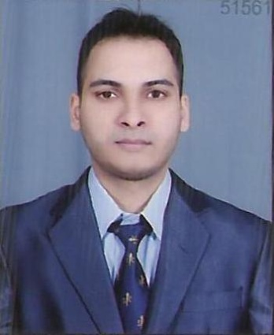AQUIB NIHAL
Dubai, Deira
E-mail: nihalaquib@gmail.com
Mobile: 971502240346
971504232019
971566030382

CAREER OBJECTIVE:
Excelling in my field with a growth oriented and reputed organization that utilizes my expertise
to the optimum possible and provides opportunities to achieve both personal and professional
goals.

WORK EXPERIENCE: Worked as a”Trainee Software Developer” from 4th aug to 30 jan 2015 at INFRANIX TECHNOLOGIES.

EDUCATION QUALIFICATION :

Have done Bachelors in Technology in COMPUTER SCIENCE AND ENGG., from Integral University, Lucknow.

1st Year |  | 2nd Year |  | 3rd Year |  | 4th Year
1st Semester | 2nd Semester | 3rd Semester | 4th Semester | 5th Semester | 6th Semester | 7th Semester | 8th Semester
62.09% | 63.63% | 60.00% | 72.36% | 71.00% | 75.00% | 75.82% | 77.54

Aggregate Percentage = 72.02%(1st Div)

PASSED HIGH SCHOOL examination in 2008 from CENTRAL ACADEMY, LUCKNOW
(CBSE BOARD) with 79% aggregate.

PASSED SENIOR SECONDARY examinations in 2010 from CENTRAL ACADEMY, LUCKNOW (CBSE
BOARD) with 66.6%aggregate.

SKILL SET:

Languages & Skills : C, C++
Platforms/OS : Microsoft windows XP/2003/2007,VISTA
Packages : MS access, MS Visual Basic/Visual Studio, MS office 2010
Database : SQL server 2008

STRENGTH:

- Self confidence & hardworking
- Strong interpersonal & communication skills
- Patience
- Willing to learn & adapt to new opportunities and challenges
- Can handle the presssue well
- Team leader

PROJECTS UNDERTAKEN IN UNIVERSITY:

TITLE: SCENE IT!(Augmented Reality Based Android Application)
- Augmented reality (AR) is a live, direct or indirect, view of a physical, real-world environment whose elements are augmented by computer-generated sensory input such as sound, video, graphics or GPS data .
A camera is used with AR software to detect augmented reality markers as the location for virtual objects. The result is that an image can be viewed, even live, on a screen and digital assets are placed into the scene at the location of the markers. Limitations on the types of augmented reality markers that can be used are based on the software that recognizes them. While they need to remain fairly simple for error correction, they can include a wide range of different images. The simplest types of augmented reality markers are black and white images that consist of two-dimensional (2D) barcodes.
- INTEGRAL HELP DESK
The project was made to meet the requirement to view & update the daily attendance and examination marks of the students.
It was accessible to all the students as well as all the staff of the respective department.
ABILITIES:
- An articulate speaker with Strong Interpersonal, Analytical Skills & communication Skills. Ability to seed & disseminate knowledge.

- Skills to work under pressure, stress and meet deadlines in a team with high level of involvement. Considerable awareness of global players, products & services.

- I can also assure you that I will plan and execute policies which help in achieving goals and I will also be the part and partial of the organization in every respect.

ACHIEVEMENTS:
- Have been Captain of my school and have represented my school in various activities.
- Active member of CSI (Computer Society of India) in the year 2010-2011.
- Actively participated in co-curricular activities and technical events organized by my school and college.
- Appreciated for my participation in dance competition at the school level.
- Organised and coordinated various science and technical quizzes in my university.

PERSONAL DETAILS:
Father’s Name: Mr.Nihal Ahmad.
Mother’s Name: Mrs.Kahkashan Nihal
Marital Status: Single
Date of Birth: October 09, 1991
Nationality: Indian
Passport Detail.: Passport No.:L4453402
Date of issue:12/09/2013
Date of expiry:11/09/2023
Visa Status: Visit (12th February 2015 onward for 3 months)

