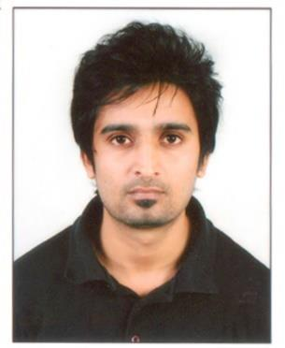

Gulfjobseeker CV No: 1354464
To interview this candidate call: 971505905010
Or email us back filled up Vacancy Form
http://www.gulfjobseeker.com/Free_Job_Posting_Form.doc

CAREER OBJECTIVE

- To get a strong foothold in the industry and keep updating myself with new technical knowledge and try to develop more innovative ideas in my field, dedicating myself for the growth of the organization, I am under.

EDUCATIONAL QUALIFICATION

SL.NO. | NAME OF | SCHOOL\ | BOARD\ | YEAR OF
 | EXAMINATION | COLLEGE | UNIVERSITY | PASSING
1 | GRADUATION | JAY NARAYAN | AJMER BOARD, | 2010
 |  | VYAS UNIVERSITY | RAJASTHAN

TECHNICAL QUALIFICATION

SL.NO. | NAME OF COURSE | INSTITUTE | YEAR OF PASSING | GRADE/MARKS
 |  | NAME
1. | COMPUTER HARDWARE | THE GEORGE | 2014 | PASS (78% ,Final
 | AND ADVANCE | TELEGRAPH |  | Sem.)
 | NETWORKING | TRAINING |  | First class honours
 | ENGINEERING | INSTITUTE
2. | CCNA | CISCO | 2014 | PASS (97.2%)

WORK EXPERIENCE

MARCH, 2014 TO AUGUST 2014- HARDWARE AND SOFTWARE SUPPORT COORDINATOR

- First-level help desk technical support and troubleshooting on IT network.

- Installation, configuration and administration of Cisco IT infrastructures – Cisco switches, routers and network protocols.

- Managed installation, configuration and administration of Cisco equipment in IT architecture of organization. Configured IT LAN elements and held responsibility of maintaining and monitoring performance of network.

- Provided Tier1 technical support; assisted users facing network problems. Performed advanced troubleshooting, diagnostics and provided tier/level-1 solutions to network failures.

- Worked in coordination with team members to decrease key IT problems and complete assigned projects.

Responsibilities Handled

  - Testing of computers to see they are working well

  - Installing various applications and programs for end users.

  - Assisting the staff with their computer problems - hardware as well as software

  - Troubleshooting routine problems and maintenance of desktops.

  - Ability to handle computer hardware and software.

  - Maintaining all the desktops & network devices.

Key Skills and competencies

- Excellent customer service skills; top communication.
- Works cooperatively as a team.

- Handles high work load.

- Good knowledge of desktops/laptops/workstations.
- Sound knowledge of various operating systems and security software for desktops.
- Proficient in best networking practices

CCNA
- CCNA (Routing & Switch)

Routing:
- Configuration of Cisco Router “1800, 2500, 2600”

- Configure and Troubleshooting of Routing Protocol: Static Routing Protocol, Default Routing Protocol, RIPV-1, RIPV-2, OSPF, EIGRP.

- Traffic Filtering using “Standard and Extended access-lists”
- Static & Dynamic IPV4
- IP Addressing (IPV4), Sub-netting.

Switching:
- Configuration Cisco Switches “2960 & VLAN setup in Cisco switches.

- PERSONAL DETAILS
- DATE OF BIRTH | - :- | - 29-10-1982
- NATIONALITY | - :- | - INDIAN
- GENDER | - :- | - MALE
- MARITAL STATUS | - :- | - MARRIED
- LANGUAGES KNOWN | - :- | - ENGLISH,HINDI, BENGALI

