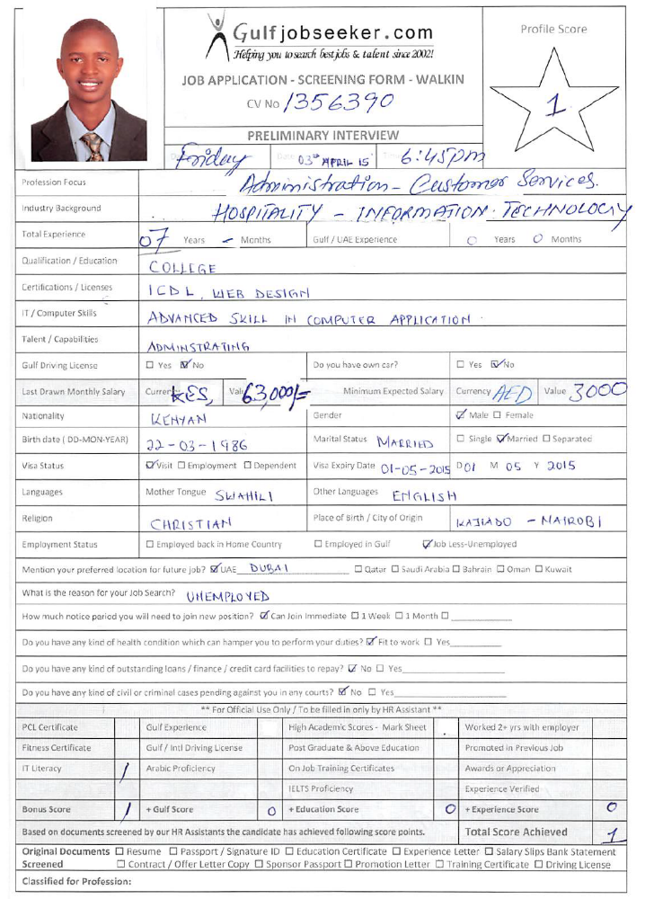

Gulfjobseeker CV No: 226065 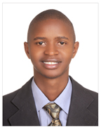
To interview this candidate call 971505797566
Or email us back filled up Vacancy Form
http://www.gulfjobseeker.com/Free_Job_Posting_Form.doc

Enthusiastic and dynamic professional who seeks suitable position in the Hospitality and Sales Industry. Possess capability in providing administrative support, customer handling and client relationship. An independent worker with ability to work in a pressurized environment and effectively prioritize job responsibilities with previous experience in hospitality / sales operations. Highly motivated and flexible team player, who can bring to your business: additional professionalism, enthusiasm and practical work experience. Also a trustworthy colleague with willingness and capability of dealing with constant challenges and leading change. Possess good communication, interpersonal, coordination, time management and client relationship skills.

PERSONAL DETAILS

Nationality : Kenyan
Date of Birth : 22nd March 1986
Marital Status : Married
Languages : English and Swahili
Visa : Tourist Visa

EDUCATION

Web Design Specialist July 2006 - Oct 2006
Infotech Training Institute

User Support Professional Course Apr 2005 - Jun 2005
Institute of Advanced Technology

International Computer Driving License (ICDL) Aug 2004 - Aug 2005
Institute of Advanced Technology

Kenya Certificate of Secondary Education Feb 2000-Nov 2003
Ribe Boys High School

Kenya Certificate of Primary Education 1992 - 1999
Mariakani Garrison Primary School

PROFESSIONAL EXPERIENCE
Adminstrator Apex Resort Ltd. Nakuru, Kenya March 2013 - Jan 2015

- Overall Supervision of the complex.
- Associate with customers and serve them in a professional, discreet & personalized way.
- Acquire in depth knowledge of the food & beverage menu of the assigned outlet in order to assist and provide advice to guests.
- Consistently monitor quality of food & beverage being served.
- Maintained personal files for all employees.
- Handled filling and control of incoming and outgoing faxes and e-mails and all companies accounts
- Controlled attendance register.

IT Administrator/Marketing Rep. Locate Group Holdings. Nairobi, Kenya Jan 2012 - Feb 2013

- Repair and Maintenance of company’s desktops, laptops, printers and network lines.
- Find out prospective customers/clients and new target segment and penetrate sales in that area.
- Monitoring the situation of the market, ups and down, finding out the competitors, latest innovation of the products.
- Transmitted information / documents to clients, using computer, mail or facsimile machine.

Manager Le Motel Camp David Ltd. Nairobi, Kenya Jan 2OO7 - Dec 2012
- Perform all necessary tasks to service food & beverage according to the standard of performance manual of the restaurant.
- Associate with customers and serve them in a professional, discreet & personalized way.
- Acquire in depth knowledge of the food & beverage menu of the assigned outlet in order to assist and provide advice to guests.
- Consistently monitor quality of food & beverage being served.
- Practice good customer relations and attend to customer complaints / queries satisfactorily.
- Responsible for maintaining hygiene and cleanliness standards in the outlet & upkeep of all service equipment.
- Responsible for all service preparations before, during & after the service (mis-en-place & mis-en-scene.
- Ensure minimum wastage, breakage and spoilage.
- Overall Supervision of the complex.

IT Specialist Databraine Engineering Ltd. Nairobi, Kenya Jan 2005-Jan 2007

- Ensure the IT team force is positive and are geared up for the challenge.
- Repair and Maintainance of company’s desktops, laptops, printers and network lines.
- Find out prospective customers/clients and new target segment and penetrate sales in that area.
- Monitoring the situation of the market, ups and down, finding out the competitors, latest innovation of the products.
- Complete understanding about the product and finding out how to market products for different segments.
- Transmitted information / documents to clients, using computer, mail or facsimile machine.
- Handled filling and control of incoming and outgoing faxes and e-mails.
- Controlled attendance register.
- Maintained personal files for all employees.
- Attended phone calls, took messages and forwarded the calls to the right person.

OTHER DETAILS

- Enhancing charitable work to the less fortunate and disabled.
- Participating in voluntary work during free time.
- Organizing events and outside catering

STRENGTHS

- Report writing  - Professional Service  - Bar Stock control |  | - Customer Support  - Good Telephone Manners  - Proficiency in Computers

Referees upon request

