Mohammed  Mohammed.226306@2freemail.com  Educational details:  Work Experience1:  Designation: Professional sales Executive.  Period: Aug. 2010 to July. 2013  Duration: 3 years.  Role & Responsibilities: |  | 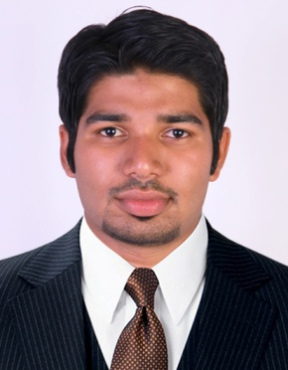  Objectives: To get experience and rise to a successful managerial position in an organization which believes in professionalism and development of an individual and encourages sustained contribution.  Personal Information  Date of Birth : 29-12-1988  Sex : Male  Nationality : Indian  Religion : Islam  Marital Status : Single  Academic Profile  - MBA (Marketing and systems-ERP &MIS)  Mahatma gandhi university , India  - BSC physics, University of Calicut , India  Pfizer Pharmaceutical Ltd , kerala , India  Responsible for sales of a full line of prescription products, primarily to Gynaecology Medicine, Family and General Practitioners, retail and hospital Pharmacists.  - Maintain detailed call records and communicate information to regional office.  - Analyze weekly sales, call reports and schedule calls efficiently .  - Provide field experience to new representatives as part of formal corporate training program.
 | Work Experience2:  Designation: Benefit Management  Analyst.  Period: Sep. 2013 to Jan. 2015  Duration:1 year 6 months.  Role & Responsibilities:  Technical proficiency:  Summer internship details:  Declaration: | Hinduja Global Solutions (HGS) - Bangalore, India  Job Profile: Health care - Operations (US Health care)  - Analyzing of providers claims(EDI and paper) for the credibility.  - Maintain the processing accuracy, payment accuracy, financial accuracy and delivering in line with the client expectations.  - provide timely, high quality response to all client queries.  Academic projects.  - Company : ABAD Builders and properties Ltd, Cochin.  Duration : Two months.  Project Details: "Brand perception of ABAD builders among the customers".  - Company: FOODWORLD Supermarkets Ltd. Bangalore  Duration : Two months.  Project Details :Organization Study.  Interests and Hobbies.  - Playing football and kabaddi; Participated in national kabaddi championships.  - Participating in management games and events.  - Traveling.  Professional strength  - Hard Working.  - Innovative, Flexible, Punctual and Obedient.  - Good Team Spirit and managerial skills.

