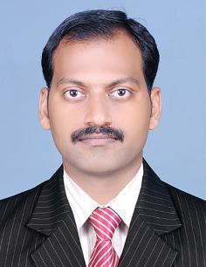
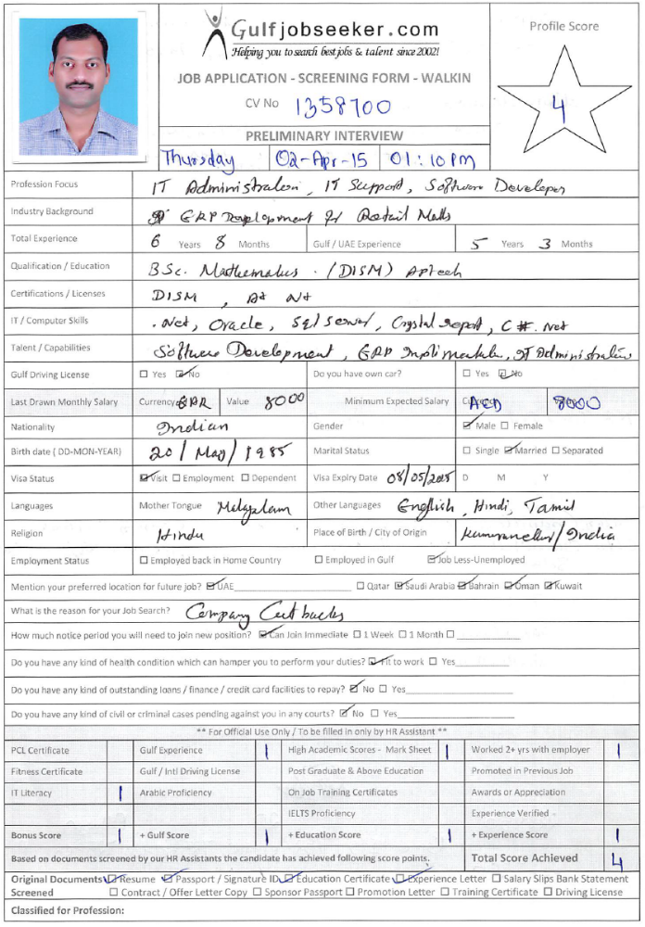Gulfjobseeker CV No: 1358700
To interview this candidate call 971505797566
Or email us back filled up Vacancy Form
http://www.gulfjobseeker.com/Free_Job_Posting_Form.doc

SUMMARY

More than 6 years’ IT experience in various fields of Programming Development, Crystal Report Development, ERP Implementation, Software Maintenance, Networks Designing, Network and Server Administration, Hardware Installation & Maintenance and Technical Support.

COMPUTER SKILLS

- Languages: C#.Net,Vb.Net

- Database: Oracle 11g , Microsoft SQL Server and Microsoft Access

- Platforms: Microsoft Windows XP,7,8 and Windows Server 2008, 2013

- Tools: Crystal Report ,Toad ,MS Office, MS Outlook 2013,Sonic Wall

EXPERIENCE

Software Engineer Jul / 09 – Oct/14

Safari Hypermarket – Doha-Qatar

- Meeting with clients to determine requirements .
- Working with clients to define the scope of a project .

- Developed (ERP, POS system And Mobile Device Application) for Safari Group Of Companies .Net C#.

- Network Designing, Support to implement and Administration.
- Designed Database schema and Maintained Data Integrity in Database.
- Designed Reports for various application used Crystal Report.

- Software trained to the end user.
- Reports Generated Upon Management Request .
- Oversees day-to-day operation of Servers, Services, Networks & Software support.
- Mail Account creation, configuring for end user and Administration.
- Monitor usages and security of data access privileges & Backup Database and Flies .
- System Administration including Remote Support and Server Administration.

- Server Administration, hands on experience in Active Directory.

Software Programmer Jan/08 - Jun/09

Ultra Oasis Techno Solutions(P) Ltd. – Edapal,Kerala-India

- Developed & Maintained (Retail market Inventory Management System, Clinic Management System ) written in .Net C#.

- Designed Database schema and Maintained Data Integrity in Database.
- Designed Reports for various application used Crystal Report.
- Software trained to the end user.
- Remote Support to the Client.
LAST PROJECT DETAILS

Hyper market management system.

Role: Module wise Project Design and coding. Client: Safari Hypermarket/Mall network. Duration: 12 Months.

Technology and Framework Used: C#.Net 4, Oracle, Crystal Report XI. Project Description:

This is a good ERP solution purely built in C#.Net 4 and Oracle It’s powerful enough to control and maintain all the activities of hypermarket/ shopp ing mall network. The main modules of this software are POS (point of sale) , Inventory control, accounts and payment management, MIS reports to control the cash/inventory flows, different types of promotion management, contracts management, online data transfer, weighing scale synchronizations, price checker application, integrated SMS and email alerts and reports, SMS/Email control panel for controlling the software services or getting emergency reports by SMS or Email (travel assistant module).

Physical Inventory Management Solution.

Role: Module wise Project Design and coding. Client: Safari Hypermarket/Mall network.

Technology and Framework Used: C#.Net 4, Oracle, Crystal Report XI. Project Description:

This system helps control and maintains all process of Physical Inventory Verification. The main sections are taking inventory with the help of PDA and system, synchronies PDA data to system format, compare with system stock and real time updating.

Asset Management Solution.

Role: Module wise Project Design and coding.

Client: Al-Attiya Motors and Trading Company Qatar.

Technology and Framework Used: C#.Net 4, Oracle, Crystal Report XI. Project Description:

This system helps to track all Types of Asset of a company with the op tion of multi location. The main sections are asset purchase and define depreciation, transfer locations, asset maintenance selling of asset and generate reports on the base of given date.

Sweet Shop Management Solution.

Role: Module wise Project Design and coding.

Client: Japanese Sweets Shop Qatar.

Technology and Framework Used: C#.Net 4, Oracle, Crystal Report XI.

Project Description:

This system control all the activities of a retail shop Main features of this software are touch screen POS, Inventory, accounts and payment and Reports.

Restaurant Management Solution.

Role: Module wise Project Design and coding. Client: Zekreet Hyderabadi Restaurant Qatar.

Technology and Framework Used: C#.Net 4, Oracle, Crystal Report XI. Project Description:

This system control all the activities of a restaurant shop Main features of this software are touch screen POS, Inventory, accounts and payment and Reports.

EDUCATION

Calicut University
• | B.Sc. (Major Mathematics) | 2002-2006
Govt. Higher Secondary School Edapal
• | H.S.E (major: Science) | 2000-2002
PERSONAL DETAILS
 | Gender | : Male
 | Date of Birth | : 20-May-85
 | Nationality | : India
 | Marital Status | : Married
 | Driving License | : India

DECLARATION

I hereby solemnly affirm that all details provided above are true to the best of my knowledge and belief and that at all times, I shall carry myself in a manner that lends dignity to the organization and worthy enough of the person.

