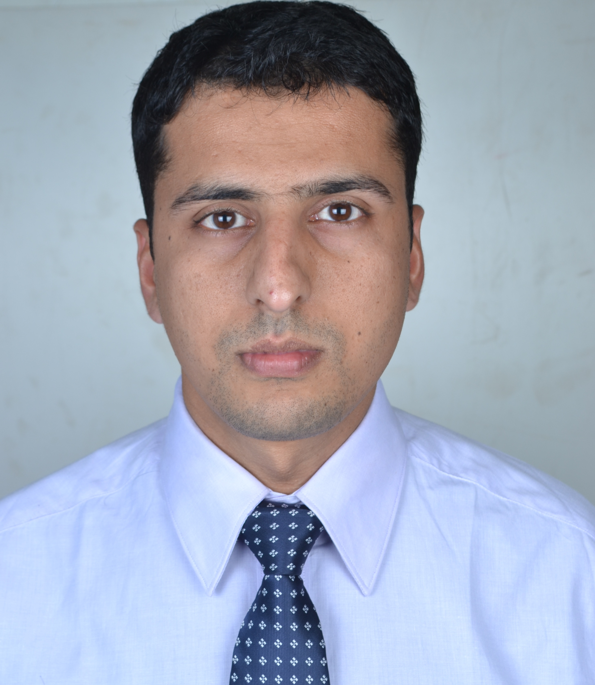
Gulfjobseeker.com CV No: 1358736
Mobile +971505905010 cvdatabase[@]gulfjobseeker.com

To contact this candidate use this link
http://www.gulfjobseeker.com/feedback/contactjs.php
Career Objective
- To work in a dynamic and challenging administrative environment where I can facilitate complete balance in-between employee satisfaction & employer’s growth in terms of profit, by using my skills and experience.
- I am seeking for a position where my professional experience and management skills will allow me to make an immediate contribution as an integral part of a progressive company.

Professional Synopsis
- A competent professional with 5 years of experience in India as well as on Middle East Platform, Industries such as Construction, Security Systems & Financial Brokering as an experienced Human Resources & Operations Professional in following roles responsibilities :
- Talent Acquisition.
- End to End Recruitment.
- Payroll.
- Performance Management & Appraisals.
- Succession Planning.
- Organization Development.
- Employee Engagement and Welfare.
- Exit Interviews and Full & Final Settlements.

CAREER CONTOUR

Experience on Middle-East Platform.

- Company: Multiplex International LLC., Dubai.
- Designation: HR Executive.
- Period: February 2014-Present.

- Company: Golden Relief Resources LLC., UNMISS (United Nations Mission in South Sudan).
- Designation: Senior Executive (HR & Administration)
- Period: June 2013 – November 2013

- Company: Recon-International LLC., Camp Leatherneck, Afghanistan.
- Designation: HR Coordinator.
- Period: March 2010- September 2012.

AREA OF EXPERTIES

Talent Acquisition
- Assessing the Company’s future staffing requirements over a short, medium and long term.
- Responsible for end to end recruitment process.
- Generate and implement a recruitment plan that utilizes a variety of media and recruitment
options to source the best candidates and Initiated Graduates Intern Program.
- Responsible for offer release & conducting joining formalities
- Reduced employee expenses by introducing cost effective schemes (placement of vocational trainees,
internal transfers, job rotation).
- Manpower planning, budgeting and deployment.

On Boarding
- Induction.
- Processing of UN identity cards for all employees.
- Taking care of all Joining formalities (Joining forms, Bank Account Openings).
- Ensures that the database system records, including human resource files are maintained in accordance with Organization’s policies and legal requirements.
- Preparing New Joiner data for Employee Code generation and HRMIS Issuing Offer & Appointment Letters.
- Preparation of Organization chart and periodic updating.
- Co-ordination with Functional Heads & conducting Departmental induction.

Leave and Attendance
- Preparation of daily Attendance & Leave MIS for sending to the Corporate.
- Maintaining leave records of staff members / deputation and project transfers.

Compensation and Benefits (Payroll Administration)
- Implementing various remuneration policies, including pay packages for newly hired employees.
- Preparation of monthly payroll for employees.
- Developing reports for annual salary review in order to ensure timely, accurate compensation and benefit administration.
- Preparation of leave salary of employees.
Performance Appraisal
- Conducting and implementing Performance Appraisal, using tools like 180degree method.
- Putting the assessment ratings into Normalization curve (Bell Curve).
- Ensuring proper feedback on Performance Management System.
- Responsible for post appraisal analysis and recommendations.

Policies & Strategies
- Formulation of policies and strategies to comply the standard of UNMISS (United Nations Mission in South Sudan).
- Keeping the senior management team informed of the operation and progress of compliance efforts.
- Reduces turnover and absenteeism while improving performance by recommending implementation of organization-wide policies, procedures and reporting.
- Successfully updated all company policies and procedures to reflect contemporary changes in company status and current employment laws on regular basis.
- Preparation of training matrix by identifying the needs for both technical and non technical staff in consultation with department heads, training calendar, attendance and feedback analysis.
Employee Relations, Employee Welfare and OD Interventions
- Counseling and supporting employees to have a good employee relation.
- Creates the communication channels to improve the transparency and helps to create an environment of trust and empowerment.
- Continuous interaction with employees to understand and resolve their grievances, inquiries and employees investigations and keep them motivated.
- Rewards & Recognition- Organizing official functions, Best Employee Awards, Year completion awards, Birthday & Anniversary Celebrations, recreational activities like sports & social activities etc.
- Played an instrumental role in reduction of staff turnover; developed positive employee culture that improved public image and enhanced performance and job satisfaction at all levels.
- Advise and direct other department managers on HR issues and employee relations.
- Handling Medical & Group Insurance for all 450 employees.

Data Analysis & MIS Preparation
- Preparation of reports on Monthly/ Half Yearly Basis for exit interviews.
- Head Count Reports – Average Cost Head Count. Consolidated Manpower-Regular Associates, Functions wise Head Count, Experience wise and Qualification wise.
- Attrition report – Tenure wise, reason of attrition.
- Other MIS – Exit MIS, Leave MIS, New Hiring and Workstation allocation reports.
- Cost Analysis – Comparison of monthly expenses of HR department with the yearly budget.
- Weekly Reports – Manpower details – Functions wise, Locations wise.
- Preparation of reports for British Army and for US Marines.

Exit Interviews, F & F Settlement and Separation
- Handled separation and transfer of employees.
- Conduct exit interviews to understand the suggestions or dissatisfaction level.
- Cancellation of resident visa, labor cards of all exiting employees.
- Responsible for the employee exit formalities including the clearance from all the concerning departments, final settlement and also arrange the exit interview with Anti Terrorism/Force Protection officials.
Learning and Development
- Conceptualizing & implementing training & development initiatives for improving employee productivity, building capability and quality enhancement like Basic Food Hygiene Certification,
in-house customer handling training.
- Organizing process training and process knowledge tests to bridge the process gaps and updating of new requirements; identifying the learning gaps of associates.
- Successfully got HACCP (Hazard Analysis and Critical Control Point) for company’s Warehouse in
UAE.

Administration
- Supervise and manage the overall discipline, well being and performance of staff.
- Visa applications and renewals – Processing and acquiring all statutory documents relating to the employment of all employees, new visas/renewing existing visas for staff, business visitors.
- Responsible for organizing travel (bookings, visa etc) for department heads/employees.
- Managed the administration and Human Recourse related activities on daily basis.
- Allocate the employees in SPOT system of US ARMY (Synchronized Deployment and Operational Tracker).
- Coordinates with the ISAF/NATO officials to solve the security issues on the base by providing them the accurate working location of more than 500+ employees in case of any threat from intruders, etc.
- Responsible for maintaining the stocks and inventory records for office assets and consumables.

Security Systems & Financial Brooking Industry experience in India.

- Company: Beltex Engineering Services, Panchkula, Haryana.
- Designation: HR/Operations Supervisor
- Period: November 2012-March 2013.

- Company: Fortune Equity Broker’s (I) Ltd, Jammu, India.
- Designation: Relationship Manager
- Period: September 2009-March 2010.

AREA OF EXPERTIES
- Perform all necessary actions to ensure that adequate personnel scheduling, material, equipment and other coverage is available for all construction, operational, maintenance and emergency functions.
- Supervise and work in close coordination with the Engineering, Planning, and Materials Supervisors to accomplish the efficient and timely completion of all construction projects, operations and maintenance requirements.
- Improved the operational systems, processes in support of organizations mission-specifically, support better management reporting, information flow and management, business process and organizational planning.
- Manage and increase the effectiveness and efficiency of Support Services (HR, IT and Finance), through improvements to each function as well as coordination and communication between support and business functions.
- Played a significant role in long-term planning, including an initiative geared toward operational excellence.
- Oversee overall financial management, planning, systems and controls.
- Assisting Executive Director and Board in creating annual organizational budget and monitoring cash flow.
- Ensure that Accounting Department requests are resolved and communicated in a timely manner to internal and external parties.
- Worked closely with seniors, operational managers and application end-users for increasing the revenue.
- Identified, tracked and resolved issues/risks related to delivery of client contracts.
- Offered consultations regarding client’s financial portfolio services to gain customer confidence to manage his/her complete financial portfolio.
- Analyzed the index and stock movements in the domestic markets i.e. BSE and NSE by using
technical and fundamental analysis.
- Responsible for Online Trading in equity markets of NSE and BSE with the daily transactions of average INR 50, 00,000 a day.

ACADEMIC CREDENTIALS:
- MBA (Finance) University of Pune 2009 Degree aggregate 61.14%.
- BE (Electronics and Telecommunication) Amravati University
2006 Degree aggregate 64.35%.

HONORS/AWARDS:
- Worked as a volunteer in NGO-Door Step School under Teach India Program of “The Times of India” in 2008.
- Sports In-charge of college for 2004-2005.
- Won second prize in Amravati University’s Youth Festival (2005-06) in Quiz event.
- Represented College for three successive Years in T.T and Badminton.
- Organized events such as Quiz competitions, Science exhibition during college festivals.

PERSONAL PROFILE:

Nationality | Indian
Date Of Birth | 30th May 1984
Marital Status | Single
Passport Details | Holding Valid Indian Passport with UAE’s Resident Visa.

References
Available on request.

