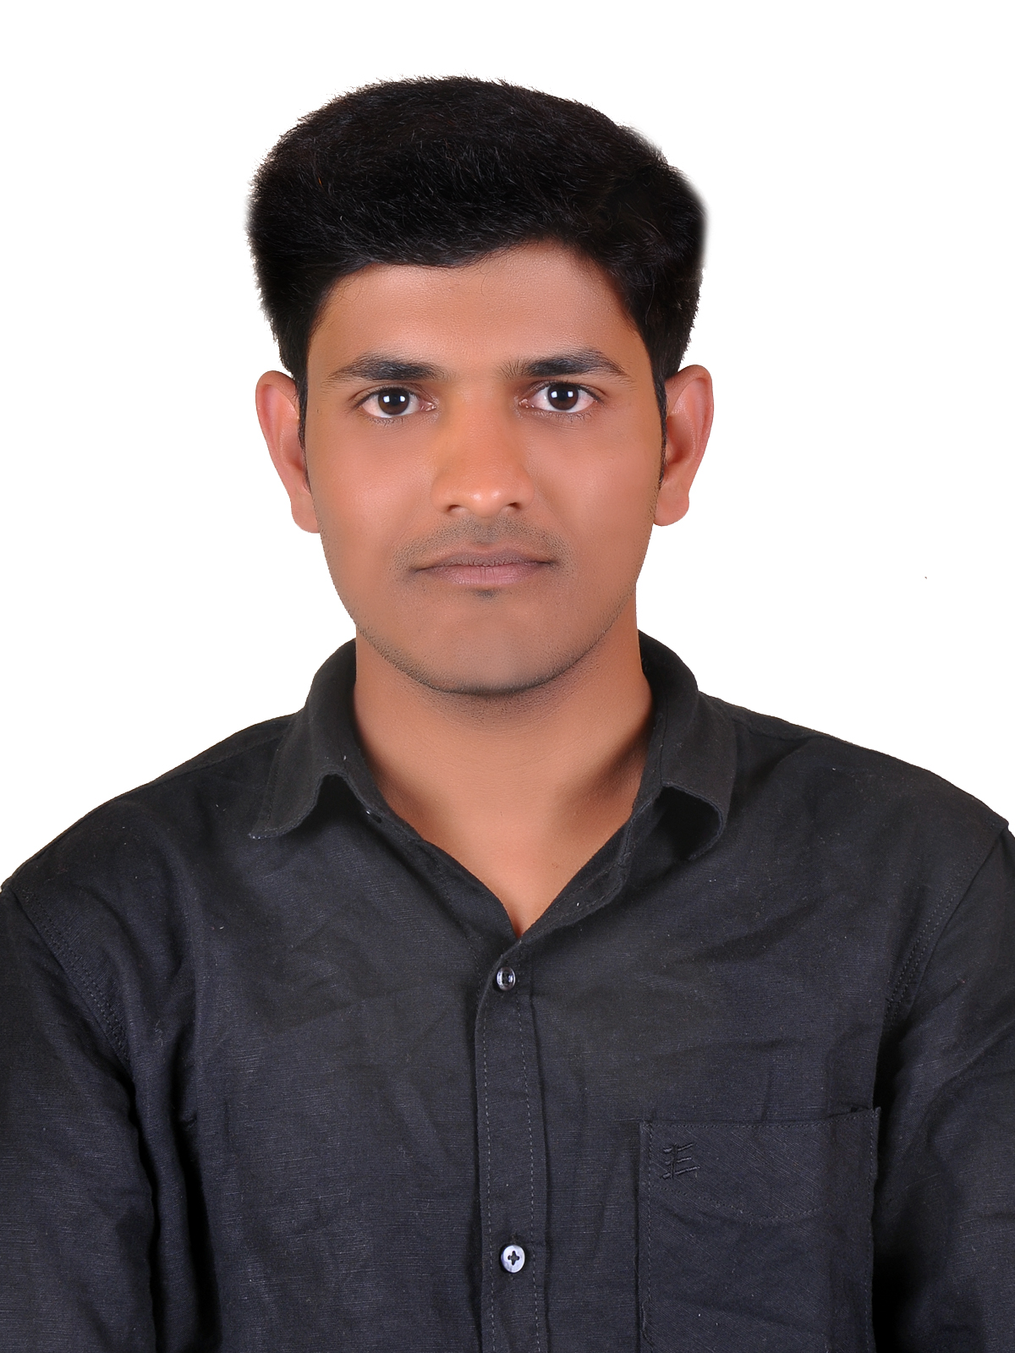  Personal Data :  Date of Birth : 10-05-1991  Marital Status : Single  Gender : Male  Nationality : Indian  Religion : Hindu  Language Known: English, Kannada & Hindi.  Visa Status : Visit | Gulfjobseeker.com CV No: 1360350  Mobile +971505905010 cvdatabase[@]gulfjobseeker.com  To contact this candidate use this link  http://www.gulfjobseeker.com/feedback/contactjs.php  Carrier Objective  To be an active employee in your company and to express and develop my skills for the mutual development of company and myself.  Professional Qualification  Diploma in Electronics & Communication (2009-2012)  MARATHA MANDAL POLYTECHNIC BELGAUM  - BOARD OF TECHNICAL EDUCATION BANGALORE  - Three year training program with average 85.25%  Academic Qualification  - Matriculation from Karnataka Board with 89.28%  - Pre-University Education from Karnataka Board with 55.66%  Area of Interest  - Technical Support Executive .  - Customer Service Executive (BPO).  - Computer Hardware & Networking .  - Software Installation & Troubleshooting.  - Data Entry Documentation.  - Electronics Products Testing & Quality Management System.  - Software Testing.  Work Experience  1. Vijay Computers , BELGAUM,KARNATAKA,INDIA  Designation : IT Support.  Duration : July 2009 to July 2010  2. I-TECH SOUTIONS , BELGAUM,KARNATAKA,INDIA  Designation : CSA [Customer Support Executive]  Duration : July – 20010 to Aug – 2012.  3. AEGIS INDIA LIMITED , BANGALORE , INDIA.  Designation : Technical Support Executive.  Duration : Jan-2013 – Jan-2015
4. Centum Electronics Ltd. Bangalore , INDIA
Designation : Jr.Engineer.
Duration : Oct-2012 to March-2015.
Job Responsibilities :
- Data Entry , Form filling .
- Worked as a Inbond & Outbond CSA .
- Worked in Different Processes of BPO’s.
- Worked as a Technical Support Executive .
- Installation of Drivers , Operating Systems.
- Trouble shooting of Computer & Laptops .(Hardware & Software).
- Assembling & Dis-Assembling of Computers.
- Expert in handling Electronics equipments& Chambers.
- R&D in projects according in customer requirement.
- Testing of PCBs, and Software Testing .
- Maintaining Shift List according to the process plans.
- Assist in development of maintenance procedures &Test Documentation of best-known methods.
- Quality & Documentation.
- 5’s Internal Auditing , Daily Preventive Maintains.

Technical Profile :
- Operating System : Win-XP , Win-7 , Windows–8
- Server OS : Win-Server 2003,2008.
- Package : M.S.Office – 2007 .
- Computer Hardware & Networking , MCSE , CCNA.
- Computer Typing : 30-40 WPM.
Training & Awareness :
- 5S and Kaizen Activities .
- Airtel Out-Bond Call Center Service Training.
- ISO 14001& 9001training,fire fighting, first aid .
Hobbies :
- Playing Badminton , Watching & playing cricket.
- Internet surfing.
Declaration :
I do hereby declare that all the above furnished particulars are true and correct to the best of my knowledge and believe.

