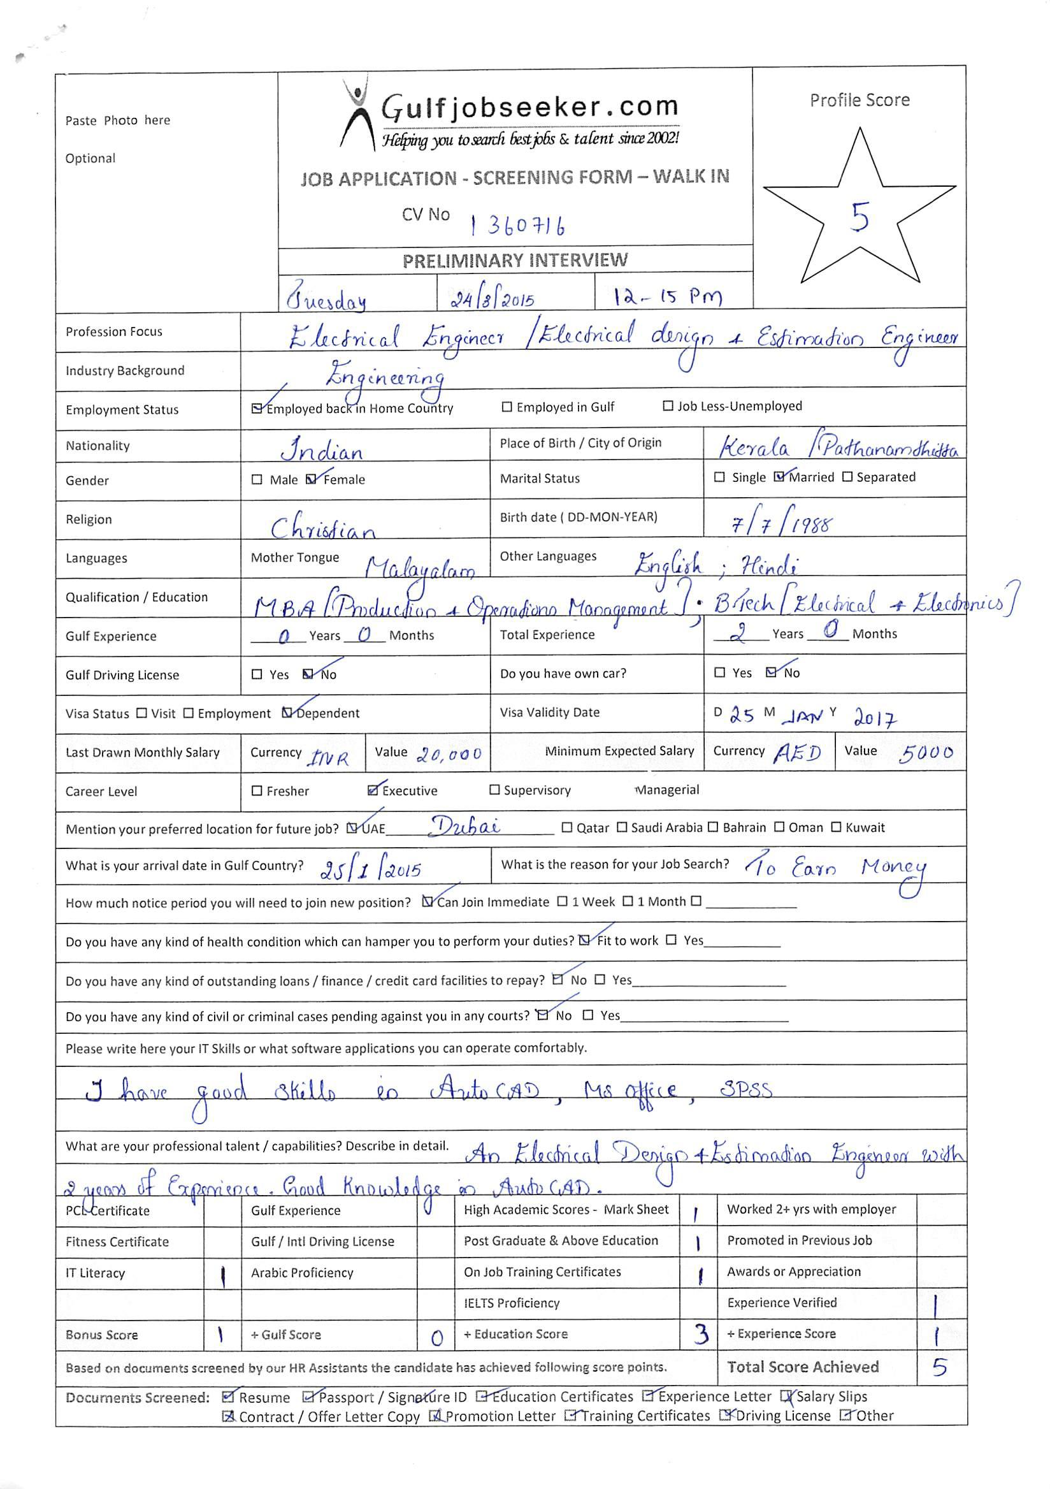
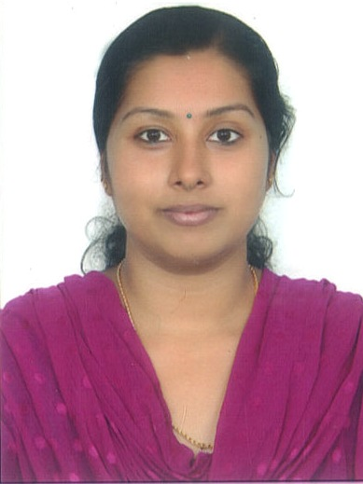

OBJECTIVE

A career with a progressive organization that will use my education, skills, abilities and experience in an executive capacity, where I can effectively contribute to operations in any capacity that matches my interpersonal skills and team building capabilities.

PROFESSIONAL SUMMARY

Accomplished proactive engineer with significant experience (two years) in electrical designing, estimation, tendering, Third Party inspection services and project coordination. Possess extensive educational qualifications with Bachelor’s degree in Electrical and Electronics Engineering. Recognized for the ability to work well as a team member and a coordinator, and exceptional work ethic. Proven technical interpersonal communications, and training skills.

Designation :- Electrical Design Engineer
Duration :- August2010 – June 2011 , June 2013 – October 2014

JOB RESPONSIBILITIES HANDLED :-

- Ascertaining the scope of the projects
- Preparing the Design Schedule
- Designing the Electrical and Low Current Systems for the project ( such as lighting, power, UPS, transformer, generator, Fire Alarm system, Telephone system, CCTV system, Access Control system, Security system etc)
- Preparing the schematic layouts for the project
- Cost and Resource Estimation of entire electrical system.
- Preparing Bill of Quantities
- Getting competitive prices from suppliers
- Submission of tenders and quotations to the clients including government organizations.
- Attending tender discussions.
- Site visits for technical updates on job progress and status evaluation.
- Carried out Energy Audits for government organizations.

EDUCATIONAL QUALIFICATIONS

- MBA –Operations Management and Marketing ( 2011-2013) from FISAT Business School. (MG University, Ernakulam).

  - Internship – Havells India Ltd,Chennai
  - Project in Logistics – Aramex India Ltd

- B.Tech in Electrical and Electronics Engineering (2006-2010) from
Mar Baselios College of Engineering and Technology. (Kerala University, Trivandrum)

  - Project - Electrical System Designing for an Engineering College

PROFESSIONAL CERTIFICATIONS

- Auto CAD (Electrical Designing)

TECHNICAL SKILLS

- SPSS STATISTICS
- MS OFFICE
- AUTO CAD

PERSONAL INFORMATION

- Date of Birth : 07 July 1988
- Marital Status : Married
- Languages Known : English, Hindi, and Malayalam.

PASSPORT DETAILS
Place of Issue : Trivandrum

DECLARATION

I hereby declare that the information provided above is true to the best of my knowledge.

