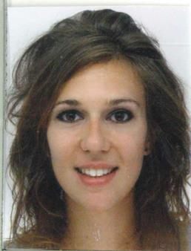VAULOT MATHILDE
Telephone: 0563582996

E-mail: mathilde.vaulot@hotmail.fr
Address: Bennett House 2, Motor City, Dubai, UAE

Nationality: French
Age: 26 years old

OBJECTIVE
Seeking a challenging role in the Fashion Industry in Dubai where I could utilize my good interpersonal and communication skills for the benefit of the organization.

EDUCATION
2009-2010 Bachelor’s degree in Management and Textile Production,

Université de Troyes, Troyes, France

2006-2009 Professional Certificate in Fashion Design and Pattern Making,
Ecole Supdemod, Lyon, France

WORK EXPERIENCES
Cotélac, Lyon Area, France ( 04/2011 – 10/2014 )
Quality Co-manager, French brand of men’s and women’s ready-to-wear clothing, High end
- Monitoring the finished goods quality ( clothes, accessories, shoes )

- Drafting reports of conformity ( aspect, dimension, fabric, manufacturing method , functional tests…)

- Analyzing basic material ( knitted fabric, woven fabric, leather )

- Problem-solving in case of non-compliant products, proposing corrective and preventive actions

- Ensuring the integrity of the merchandise and customer returns

- Liaising with the manufacturers, the production manager, the design team and the sales team

- Achievement : About 1% of customer returns by season in 2014, 2013, 2012 ( vs 2% in 2011 and 2010 )

Armand Thiery, Lyon Area, France ( 09/2010 – 04/2011 )
Assistant Store Manager, French brand of men’s and women’s ready-to-wear clothing, Leader in France ( Retail )
- Welcoming and advising the customers ( loyalty )

- Supervising the sale team ( division of tasks )

- Managing the merchandising of the retail store

- Achievement : Ensure the opening of a new store in a new mall

Méli-Malo, Lyon Area, France ( 08/2010 – 09/2012 )
Freelance Fashion Designer, Workshop of textile creation
- Designing and developing women’s ready-to-wear fashion collection

- Creating tailor-made women’s clothing

- Organizing events to promote the products ( fashion show, photo shoot, house party selling )

Rose Carbone, Lyon, France ( 02/2010 – 09/2010 )
Assistant Fashion Designer, Workshop of textile creation
- Sourcing to prepare the new collection ( Fall-Winter 2010/2011 )

- Designing and tailoring ( men’s and women’s ready to wear clothing, single model )

- Customization design, tailor made

SPECIAL SKILL
Attended training in the field of image consulting

COMPUTER LITERACY
MS Office, Illustrator, Photoshop, Lectra Modaris

LANGUAGES
French ( Mother tongue ), English ( Fluent ), Spanish ( Beginner )

INTERESTS & ACTIVITIES

Fashion, Travels ( Australia, Thailand, Turkey,…), Sports ( Running, Hiking and Skiing ), Cinema and music

