Flat 116 Al Gassimi Building Bur Dubai, Dubai UAE
Email: maryjohannajamero@gmail.com

Dear Sir/ Madam,
My name is Mary Johanna Claudine Jamero, 23 yrs old, single, a Filipino citizen. I am a Licensed Nurse in the Philippines.I am writing to express my interest in applying for your company. I believe my skills, experience, knowledge, and willpower for sales will make me the best candidate. As you will note from the enclosed resume, I have worked as a Customer Service representative for a year and I have many skills that would aid me to work for your company.

During my work as a Customer Service Representative, I have demonstrated the ability to effectively handle situations or inquiries while working within policy, procedures and standard processes. You will find I am detail oriented and able to analyze, prioritize and resolve client requests or issues quickly and effectively. I possess excellent communication skills both oral and written.

I have remarkable interpersonal, organizational and time management skills. I am well versed in all the Microsoft Office suite applications. Furthermore, I learn new applications quickly and efficiently. I am able to support team goals along with finishing my assigned tasks which makes me a perfect fit for a multitasking environment such as yours. My main drive to work is not just because of the benefits that I will be getting while working but mostly the privilege to serve others.

I have also worked in the Hemodialysis unit for 8 months at the Doctors’ Hospital Incorporated. I worked with patients with renal problems from ages 15 to 85 years old. I have the ability to run diagnostic tests to help determine the source of the problem patients are suffering from, to monitor vitals, administer medication according to doctor’s orders and to follow up with the patients to keep an eye on their condition. I have the ability to follow detailed instructions and to respond quickly and efficiently in an emergency.

This summary, as well as my resume, cannot adequately communicate my qualifications in-depth; I look forward to meeting with you to discuss why I would be an asset to your institution. I am available to schedule an interview at your earliest convenience by phone or email. My certificates of employment are also available on hand should you need to see them. Thank you.

Sincerely yours,
Mary Johanna Claudine Jamero
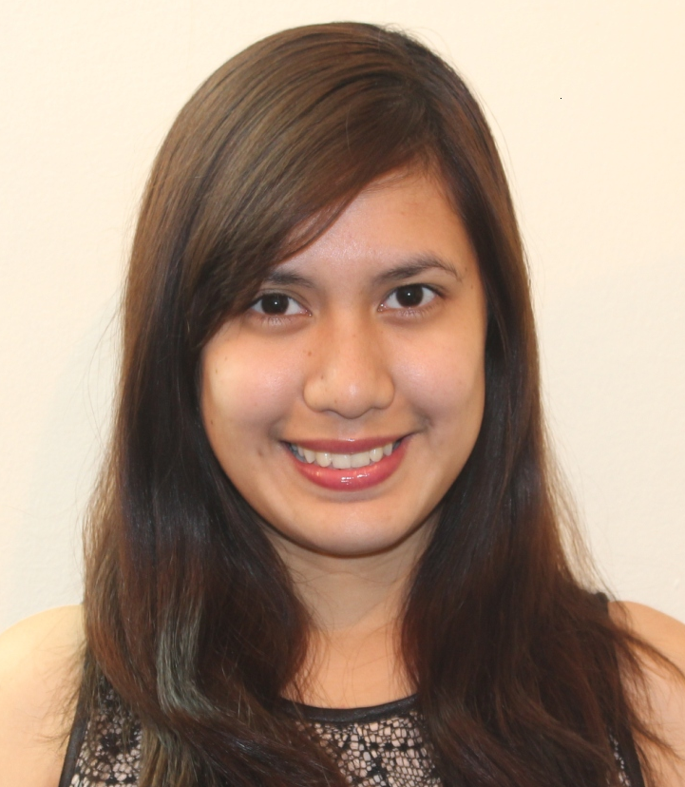

Mary Johanna Claudine A. Jamero, RN
Personal Details:
- Female, Single, 23 years old
- Filipino National
- Born November 2, 1991, Bacolod City Philippines
- Address: Flat 116 Al Gassimi Building Bur Dubai, Dubai UAE
- E-mail:maryjohannajamero@gmail.com

Availability:
- Can join immediately

Skills and Strengths
- Computer Savvy – MS Office, Call Center database and systems
- Quality Customer Service orientated
- Sales and Marketing Skills
- Fast learner, willing to be trained, adaptable to change, solutions provider
- Can speak good English
Education:
- Bachelor of Science in Nursing, School Year 2008 - 2012
University of St. La Salle, Bacolod City
- Philippine Nursing Licensure Exam Passer – Professional Regulation Commission, Iloilo City Philippines December 2012
- With consistent honors in Elementary and Secondary Education – University of St. La Salle Bacolod City
College Clinical Area Experiences
Area of Related Learning Experience :
- Corazon LocsinMontelibano Memorial Regional Hospital
- Negros Occidental Rehabilitation Foundation, Inc
- Bacolod Our Lady of Mercy Specialty Hospital
- Bacolod Mental Health Care Center
- Bacolod City Health Office
- Teresita L. Jalandoni Provincial Hospital
Roles:
- Observed patients, charted and reported changes in patients' conditions, such as adverse
reactions to medication or treatment, and took any necessary action
- Provided basic patient care and treatments, such as taking temperatures or blood pressures,
- dressing wounds, treating bedsores, giving enemas or douches, rubbing with alcohol, massaging,
- or performing catheterizations
- Measured and recorded patients' vital signs, such as height, weight, temperature, blood pressure, pulse and respiration
- Gave emotional support to calm scared patients and created a very comfortable atmosphere
- Provided medication to the patients as scheduled
- Assisted doctors and midwives in delivering newborn babies
- Provided newborn care
- Assisted the surgeon in the operating room

Professional Experience
The Doctors Hospital
Hemodialysis Nurse
January 2014 – September 2014
- Participated in team nursing and promoted team concept throughout all clinic activities
- Assisted other staff in the performance of their duties in accordance with policies and as allowed by state regulations
- Obtained vital signs and evaluated data
- Implemented dialysis treatments on patients with permanent fistulas, grafts, and catheters
- Administered medications and intravenous solution
- Prepared dialyzer and delivery system for use
- Monitored all equipment in use for correct functioning
- Performed appropriate terminal cleaning following each treatment
- Assessed assigned patients before and after each treatment
- Conducted, monitored, and terminated dialysis treatment
- Developed plan of nursing care for each treatment and altered the dialysis management, based on standing and current physician's orders
_________________________________________________________________________________________________________
Customer Service Representative (BPO- Voice account)
Transcom Worldwide Philippines (Bacolod City)
Comcast – West Division
September 2014 – January 2015
"Consistent top performing CSR"
- Facilitated Technical Support and Repair assistance (cable TV, internet service)
- Processed phone in Billing status requests (cable TV, telephone, internet service)
- Managed sales calls (cable TV, telephone, internet service)

_________________________________________________________________________________________________________
Customer Service Representative (BPO – voice account)
Convergys Philippines (Bacolod City)
Time Warner Cable – Southern California Division
January 2013 - September 2013
- Extended Technical Support and Repair (cable TV, telephone, internet service)
- Provided Billing Information (cable TV, telephone, internet service)
- Handled outbound sales calls (cable TV, telephone, internet service
___________________________________________________________________________________________________________
Seminars Attended 2011-2014
- Obstetrics and Gynecology Complications
- Pattern of living in Elderly
- Nursing Research: A Whole New Perspective
- Impact and Challenges of Reproductive Tract Infection
- Triage Exercises
- Nurse-Leader-Manager for the New Millenium
- Acute Coronary Syndrome
- Community Health Nursing
- The "UNLI" Lifestyle
- Myths and Facts of Psychiatric Nursing
- Hemodialysis
- Basic IV Therapy Training

Reference

Ms. GeozetteBaterna
Senior Nurse, The Doctors Hospital Inc.

Mrs. EdithaBayoneta
Chief Nurse, The Doctors Hosp, Inc. Bacolod City, Ph.

