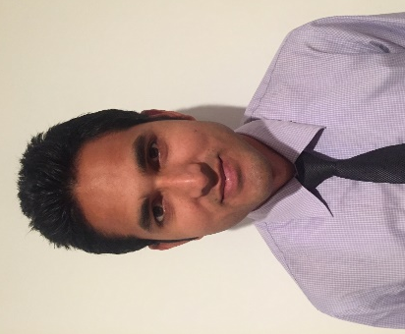

Gulfjobseeker.com CV No: 1368804
Mobile +971505905010 / +971504753686

To get contact details of this candidates
Submit request through Feedback Link
http://www.gulfjobseeker.com/feedback/submit_fb.php

JOB OBJECTIVE

Looking for a challenging career with a company of global repute, where there is scope for demonstration of hard & smart work with my maximum potential to achieve organization & individual goals.

PROFESSIONAL SYNOPSIS

- 5 Year working Experience with proficiency and expertise in customer service, customer relation, tele sales, customer reports and collections.
- Excellent communication, presentation and interpersonal skills blended with strong leadership skills.

WORK EXPERIENCE

Worked with Kotak Mahindra bank Noida, India as an Assistant manager from June 2013 to JAN 2015.

Role and Responsibilities:

- Generate business from open market like cold calling, data calling.
- Generate leads from software companies through calling and visit the companies.
- Customer handling through attend the inbounds calls or visit customer of Branch.
- Identifying prospective clients.
- Maintain MIS on daily basis.
- Acquiring new client from different sources.

Worked with Religare Broking ltd As Relationship manager Delhi, India From 1st June 2009 to 3RD May 2013.

Role and Responsibilities:
- Maintain weekly and monthly report of target and achievement.
- Maintain MIS on daily basis.
- Generate leads through marketing activity like campaigning and distribute pamphlet at corporate offices, and big society, Conferences, seminars etc.
- Acquiring new clients from Branch exist customer as well as self-source.

ACADEMIC QUALIFICATION

- B.sc. maths (2008) from C.C.S. University Meerut U.P. India
- Intermediate (2003) from U.P. Board India
- High school (2001), from U.P. Board India.

COMPUTER SKILLS

- Microsoft office & internet
- One Year Diploma in Basic networking from Anamika computer

NOTABLE ACCOMPLISHMENT

- Holding NCC "A” certificate
- District level player of Cricket
- Participated in various quiz,cultural activities,sports event at college and corporate level.

PERSONAL DETAILS

- Date of Birth : 19/04/1986
- Languages Known : English, Hindi
- Hobbies & Interests : Traveling, Social Networking, Music, cricket

Declaration

I confirm that the information provided by e is true to the best of my knowledge and belief.

