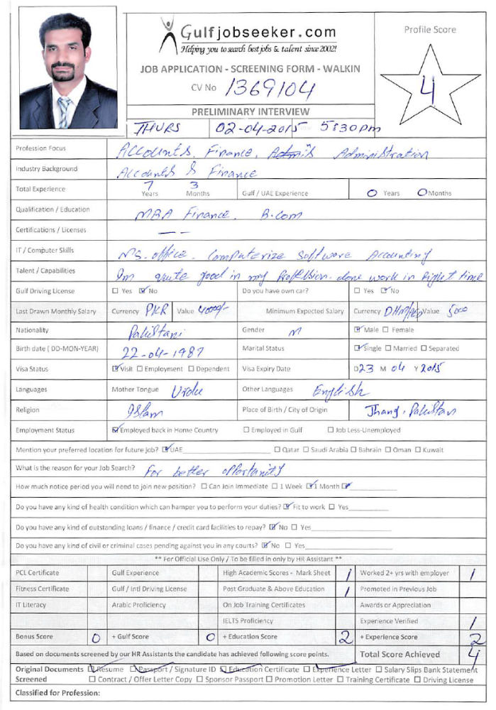
Gulfjobseeker CV No: 1369104
To interview this candidate call 971505797566
Or email us back filled up Vacancy Form
http://www.gulfjobseeker.com/Free_Job_Posting_Form.doc

MBA (Finance), B-Com

OBJECTIVE
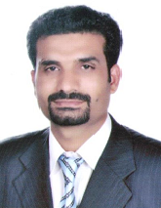
Seeking a challenging and rewarding career in a reputable organization where I can complement my skills, knowledge and experience and to make aprominent contribution to the organization which I could serve.

Qualification

Degree : MBA(Finance)
Education : B.Com
Working experience : 7 years

Professional carrier summary

Designation Duration Organization

Manager Accounts Feb, 2011 to till date Mediland Pakistan (Pvt) Ltd.

Senior Accountant July, 2010 to Jan, 2011 Mehmood Ebraheem & Co

Aaccountant December, 2007 to June, 2010 Pak Dream (Pvt) Ltd

Work Experience (Recent)
Organization | Mediland Pakistan (Pvt) Ltd.
Organization Type : | Services/Importers/Medical Solutions
Designation : | Manager accounts
Tenure :  Location  Areas(s) of Experience | Feb- 2011 to till date  Islamabad, Pakistan  Finance & Accounting, Administration,
Brief Job Description : | - Prepare monthly bank reconciliation statement.  - Check all vouchers.  - Verification of all vendor bills in order to make timely payments.  - Review Peachtree Accounting & QuickBooks regularly and identify bookkeeping and accountassistant's entries required to be made or corrected in the books.  - Monthly financial reporting.  - Prepared balance sheet  - Ensure correct filing and safekeeping of all concern vouchers and documents.  - Handling of all suppliers' bills & their reconciliation.  - Handling petty cash.  - Prepared payroll sheets.  - Carry out other responsibilities as identified by the Management  - Reconcile all ledgers of A/P & A/R.  - Receivable Aging  - Customer dealing  - Office administration  - Traveling Tickets  - Hotel reservation
Organization : |  | Mehmood Ebraheem & Co
Organization Type : |  | Cost Management Accountant Firm
Designation : |  | Senior Accountant
Tenure :  Location  Areas(s) of Experience |  | July 2010 to January 2011  Islamabad, Pakistan  Accounts & Finance, Auditing  - Audit of the daily Sales statement received from the different companies  - Checking of daily discrepancy reports  - Audit of receivables and their aging  - Audit visits to different companies  - Preparation Daily Management Report (DMR)  - Preparation Daily Performance Report (DPR)  - Inter-company reconciliations  - Maintain the computerized accounting system.  - Checking / verifying of expenses  - Assist in reviewing of the trial balance  - Assist account manager  - Preparation of sale report  - Any other duty or duties assigned by the management from time to time

Organization | Pak Dream (Pvt) Ltd.
Organization Type : | Manufacturing of Construction Material
Designation : | Accountant
Tenure :  Location  Brief Job Description : | Dec- 2007 to June, 2010  Islamabad, Pakistan  Accounts & Finance  - Reconciliation of all types including banks, debtor & creditors.  - Debit, credit & Age analysis  - Completed and verified fixed asset register, including depreciation, revaluation, impairment & deferred taxes.  - Detailed scrutiny and verification of all types of transactions, including sales, purchase , payments and expenses
Professional Certification & Academic Education
Sr. | Certification / Degree | Institution / University | Specialization / Major | Passing Year
1 | MBA(Finance) | Preston University | Master in Business Administration | 2013
2 | B.Com | PunjabUniversity | Bachelor in Commerce | 2008
3 | F.sc | Faisalabad Board | Pre-engineering | 2005
4 | SSC | Faisalabad Board | Science | 2003
Computer Skills and Other Abilities
Sr. | Skills & Abilities | Proficiency Level | Last Used / Practiced
1 | Peachtree accounting (computerize accounting software) | Excellent | Currently Using
2 | QuickBooks (Computerize accounting software) | Good | 2013
3 | Microsoft Office | Excellent | Currently Using
4 | Tally Accounting | Basic | 2014
Social Membership & Co-curricular / Leisure Activities
Sr. | Description of Activities
1 | Reading Books
2 | Playing Cricket, Football
Personal Information
Marital Status : | Single
Religion : | Islam
Language Competency : | Urdu, English
Countries Visited : | Dubai

