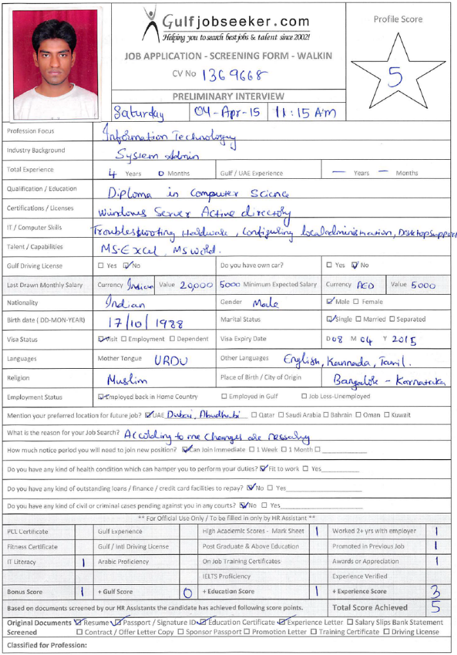
CURRICULUM VITAE

Gulfjobseeker CV No: 1369668
To interview this candidate call 971505797566
Or email us back filled up Vacancy Form
http://www.gulfjobseeker.com/Free_Job_Posting_Form.doc

CAREER OBJECTIVES:
Proactive and devoted assistant manager adept at collaborating closely with the manager/executive and assuming responsibilities of managing daily activities, directing operations and supervising staff in order to assist in actualizing firm’s aspirations, short term initiatives and long term goals and objectives.

WORK EXPERIENCE: Dedicated Assistant Manager (May 11,2011- to date)

Roles & Responsibilities:
- Managing a team of 35 people; deputed at different client locations.
- Providing knowledge training for the newly joined candidates.
- Demonstrating the resources provided by our organisation and induction training to the client.
- Co-ordinating with Client and Senior staff as an intermediate for smooth operations.
- Generating reports on daily, monthly and annual basis.
- Reviewing team performance and implementing required initiatives for improvement.
- Making sure all administrative functions operate at the highest levels.
- Performing clerical and administrative duties to support senior managers.
- L1 and L2 Support for all Core devices located at client place.
- IT Service Desk support.
- Windows troubleshooting by taking remote access.
- Responsible for Network Implementation and Support for Internal and External Customers.
- Troubleshooting of Outlook.
- Windows Server 2008(Active Directory).
- Maintaining Users and Group policies.
- Validating software policies.
- Resolving applications defects, windows error configuration.

EDUCATION:
- B.Sc Networking in Sikkim Manipal University Pursuing
- Diploma in Computer Science (3 years) from Al-Khateeb Polytechnic, (Board of Technical Education), Bangalore-India
- SSLC from Abdul Baris High School, Bangalore-India
CERTIFICATION:
- Windows Server 2008 Active Directory, Configuring - Certification ID: 8859063 (Microsoft)
- Network Technician - Certification no. : 727000111215 (Dimension Data Certified)
- A+, N+, CCNA from HCL Career Development Centre

TECHNICAL SKILLS:

- Troubleshooting Hardware, Windows 98-2000/XP/Vista/Win 7, Windows Server 2008(Active Directory
- Configuring Local Administration and Users Groups
- Remote Assistance
- LAN,WAN.
- Managing IP Address conflicts

PERSONAL INTERESTS:
- Reading Technical updates & magazines.

- Listening to music, Travelling and Internet surfing.

PERSONAL DETAILS:
Date of Birth : 17-Oct-1988
Sex : Male
Languages Known : English, Hindi, Kannada
Hobbies : Travelling, Swimming

