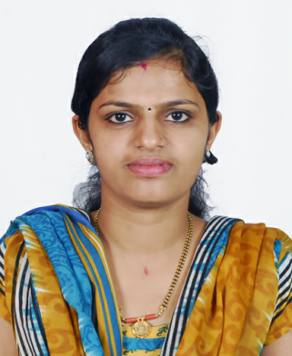
CURRICULUM VITAE
RASHMITHA

Email: rashmitha.228553@2freemail.com

OBJECTIVE
To work on a challenging environment where my knowledge and experience can be shared and enriched to organization’s best use and which would give me ample experience in the field.

SKILL SET
- Ability to plan and prioritize work activities effectively.
- Problem solver with good common sense.
- Sincere and flexible to any work environment.
- Highly disciplined.
EDUCATIONAL ATTAINMENT
ACADEMIC
- Diploma in General Nursing and Midwifery- Dr. Kaje Thimmanna Bhat Institute of Nursing, Darbe Puttur
- PUC - Board of Pre University Examination, Karnataka
- SSLC - Board of Secondary Examination, Karnataka
- DHA (RN) Licensed - Government Of Dubai.
- Successfully completed BLS course
COMPUTER SKILLS
- MS Office, Multimedia,
- Basic, Internet

LANGUAGE ABILITY
- English, Malayalam : Reading, Speaking, Writing
- Hindi, Kannada : Reading, Speaking, Writing
- Tamil, Telugu and Arebic : Speaking
WORK EXPERIENCE
- Worked as a STAFF NURSE in Medicine Department with M/S. YENEPOYA Medical College Hospital MANGALORE – INDIA
- Worked as a STAFF NURSE in Physical Medicine and Rehabilitation Department With M/S St. John Medical College Hospital - BANGALORE – INDIA
- Worked as a Staff nurse in Albakrar Medical center DUBAI.
- Worked as a staff nurse in neuro department with First Neuro Hospital MANGALORE INDIA.
- Worked in Gental Health care DUBAI
PERSONAL DETAILS
Sex : Female
Date of Birth : 15-06-1989
Marital Status : Married
Nationality : Indian
PASSPORT DETAILS

Date of Issue : 20-08-2014
Date of Expiry : 19-08-2024
Visa Status : Visit Visa
EXTRA CURICULLAR ACTIVITIES
- Singing,
- Dancing,
- Reading Books
CONCLUSION
In addition to above mentioned qualifications. I have strong desire to learn new concepts of the job without giving up while facing difficulties. I hereby declare that the above mentioned details are true and correct to best of my knowledge.

Date: Yours Sincerely
Place: Rashmitha

