CHAITHRA
Career Objective
To continue my career with an organization that will utilize my skills to benefit mutual growth and success.
Educational Qualification
Degree/Exam | University/Board | Institute | Year of passing | Score (%)
MHA  (Masters in Hospital  Administration) | Yenepoya University | Yenepoya Medical College,  Mangalore | 2014 | 68.63%
BSc  (Biotechnology, Botany, Chemistry) | Mangalore University | St. Agnes degree College,  Mangalore | 2011 | 87.45%
PUC | Karnataka Board | Sharada PU College,  Mangalore | 2008 | 77%
SSLC | Karnataka Board | Sneha high school, Sullia | 2006 | 88%
Work Experience
Organization: Mphasis an HP Company
Designation: Trainee Customer Support Officer
Duration: September 2011 to August 2013
Key Responsibilities
- Meeting day to day targets of loans processed.
- Maintain systematic record of loans processed.
- Coordinate with different individual (Quality Analyst) and resolve the queries raised in the process.
- Responsible for client SLA, vista

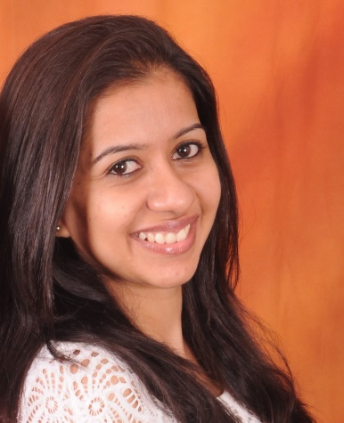

IT Skills
- Operating system- Windows 8.1, 8, Vista 7
- MS Office- 2007-2010
Project Details
Title: Study on waste management practices in a selected private teaching hospital.
- A descriptive study to understand the waste management practices of medical professionals
- Structured questionnaires with both open and closed ended questions were distributed among nurses, doctors and housekeeping staff
- Observational study was also conducted with the help of checklist.
- Results were illustrated using frequency and percentage.
Extra-Curricular Activities
- Served as a member of cabinet in St. Agnes College (2010-2011) as Secretary of Biotechnology.
- Won 1st place in ‘Imprints’, intercollegiate fest in St Aloysious College, Mangalore.
- Poster presentation: Infection Control Practices – Needle Stick Injury in A J Institute of Medical Sciences.
- Poster presentation: Innovation In Designing Hospital Facilities- Emphasis on Electrical Safety in M S Ramaiaha Medical College, Bangalore.
- Designed drug formulary for Yenepoya Medical College Hospital.
- Volunteered in conducting CME’s and conferences in Yenepoya Medial College.

Declaration
I hereby declare that all the above information given by me is true to the best of my knowledge. References available on request.

