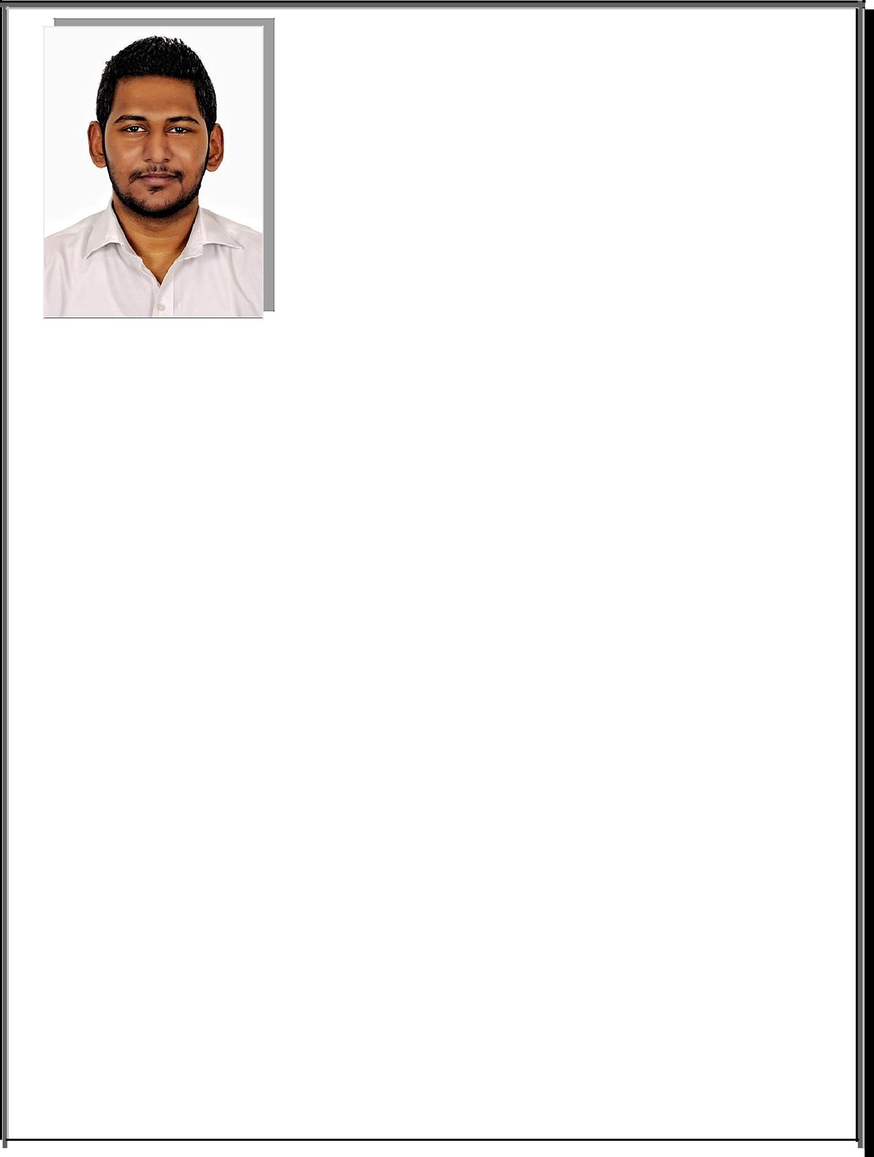
Curriculum Vitae

Riyaz
Riyaz.228847@2freemail.com

Career Objective:-

- To be employed with an organization, where I can utilize my mechanical & computer skills, knowledge and experience to grow professionally so as to enhance personal & organizational devel-opment.
- Aiming to be a successful Mechanical Engineer.

Profile:-

- Currently working as a Mechanical Auto Cad Draftsmen in a well-established firm in Dubai.

- 1 year rich experience as Design Engg. In a manufacturing firm of stainless steel.

- Trained as maintenance technician for 6 months, absorbing technical knowledge of Mechanical ma-chines like compressors, pumps, chillers & Turbines.

- Hands on AUTOCAD 2D- 3D on all version, isometric designing, developing products etc.

- Proficient in SOLID WORKS 2014, creating designs, creating Assemblies, developing sheet metal parts etc.

- Proficient to office software’s such as Microsoft word, Excel & PowerPoint

- Daily encounters with Internet and Emails

Key Structures:-

- Proficient Communication Skills, Leadership Strength & Multitasking capacity.

- Better grasping efficiency, always willing to learn and stay updated.

Professional Experience:-

- Auto Cad Draftsmen :- In a reputed organization dealing in Storage and Racking Solutions, Dubai-

UAE
  - Job description:-

      - Preparing designs proper planning and as per customer needs.

      - Working in Coordination with colleagues and sales team.

      - Customer interactions

      - Calculations and Estimations

      - Quotation Preparation

      - Finalizing & Execution.

- Design Engineer: - In a Stainless Steel manufacturing plant, Verna, Goa- India(2014-2015)

  - Job description:-

    - Visiting sites / companies,

    - Preparing design as per customer needs,

    - Coordination with colleagues and workmen for approval & developing mechanically,

    - Creating 3D design Pdf’s,

    - Taking approval of the design and correcting it if needed.

    - Evaluating material usage along with weight estimation.

    - BOM preparation in Excel and documentations.

    - Finally interacting with customers and taking orders and

    - Also marketing our products.

    - Maintaining materials & products in stock.

- Maintenance Engineer: - Apprenticeship Training as a maintenance technician in Agro Chemical industry, Verna, Goa- India(2013)

- Job description:-

  - Maintaining all mechanical equipment’s and overhauling of same using PPE & tools.

  - Have good knowledge of pumps like centrifugal & plunger pumps driven by motors using couplings. Maintenance like changing the inner and outer casing bearings etc.

  - Have worked on heavy duty air compressors like double acting horizontal & vertical reciprocating compressors. Maintenance like changing of valves, repairing the valves (inlet & outlet valves) & regular breakdown maintenance of the compressor.

  - Overhauled Co2 compressors, Ammonia (NH3) compressors and air compressors in team.

  - Assisted with senior engineers with the periodic maintenance of Steam turbines. Like cleaning the turbine blades / vanes and the gear box used for drive.

  - Also was admitted with the team of engineers for long period or emergency break-down maintenance.

  - Initializing remedy and discussing it with senior engineers

  - Proceeding with the approval for maintenance or overhauling or changing the me-chanical part

  - Testing the installed part and its efficiency

  - Reporting to head of dept.

Academic Achievements:-

- Highest Degree Attained – Flourishingly completed Diploma in Mechanical Engineering from In-stitute of Ship Building Technology, Goa-India with First class in 2013.

- Mid-level/ Higher Secondary – Obtained higher secondary education in Science field from K.E.S Higher secondary school, Goa-India with First class in 2009.

- High School - Attained high School education from St. Mary’s higher secondary school, Goa-India with First class in 2007.

Professional Qualifications:-

Computer Aided Design – Personalized with the degree of professional CAD software’s from IMS CAD Center, Goa-India with A+ in 2014.

Additional Computer Qualification:-

- Highly gripped with professional CAD software’s like AutoCAD (2D-3D) , Solid works, Catia v5

- Successfully completed Diploma in Computer Software Technology and Engineering.

- Exposer to CAM software’s

College Project Undertaken:-

- Fabrication of 1800 revolving tipper truck .To minimizes traffic jams in congested areas and to save the precious time and resources.

Personal Details:-

Nationality: -Indian.

Languages Known: - English, Hindi, Konkani, Marathi & Urdu.

Permanent Address: - Near St. Anne’s Church, Silvanagar, Ponda-Goa (India)

Local Address: - Al Maha Centre, Hor Al Anz East, Deira- Dubai

Declaration:-

I hereby declare that all the above information provided is true and correct to the best of my knowledge.

Riyaz

