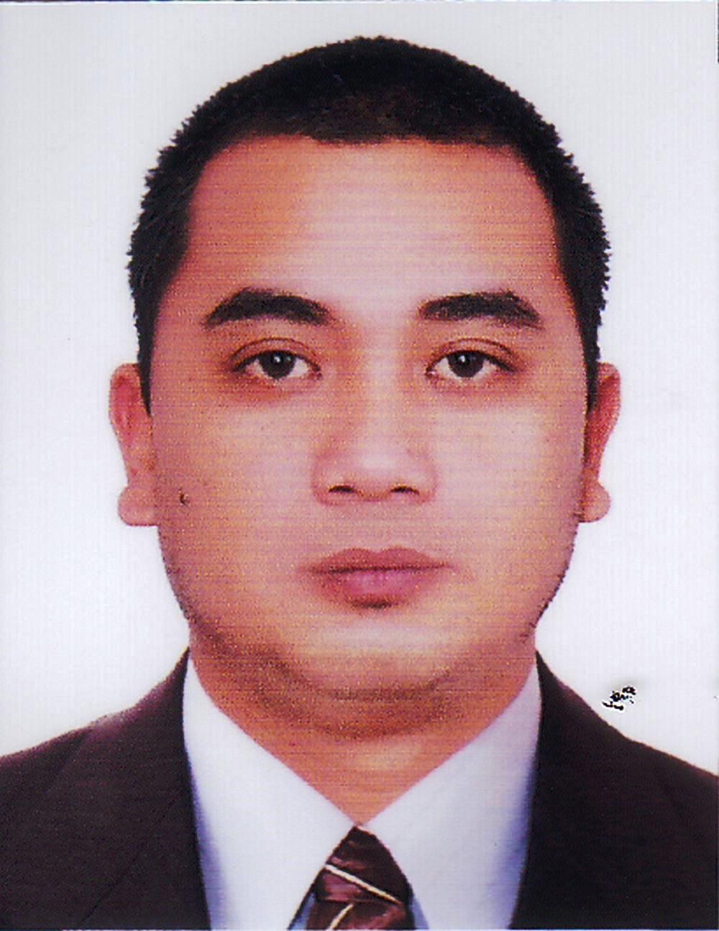
Adrian Peter Mirasol
Al Nahda, Sharjah
adrianpetermirasol@gmail.com

Objective
To work in an established organization that provides equal opportunity for all staff to
perform at their best, enhance their skills at the same time support career growth.
Profile
- Highly trainable, fast learner and can easily adapt to pressure in the workplace.
- Hard working with commitment to excellence.
- Works effectively and efficiently with diverse group of people.
- Can work harmoniously among peers.
- Computer literate.
WORK EXPERIENCE
Part time Administrative Assistant
Tabaco City Hall ofJustice
Albay, Philippines
December 2012 – February 2015 (three days a week)

Job Responsibilities:
- Assists in organizing files (documents, log books, etc.) according to procedures
- Makes copies of files according to instructions
- Runs official errands for staff (pick up documents from other government offices)
- Retrieve documents from filing system as required
- Assists and directs visitors on their queries

Store Manager / Owner
Querdz General Merchandise (Grocery items)
Albay, Philippines
October 2009 up to present

Job Responsibilities:
- Monitors and maintains store shelves by removing damaged or out of date products; tidying store shelves
- Restocks shelves with available products
- Reorders when levels appear low; arranges for return and credit for damaged products
- Coordinates with and maintains good relationship with suppliers
- Observes pricing of competitors' products and readjusts own pricing as needed
- Manages inventory of products
- Performs accounting of finances
- Maintains customer relationships

Caregiver
Noel Budy
Albay, Philippines
September 2007 – June 2012

Job Responsibilities:
- Assists with bathing, dressing and grooming
- Performs range of motion exercises
- Makes beds and change linens, as needed
- Engages in conversation and verbal exercises
- Administers prescribed medications
- Runs errands (pickup prescriptions)
- Accompanies to events as required
- Records daily care notes
- Reports any significant information to relative/family

Receiving Clerk-Freezing Team
Anjo Farms Incorporated
Pangasinan, Philippines
April 2003 – January 2004

Job Responsibilities:
- Signs for and receives packages
- Unpacks packages and checks the contents
- Counts items received and compares to the invoice/delivery order
- Reports any discrepancies to supervisor

PERSONAL DATA

Date of Birth October 25, 1981
Civil Status Married
Sex Male
Height 5’8”
Weight 140 lbs.
Language English, Filipino

EDUCATIONAL BACKGROUND

Bachelor of Science in Computer Science
AMA Computer College
Legazpi City, Philippines
2000 – 2006
Caregiver Course
Divine World College
Legazpi City, Philippines
June – December 2006
TRAININGS ATTENDED
Basic Safety Training
Philippine Merchant Marine Academy
Zambales, Philippines
August 04 – 10,2008
Mesman/Steward Training
Blue Horizon Maritime Training center
Manila, Philippines
January 28 – 31,2008
Elderly Care
Ladies of Charity
Home for the Aged
Sorsogon City, Philippines
December 10 – 17, 2006
Child Care
Holy Cross Children’s Home
Sisters of Saint John the Baptist
Tabaco City, Philippines
December 04 – 09, 2006

Hospital Care
Esteves Memorial Hospital, Inc.
Legazpi City, Philippines
November 20 – Dec. 01, 2006
Cellular technology – Cellular
Fundamentals, Tools, and Devices
AMA Computer College
Legazpi City, Philippines
March 23 – 24, 2006
Cellular Technology – GSM and Wi Fi
(Wireless Fidelity)
AMA Computer College
Legazpi City, Philippines
March 23 – 24, 2006
First Aid Training in Red Cross
AMA Computer College
Legazpi City, Philippines
March 2006
On – Job – Training
DigitelTelecomunications Company
Legazpi City, Philippines
June 22 – September 5, 2006

