

CV No: 1384674
Email: cvdba15@gmail.com
Mobile: +971505905010 / +971504753686
VISA STATUS: - VISIT VISA

CAREER OBJECTIVE________________________________________________
A MBA finance graduate who has the required attitude, passion and energy required to make an immediate and positive difference to any company.
To seek a challenging position in a dynamic environment and desire to progress further in the same field and likes to grow with the organization and prove to be an asset for its effective functioning and be a team player for the achievement of organizational goals and its success.
EDUCATIONAL QUALIFICATION______________________________________
2014 | Master of Business Administration (MBA-Finance) First Division | university of lucknow , INDIA
2012 | Bachelor of Business Administration (BBA - Finance) First Division | Amity University , NOIDA
2008 | Intermediate | ISC
2005 | High School | ICSE

PROFILE AND STRENGTH____________________________________________
- Top-notch Banking Professional with mathematical skills and financial knowledge over 8 Months of comprehensive experience in Bank Sales of Bank Accounts, Credit Card, Personal Loan, Consumer Durable loan for a leading Bank in India.
- Recognized as a top performer consistently achieving Monthly goals or targets.
- A highly motivated individual with excellent organizational and leadership skills.
- Knowledge and proficiency in business development, relationship management and product development.
- Excellent business management with proven analytical and decision making skills
- Inhibits strong communication skills and pleasing personality to attract more customers

AREA OF EXPERTISE _______________________________________________

- Finance
- Operations Management
- Sales
- Customer Service Management
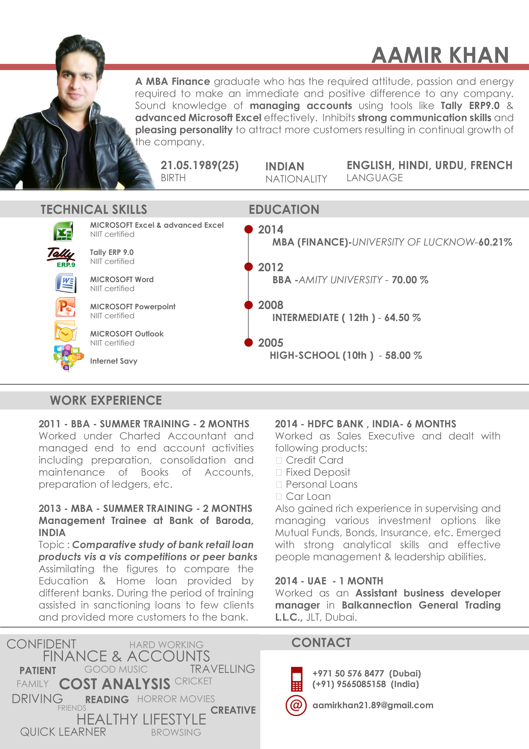
TECHNICAL SKILL__________________________________________________

PROFESSIONAL EXPERIENCE_________________________________________
2014 – INDIA –8 MONTHS
Description
Worked as Sales officer and dealt with following products:
- Credit Card
- Accounts opening
- Consumer durable loan
- Personal Loans
Key Tasks and Responsibilities
- Acquire clientele for bank products
- Market the bank product by selling
- Setting up meeting with new clients
- Maintain and develop good relationship with customers through personal contact or meetings or via telephone etc
- Act as a bridge between the bank and its customer
- Reviewing own performance and aim at meeting my targets
- Record sales and order information and report the same to the sales department
- Identify the credit worthiness or risk appetite of clients and introduce them with banking product and services according to the maximum port
- Reviewing Financial Statement Analysis & checking Credit Risk Rating of clients.
- Preparation of credit application, documentation & post-sanction monitoring through periodic account review/renewal
- Originated, reviewed, processed, closed and administered customer loan proposals.
- Understand the market or read the market as far as new business opportunities are concerned
Achievements:
- Achieved & sometimes exceeds the monthly Targets.
- Brought in Deposit worth 20 lakhs rupees.

2013 - MBA - SUMMER TRAINING - 2 MONTHS
Description
Worked as Management Trainee at Bank of Baroda, INDIA
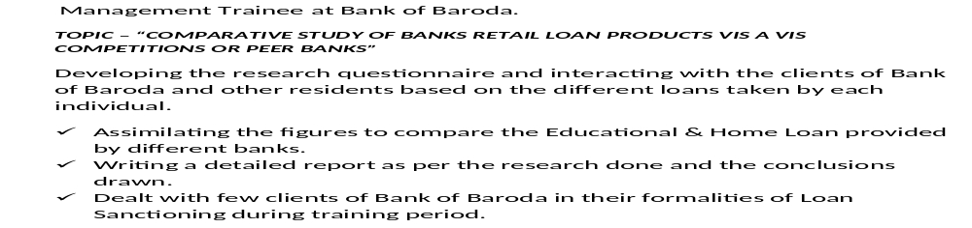
Responsibilities
2011 - BBA - SUMMER TRAINING - 2 MONTHS
Description
Worked under Charted Accountant as an TRAINEE
Responsibilities
- Working with spreadsheets, sales and purchase ledgers and journals.
- Preparing statutory accounts.
- Managing petty cash transactions.
- Controlling credit and chasing debt.
- Reconciling finance accounts and direct debits.
EXTRA CURRICULAR ACTIVITIES__________________________________________
- Actively participated in organizing the SANGATHAN 2011 of Amity University and won First position at college sports event, tug of war.
- Lead the team organizing the quiz contest during the inter-college annual show.
- Participated and won prizes in swimming competitions
- Participated and won prize in Karate.
PERSONAL INFORMATION _____________________________________________
Date of Birth:- 21-05-1989
Nationality:- Indian Language known:- Hindi, English,Urdu, French

