Faiyaz

Faiyaz.231177@2freemail.com

Covering Letter

Dear Sir,
Please let me introduce myself.
My skills and experience have given me the confidence to seek a position in the Administration Department in your organization.
My Career Objective: To work as Office Executive. I have attained 1.5 years long experience in the following field including 1 year 7 months in Dubai as Document controller cum Sales Executive and 2 years in India as Administrative Assistant cum junior Accountant. And worked as a sales executive cum document receiver in Exotic Motors dealer in Hyundai Motors till date, you will find most of the necessary background information contained in my resume; however I would like to mention. I am currently on Visit Visa. I am exploring the market to obtain a position with an organization that will appreciate my skills and abilities. I seek a job to which I can be committed and dedicated for my entire contract period.
I am an Indian citizen, and willing to join immediately for any challenging assignments in any company where my credentials will be appreciated.
I am enclosing my detailed CV for your kind perusal. Please, let me know, if you encourage skilled and experienced candidates.
I hope to hear from you soon. Thank you.

Sincerely

Faiyaz

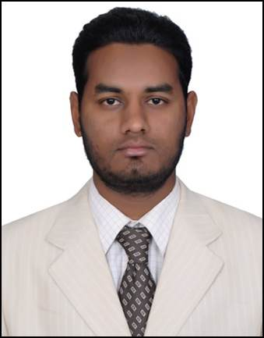FAIYAZ

Career Objective:
To prove myself dedicated, worthful and energetic in a progressive organization that gives me scope to apply my knowledge and skills that dynamically works towards success and growth of the organization.

Experience:
- Worked as Documents Controller cum sales executive, M/s. Axiom Telecom, Dubai since April 2010 to November 2011.

- Worked as an Administrative Assistant cum junior Accountant in Techno vision telecommunications, Hyderabad from March 2012 to October 2013

  - Worked as Office Executive cum Documents controller in EXOTIC CARS authorize dealer in Hyundai motors December 2013 to till date.

Education:
- B,com discontinued

- Intermediate from Board of Intermediate Education, Hyderabad, India

- S.S.C. from Board of Secondary, Hyderabad, India.
Tech Skills:
- DCA Diploma in computer applications
- Hardware and software
Achievement: Winner of 4’ gold coins on maintaining documents according to company standards, Axiom Telecom Dubai UAE

Strength:Dedication, Hard work, commitment & Strong belief in Team Work.

Personal Profile:

Marital Status : Unmarried
Date of Birth : 17-10-1985
Sex : Male
Religion : Islam
Nationality : Indian
Languages Known : English, Arabic, Hindi, Urdu

