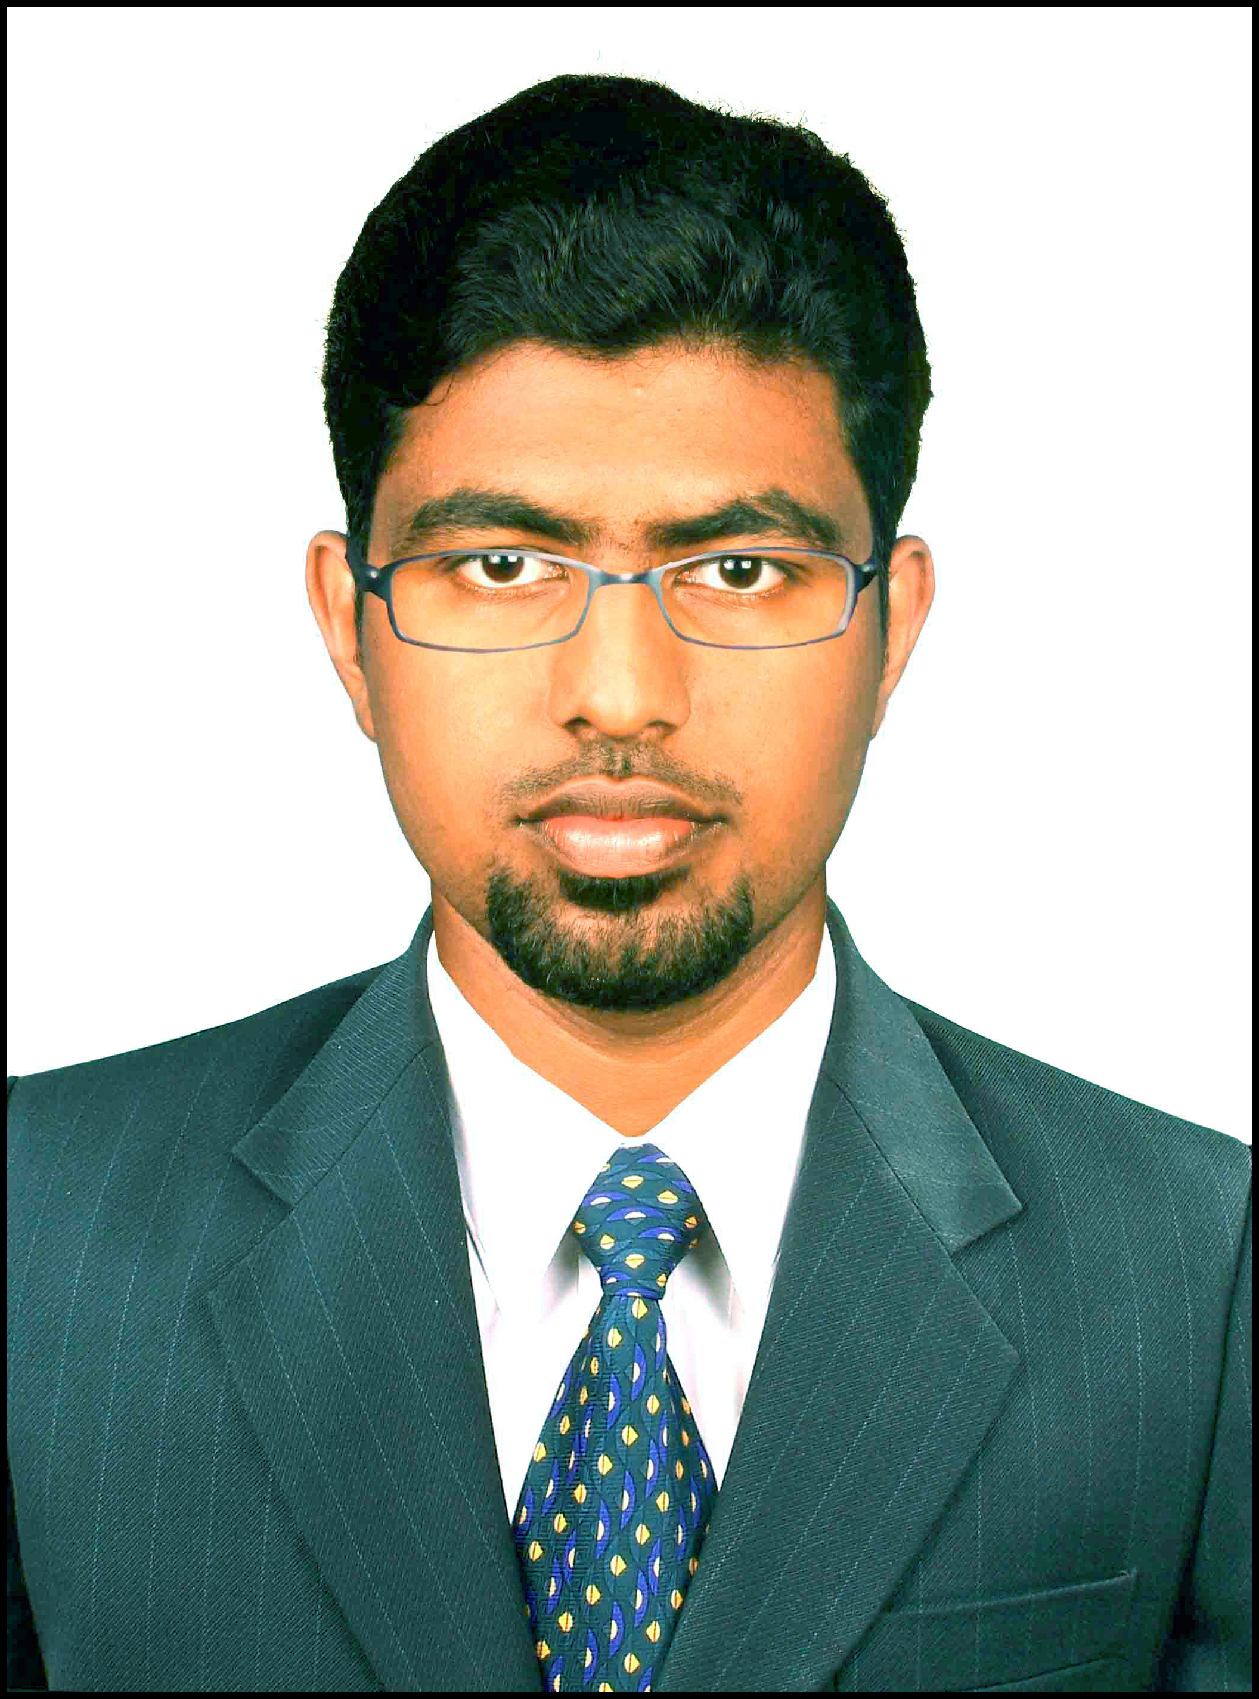
CV No: 1387158
Email: cvdba15@gmail.com
Mobile: +971505905010 / +971504753686

OBJECTIVE:
Looking forward for a challenging and dynamic career where I can best utilize my knowledge and skills, where prevails an excellent organisational culture and systems, where i can provide best services and simultaneously accomplish the targets set by organization assigned to my level of operations which in turn can pave way to career progressions.

WORK EXPERIENCE
CURRENT EMPLOYMENT

18-Oct-12 to 15-Mar-2015. K.P.M Crane Service, India.

About Company:
K.P.M Crane Services is one of the leading crane hiring service providing companies in Chennai ,which hiring business for past ten years and also do buying and selling of lifting equipments such as Cranes, Man lift or Boom lift, Aerial lift, Scissor lift, Fork lift etc. And the company having a power solution wing where selling generators, Hiring generators.

Working as Sales Engineer: Reporting to Senior Sales Manager

Primary Duties & Responsibilities
- To handle a team of three for the power solution sales and the after sales support.
- And to conduct some conferences for finding out the new customers and to make the customer relation stronger.
- To manage the technical oriented Service support to the clients by the technical experts from the suppliers.
- The main responsibility to make all our existing clients satisfied and to find out more new customers .

Sales and Marketing:
- Formulating a strategic plan for each Sales Executive to develop business and download it to them for the best sales achievements.
- Providing a stimulating and supportive environment for the entire team
- Attending direct sales calls from the listed leading company professionals.
- Conducting review meets to the existing customers and to explain the new product launch and attended many conferences to gain the technical aspects of the products from the suppliers.
- I made many presentation to the clients about the working of the products through technical ideas..
- The way I have managed the clients made me to stick on the company with a good relationship.

Operations:
- The same time i used to provide the operational support to the clients from the suppliers like the tracking of the shipping and the paper oriented servicing.
- Recording & resolving complaints as per the specified process within the stipulated TAT.
- Maintain and increase standard of customer services.

PREVIOUS EMPLOYMENT:

01-April-12 to 01-Oct-12. Radian Oil & Gas Services, KSA.

About Company:
Radian Oil & Gas Services is an engineering solutions and specialty product provider for a wide spectrum of industries in areas such as heat transfer, energy conservation, Solar/Wind (Hybrid) Energy together with recycle/reuse of water in industrial and commercial applications.

Worked as Sales Engineer: Reporting to the deputy General Manager

Primary Duties & Responsibilities
- My work was to Support the DGM to enhance the business by the technical knowledge and to train the Clients about the project and the project installation in technical aspects.
- Getting the Purchase order from the clients and pass it to the suppliers by doing the intermediate processing.
- And i was in India for a span of time to be trained from the project area about the Solar Power and to study the renewable energy concepts.
- I got a well knowledge about the current renewable energy operations as well the working mode and the wide possibilities of renewable energy.
- To make the sales progress on month on month which to be viewed by the General Manager.
- And i was introduced by all the suppliers as well the clients.
- And since there is some problem on the employment and HR department of the company , I have resigned from the Job after six months.

Sales and Marketing:
- I was meeting the customers directly for the sales calls and converting them.
- Conducting the customer meet for new customer leads and to introduce the new products.
- From the marketing side i used to conduct many conferences for introducing the company brand name and to sustain in the market.

Operations:
- Monitoring the operational procedures as per the Company’s manual of instructions.
- Recording & resolving complaints as per the specified process within the stipulated TAT.
- Tracking the baggage shipping and informing the clients and controlling the shipping.
- The same time i was giving the Technical Service Assistance to the project sites.

EDUCATIONAL QUALIFICATIONS:
COURSE | INSTITUTION | YEAR | % OF MARKS
BE –ECE | GNANAMANI COLLEGE OF TECHNOLOGY,PACHAL | 2007 - 2011 | 77%
HSC | MUHAMADALY JOUHAR HIGHER SECONDARY SCHOOL,ELETTIL | 2005 - 2007 | 75.8%
SSLC | MUHAMADALY JOUHAR HIGHER SECONDARY SCHOOL,ELETTIL | 2005 | 77.6%

PERSONAL SKILLS:
Excellent verbal and written communication skills, team facilitator, ability to deal with people diplomatically, willingness to learn fast with latest technologies, and good in team management, excellent presentation skills.

LANGUAGE SKILLS
Language | Read | Write | Speak
Malayalam | Yes | Yes | Yes
English | Yes | Yes | Yes
Tamil | No | No | Yes
Hindi | Yes | Yes | No
Arabic | Yes | Yes | No

SKILL SETS:
- Languages: Basics of C & C++ ( With Certificate )
- Operating systems: Windows XP, Windows Vista, Windows 7 & Windows 8.
- Other Skills : Good knowledge of word and excel, Photoshop , Presentation making and photo animation. Good in presentations.

TRAINING:
- Attended In plant training at Hindustan Software Solutions Coimbatore (Having Certificate).
- Attended one day training by Mr.Ponsekar (Vice President – Sales & Marketing (South Asia & MEA), CNPV Solar Power SA) at the project sight located at Coimbatore.

COLLEGE PROJECTS:
Mini projects: Computer controlled home appliances.
Controlling all the home appliances by a single PC using some relay and Port controlling Software.
Main Project: Boarding students Smart ID Card.
Locating the students and marking attendance and library operation using an embedded card and Card reader.

HOBBIES:
Driving, Hearing music, Sudoku.

WORK SHOPES
- Attended one day work shop in CMS engineering College, Namakkal (having certificate).

PRESENTATIONS
- Presented a paper at CMS Engineering College, Namakkal and JJ engineering college on 3G mobile communications (having certificate)
- Presented a paper at PAVAI College of Technology about the current Engineering Trends.(No certificate)

My Vision through my Milestones:

- My Vision is to gain well knowledge in all the area on which a technical company touching with.
- Initially I have experienced from Radian Oil & Gas Services, KSA as Sales Engineer.
- I was learning the technical aspects at Radian Oil & Gas Services at Renewable Energy area.
- And i got experience in the project sites and the installation process.
- And i used to visit the project sites for verifying the process.
- Then i came back to India and trained from Mr.Ponsekar (Vice President – Sales & Marketing (South Asia & MEA), CNPV Solar Power SA) at the project site located at Coimbatore, It made me more knowledge about the project installation.
- After that i got placed in K.P.M Crane Services, Chennai, India. One of the top Crane Service & Generators Hiring Company as Sales Engineer.
- There I have learned to handle the clients diplomatically with a better service and support.
- And I leaned to keep a better relationship to all the clients which made me to lead in the market.

In all aspects my Vision to be the a High level Electronics and Communication Engineer personal in a company where i can grow with my carrier.

PERSONAL DETAILS:
Sex : Male
Date of birth : 20/07/1989
Place Of Birth : Calicut, India.
Nationality : Indian
Marital status : Married
Languages known : English, Malayalam, Tamil.
Visa status : Visit Visa

