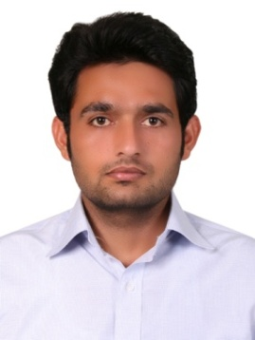
Sajad Bloch
Email: sajjadkhan58@gmail.com
Visa status: work visa
Address: AL MUTEENA STT, DEIRA DUBAI

EDUCATIONAL QUALIFICATION

B.COM HONS (4 YEARS GRADUATION) from university of Sargodha with 3.08/4 CGPA in 2014

PROFESSIONAL EXPERIENCE

EITSALAT TELECOM UAE
Currently, I have been working with Prime channel partner of Etisalat, skylines as a outdoor sales executive, since June 6 2015 to till date,
Responsibilities are as below:

- Handling to the customer’s requirements and presenting the product appropriately to make sale.
- Presenting the Etisalat corporate SIM packages with free handsets and broadband services in a structured professional way face to face.
- Maintaining and developing relationships with the existing or new customers in person and via telephone calls and emails
- Cold calling to arrange meetings with potential customers to prospect for new business.
- Responding to incoming email and phone calls enquiries.
- Acting as a contact between a company and its existing and potential markets.
- Gathering market and customer information.
- Presenting the product or service in a structured professional way face to face.
- Experience of working in a commission based sales environment.

Skill set Achieved from Etisalat

- Skills for working on multi-tier telecom environment.
- Equipped with the technical principles of telecommunication and all procedures involved there in.
- Skillful at multi-tasking and also ensuring that the jobs are done as per the desired standards and reap in the expected results.
- Good time management skills for successful management of projects.
- Remarkably strong communications skills for giving out clear orders and interacting efficiently with all levels of employees.

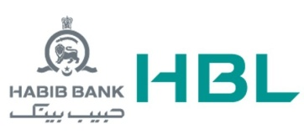
HABIB BANK OF PAKISTAN (HBL LTD ISLAMABAD 2014)

Worked with the largest bank of Pakistan as Cash Officer
Responsibilities:
- cash handling
- counter sale
- customer dealing
- cross sale
- managing accounts
- book keeping
- customer problem solving

UFONE TELECOM PAKISTAN
Worked as CSR customer service representative in UFONE PAKISTAN
RESPONSIBILITES
- counter sales
- customer problem solving
- franchise management
- SIM card selling
- UFONE mobile selling
COMPUTER LITERACY

OPERATING SYSTEMS: windows xp, win7, win 8 , win 10
Applications: All applications windows based, MS OFFICE etc
PERSONAL DATA
- Date of birth 13th DEC 1990
- Place of birth KHUSHAB , PAKISTAN
- Marital status SINGLE
- Nationality PAKISTANI
- Languages ENGLISH , URDU

