Post Applied : Hardware and Networking / Any suitable Position

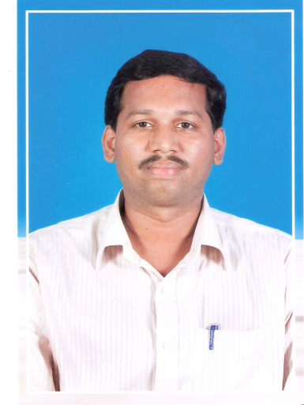

ASHARA
Ashara.231458@2freemail.com
Career Objective:
I have always been passionate about admin or data entry operator or Hardware and Networking or Accounts[payroll] profession maintained. My qualification and experience can be well utilized in Computerized working System.
Professional Experience:
I have done project “Provident Fund” in vanavil dyes and Chemicals limited,Cuddalore from August 1998 to February 1999.
I worked as “Data Entry Operator” in Election Computer Section of Collector Office, Cuddalore for a period of three months from 02.06.1999 to 26.08.1999.
I worked as “Computer Lab Assistant” in National Institute of Fashion Technology Chennai, for a period of nine months from 02.09.1999 to 03.06.2000.
I worked as “Computer Instructor” and “System Hardware and Networking” in Government Girls Higher Secondary School, Cuddalore Port, Cuddalore District from 03.07.2000 to 09.11.2008.
I worked as “Computer Instructor” and “System Hardware and Networking” in Government Higher Secondary School, Ramapuram West, Cuddalore District from 10.11.2008 to 26.07.2013.
I worked as “System Hardware and Networking” in Private organization, Cuddalore District from 01.08.2013 to Till date.

Educational Qualifications:
B.SC[COMPUTER SCIENCE], M.SC[COMPUTER SCIENCE], B.ED[COMPUTER SCIENCE]

2010-2012: Bachelor of Education in Computer Science, Tamilnadu Open University,
(Class :FIRST Pass Percentage :66% )
2008-2010: Master of Science in Computer Science, Annamalai University, Tamilnadu
.(Class :FIRST Pass Percentage :72% )
1996-1999: Bachelor of Science in Computer Science , Madras University, Tamilnadu
. (Class :FIRST Pass Percentage :72% )
MAR.1996: Higher Secondary Education in computer Science, Board of Higher Secondary
Examination. Tamilnadu (Class :FIRST Pass Percentage :72% )
APR.1994: Secondary School Leaving Certificate, Board of Secondary Education.
Tamilnadu. (Class :FIRST Pass Percentage :72% )

Additional Qualifications:

- Certified CCNA
- Certified Computer Accountant -TALLY.ERP9
- Authorized Tally academy Certificate
- Advanced Diploma in computer Hardware and Networking.
- Department of Technical Education in Type Writing English has passed in First Class
- MS Office (Word, Excel, PowerPoint, Internet & Email)
- Diploma in E-Commerce
- visual Basic 4.0, FoxPro
- Installation software and hardware.
- Installation Operation System and troubleshooting system.

