Renato
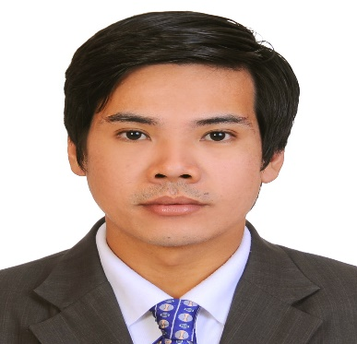
renato.231831@2freemail.com

OBJECTIVE: To obtain a position in any qualified vacancies that will serve as an avenue to continuously acquire the training and expertise needed for future advancement.

HIGHLIGHTS OF QUALIFICATION:

• Professional Photographer
• Proficient in Adobe Photoshop / Lightroom
• Proficient in computer application such as Microsoft Word, Microsoft Excel, Microsoft
PowerPoint and Basic Internet Application.

SEMINAR ATTENDED:

Basic Photography
Kodak Philippines Ltd
Studio set up

Mr. Mariano G. Miranda
• Trainer, Kodak Express
• Adobe Certified Expert
• Adobe certified Instructor in Photoshop August 2004

Ida Frietzie L. Amigo
Trade Marketing Specialist
Consumer Professional Imaging Division
Kodak Philippines Ltd

WORKING EXPERIENCE:

GSI Global Team November 2014- Present
Photographer
Dubai, UAE

Digiphoto EIS October 2012- October 2014
Burj Khalifa
Photographer
Dubai, UAE

Topico Studio Inc. January 2001 – September 2012
Head Photographer
Canlapan St., Sto Rosario
City of Malolos, Bulacan
Philippines

CERTIFICATIONS:

Employment Certificate – Head Photographer
Topico Studio, Inc.
Malolos Bulacan Philippines
January 2001- September 2012

Basic Photography Course – Kodak Philippines, LTD.
August 2004

Certificate of Appreciation – Downtown Dubai Group
Burj Khalifa & Emaar Malls Group
Security & Protocol Department

OTHERS:

Wedding Photographer
Events Photographer
Studio Photographer
Products Photographer
Videographer

EDUCATIONAL ATTAINMENT:

Vocational : 6 months Practical Electricity April 1994
Cabucbucan College Institute
Philippines

