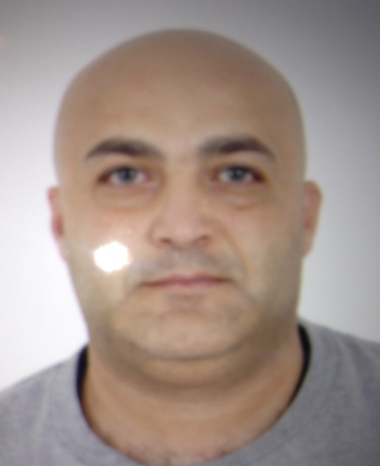

Gulfjobseeker.com CV No: 1394712
Mobile +971505905010 / +971504753686

To get contact details of this candidates
Submit request through Feedback Link
http://www.gulfjobseeker.com/feedback/submit_fb.php

Professional Competencies:

- Leadership Skills | - Target & Objectives Focused | - Effective Management Planning
- Creativity and Innovation Focused | - Sales Strategy | - Highly Motivated Individual

------------------------------------------Professional Profile---------------------------------------
  - Experienced in starting new projects, creating a market niche for targeted products and stabilizing corporation within market place.
  - Excellent Knowledge and experience in boosting sales and marketing business management, and drive all administrative responsibilities to achieve aggressive profits and reach stability in all aspects.
  - Creating and supporting of a healthy Enterprise Environmental Factors by achieving a loyal team and balancing it with the vision of the company
  - Strong historical proofs in market penetration , by creating a very strong sales record and placing products in the lead against competition

--------------------------------Professional Experience----------------------------------

Work Experience

Mar2010- going | Top1 cleaning and security items co  General Manager
Accountability | - Created 360 annual plan to achieve the total organizational objectives.  - Cascade down the annual plan to the respective department and assign a reporting system to the departments to monitor performance.  - Monitored Performance of sales and marketing to ensure the total organization strategy is implemented.  - Initiated a market intelligence system to collect data and insuring development is in the right direction.  - Ensured people development plan in place to ensure efficiency and creativity.  - Maintained a healthy tools and company assets in order to ensure smooth operation.  - Assigned tasks for HR department of implementing ongoing training programs to boost people development and mind targeting.  - Achieved company targets in terms of sales, marketing, expanding and people development.

June 2008 – feb 2010 | Biotechnology international co-LLC  Sales and Development Manager
Accountability: | - Establishing market and managing the operation in the Middle East and the North African(ie. Saudi Arabia, Jordan, Yemen, Egypt, Sudan, Libya, Syria , Oman )  - Created master plan to dominate the detergent market sector and created the necessary budget plan proposals for customers across those regions  - Created strong and long term relations across the MENA region in the FMCG and food industry.  - Managed costs and budgeting for the middle east and Levant Region and Participated in managing teams.  - Managed company Letter of Credit (LC), negotiations and managed tasks with same respect.

Dec. 2005 – Dec 2007 | Arnon co ( Saudi Arabia )  Area Sales Manager
Accountability | - Initiated the B2B Business in the Group, which included initially MEA region and planned the strategy and vision for the House Hold Department.  - Extended Business Opportunities to the Regional Markets to expand the base of the potential customers.  - Designed Promotional Campaigns to fit the product/Customer Profile.  - Implemented sales campaigns to enforce Sales strategies.  - Managed Sales Forecasting and Budgets  - Managed Incremental sales strategy to Double the sales capacity in certain outlets.  - Worked with multi-tasked team members to achieve targets.  - Created a hierarchy report system to have a live update of Sales Figures.

Sept 2001 – NOV 2005 | Henkel LLC –  Area Sales Manager
Accountability: | - Managed Distributor accounts in MEA region including UAE, Kuwait, Jordan, Egypt, Yemen.  - Enforced company objectives and Budgets in the region with distributors.  - Achieved the sales targets profits of 127.7 %  - Managed Incremental sales strategy to Double the sales capacity in certain outlets.  - . Managed Sales Forecasting and Budgets  - Created a hierarchy report system to have a live update of Sales Profits

----------------------------------------------Qualifications---------------------------------------------

BSC in psychology ….

- Higher Diploma commercial & Industrial psychology section of Advertisement.

- Practical course in German Cultural Institute (Ghotah) in Damascus regarding psychological studies of client & marketing.

- master in marketing.( Guide the behavior of consumers ) from the University of Washington on lain

TRAINNIG:

- A-Z Selling Alliance co in Dubai.

- Time management. In a Riyadh.

- Haw to balding yourself as business man ..

- Haw to work smart.

- Planning in the marketing. Alliance co in Dubai.

- Secrets of successful sales persons In a Riyadh.

- Inlays the marketing Alliance co in Dubai.

- train the trainer

- I S O internal and external editor

- Trained on the following IT solutions products : Veritas, Adic, Microsoft, Crystal Decisions, Novell, Citrix, NAI

Language Skills:

Arabic | Mother Tounge
English | Fluent in Reading, Speaking, And Written

Sports Skills:

Basketball • Swimming • Squash

