CURRICULUM VITAE  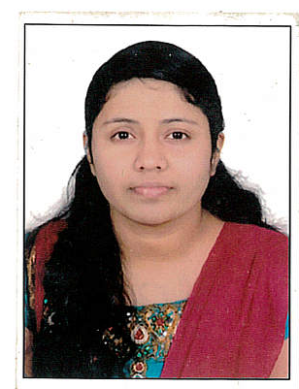  Personal Dossier:  Date of Birth : 22/04/1990  Marital Status : Married  Nationality : Indian  Religion : Christian  Linguistic Abilities  English  Hindi  Malayalam  Tamil  Telugu | Gulfjobseeker.com CV No: 1394826  Mobile +971505905010 / +971504753686  To get contact details of this candidates  Submit request through Feedback Link  http://www.gulfjobseeker.com/feedback/submit_fb.php  CAREER OBJECTIVE  To be a resourceful Nurse who wants to be part of a multi-disciplinary team, who is responsive and caring to patients. In addition, I would like to get an employer, who is willing to utilize my knowledge and experience, as well as my academic accomplishments.  KEY COMPETENCY  - Over 2 year experience in neuro surgery icu and other critical areas.  - Good leadership quality, Quick learner and ascertaining the mind of the individual through better interaction.  EXPERIENCE  - Mamata general and super speciality hospital, khammam  12th april 2012 to 7th may 2013.  - Amrita institute of medical science and research centre, kochi  11th November 2013 to 11th November 2014.  LICENSES  - Dubai Health Authority ( DHA)  - Dr. n N T R University of Health Science, Vijayawada.  ACADEMIC RECORD  Course Name University/ Board Institution Year of Passing  Bachelor of nursing dedree. Dr. N T R university of health science Mamta college of nursing khammam, AP 2011
EQUIPMENT’S FAMILIAR WITH
AED/Defibrillator, Cardiac Monitor, Ventilators, Temporary Pacemaker, Syringe pump, Pulseoxymeter ECG machine ,Infusion pump, Suction apparatus Sterilizers, Glucometer Oxygen cylinders etc.

EXPERIENCE IN DETAIL
- Head to foot assessment of the patient procedures .
- Cardiac monitoring.
- Plan care and set priorities of basic nursing procedures.
- Admission and discharge procedures
- Transfer of patient to various departments and other hospitals by well-equipped Ambulance.
- Administration of medication.
- Blood collection including ABG
- Insertion of peripheral Lines, Ryle’s tube, Foleys catheter.
- Administration of blood and products.
- Control of infection.
- Cardio pulmonary resuscitation.
- Application of traction.
- Preparing patients for Emergency Surgery.

DECLARATION

I hereby declare that the information furnished above is true to the best of my knowledge. I would truly prove myself and would sincerely serve my best for the growth of the organization.

