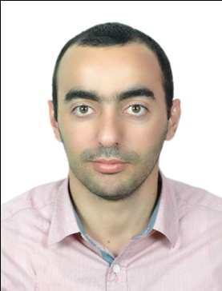
Gulfjobseeker.com CV No: 1396212
Mobile +971505905010 / +971504753686

To get contact details of this candidates
Submit request through Feedback Link
http://www.gulfjobseeker.com/feedback/submit_fb.php

Biomedical Engineer.
Personal Information

Nationality : Jordanian.
Date of Birth : 5/8/1987
Place of Birth : Irbid – Jordan.
Gender : Male
Marital Status : Married

Education

United Arab Emirates University, Alain, UAE, 2013 till now.
Master of Electronics Engineering

Yarmouk University, Irbid, Jordan, 2012
B.Sc. Engineering (Biomedical Informatics Engineering)

Training and certificates

- Cardiopulmonary machines training course. Baar, Switzerland
Training course with certificate

- Heidelberg University Heidelberg, Germany
2-Month training course with certificate

- 3-Month Cultural Exchange Program Maine, USA

- King Hussein Cancer Center Amman, Jordan
3-Month training course with certificate

- Medical Imaging Training Course Dubai, UAE

- Endoscopy Training Course Dubai, UAE

- Laser Training Course Dubai, UAE

Work Experiences

Cure Medical Supplies. Abu Dhabi, UAE.
Service & Sale Engineer 2014 till now.

Citypharmacy Co. Abu Dhabi, UAE.
Biomedical Engineer 2013 till 2014
MEDISERVE (Medical Supplies & Services) Riyadh, KSA.
Biomedical Engineer 2012 till 2013
Responsibilities:

- Set up machines.
- Presentations.
- Train the medical staff.
- Limited maintenance responsibilities.
- Responsible for the marketing of company products and services to the targeted market segment.
- Demonstrate technical marketing skills and company product knowledge.
- Experience in wide range of medical equipment.
- Sale engineer for the following principle: Schiller, Ardo, Lumenis, Given Imaging, Aircast, Mindray, Neusoft,medisafe, Dental Equipment.

Skills and Activities

- ILTES English Test Exam.
- Have excellent communication skills in Arabic and English.
- Highly self-driven and team-player who can motivate team.
- Knowledge of company culture and structure.
- High Planning and Organizing.
- Good intrapersonal skills.
- Wide computer skills.

Relationships and personality skills:
- Capable to demonstrate the ability to interact and cooperate with all company employees.
- Capable to maintain professional internal and external relationships that meet company core values.
- Proactively and innovatively establish and maintain effective working team relationships with all support departments.

- Technical skills
- Matlab
- Proteus
- PIC-C
- SQL
- Digital Jacket
- Microsoft Project 2003
- 7Edit Professional
- Microsoft Office
- Microsoft Visual Studio 2005

Conferences and Exhibitions

- Emirates Gastroenterology & Hepatology Conference.
Dubai, 2014.
- Arab Health.
Dubai, 2014.
- Arab Health.
Dubai, 2015.
- ENT Conference.
Dubai, 2015.

