Dolton
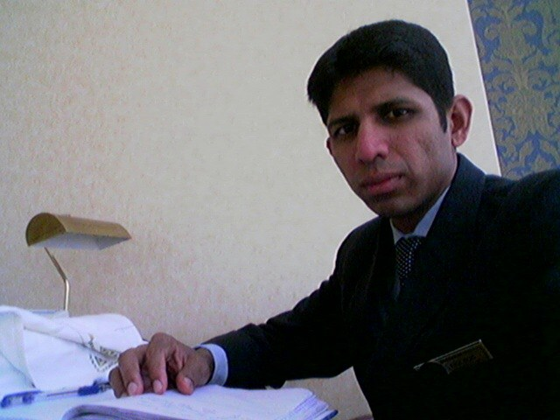
Dolton.233147@2freemail.com

OBJECTIVE : TAKING SERVICE TO A NEW STANDARD

- WORKED AS, ASSISTANT EXE HOUSEKEEPING MANAGER IN DAMAC GROUP HOTELS & RESORT SINCE AUG 2013 TILL MARCH 2015 AS PRE – OPENING TEAM..
- WORKED AS PRE – OPENING MEMBER IN HOUSEKEEPING DEPT OF MEYDAN HOTEL AS SENIOR TEAM LEADER 01.05.2011 till 21.07.2013

- (Pre –Opening Member)WORKED AS TEAM LEADER IN BURJ AL ARAB A 7*STAR HOTEL from 12.09.1999 to 30.04.2011
- (Pre Opening Member)WORKED AS ROOM ATTENDANT IN BEACH HOTEL ROTANA IN ABU DHABI FROM FEB 24/1994 TO NOVEMBER 18/1998.
- WORKED IN SEA ROCK ROTANA HOTEL BERIUT (LEBANON)FOR SIX MONTH AS ROOM ATTENDANT
- WORKED IN HOTEL HILTOP INTERNATINONAL IN BOMBAY AS CASHIER CUM ORDER TAKER FROM 14.11.92 TO 18.2.94

Languages [ENGLISH, HINDI]

Extracurricular [READING, LISTENING TO MUSIC, FOOTBALL. ]
Activities
WORK EXPERIENCE

- TOTAL HOUSEKEEPING SOLUTION
- PRE-OPENING SPECIALIST AND SUPPORT CO ORDINATION
- PREPARING REPORT IN FIDELIO/OPERA
- ALLOCATING STAFF FOR DAILY OPERATION
- INSPECTING GUEST SUITES FOR ARRIVALS
- LEAISING WITH OTHER DEPARTMENT LIKE FRONT OFFICE/GREETING DESK/RESERVATION ,ENGINEERING.
- CONDUCTING DAILY BREIFING FOR STAFF ON DAY TO DAY EVENTS/SPECIALS
- TRAINING NEW COLLEAGUES FOR ON HAND TASK WITHIN THE DEPARTMENT.
- HANDELING TOTAL HOUSEKEEPING DEPARTMENT OPERATIONS.

TRAINING TOPIC ATTENDED

TASK TRAINER CERTIFIRED
PERFECT TEAM LEADER (COURSE)
COMMUNICATION
TEAM WORK
HOW TO HANDLE VACCUM MACHINE
OPERA / FIDELIO FO / FO REPORT`S
MICROSOFT WORD/EXCEL KNOWLEDGE
TELEPHONE SKILLS
SUITES SET UP
SPECIAL BED MAKING
ROMANTIC SET UP FOR HONEY MOONERS/BIRTHDAY,SPECIAL OCCATION.
HANDELING GUEST REQUEST
FIRE FIGHTING
FIRST AID
CONDUCTING APPRAISALL FOR COLLEAGUES ANNUAL/QUATERLY

