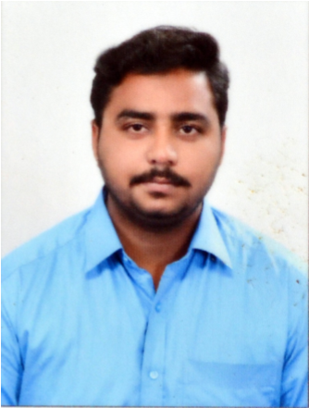
MALIK
E-Mail ID : MALIK.233311@2freemail.com

CAREER OBJECTIVE:
To become a successful professional in the field of Information Technology by utilizing my best knowledge and skills that enable further personal and professional development and work towards the prosperity of the organization.
WORK EXPERIENCE:
SENIOR EXECUTIVE- IT SUPPORT ENGINEER
MAGUS CUSTOMER DIALOG – CHENNAI (JUNE 2015 TO FEB 2017)
CAREER HIGHLIGHTS
- Good experience in Decoding the threads and scripts.
- Good experience in Jquery
- Manage Web development and interactive projects.
- Develop Facebook fan pages and applications.
- Develop project plans, specifications, application prototypes.
- Manage project change orders and impact analysis
- Conduct business process and requirements analysis
- Contribute to new business development as a technical representative
- Contribute to user interface, design and development efforts
- Contribute to application and Web site testing efforts
PROJECT WORKS:
WIKI / BLOG CONTENET MANAGEMENT SYSTEM IN PHP
Project during the college level for 6 months
- CMS/Group ware application written in PHP that fuses collaborative editing features of WIKIS with user friendly publishing characteristics of blog. Media wiki drive, wiki syntax UTF8 and extendable(google maps).
- Designed for speed and ease of use, wikiblog has a unique AJAX enhanced tabbed interface that enable users to view and edit multiple files within the same page. Custom templates, file attachments a flexible user privilege system and google maps number along t many features.
- At the core of a wiki app is the ability to collaborate. The default setting for wikiblog allow anyone to create and edit files creating an optimal environment for collaborations optionally permissions can be assigned to types of files and specific files to limit collaborations to set of users for more controlled environment.
SKILLS COMPOSED:
- Programming Languages : C, C++, JAVA, Visual Basic, PHP
- Database Systems : Oracle, My SQL
- Operating Systems : Windows, Linux
- Office maintenance : MS – Office
ACADEMIC QUALIFICATIONS:
CLASS/ DEGREE | NAME OF INSTITUTION | YEAR OF PASSING | PERCENTAGE
B. Sc.,  Computer Science | Dr. M.G.R. Chockalingam Arts College, Arni. | 2015 | 68.5
HSC | ACS Matriculation Higher Secondary School, Arni. | 2012 | 56
SSLC | ACS Matriculation Higher Secondary School, Arni. | 2010 | 60

EXTRA CURRICULAR SKILLS:
- Spirited Badminton and volleyball player
- Active participant in cultural activities
PERSONAL STRENGTHS:
- Good communication skills, dedication, team spirit, administrative and organizing, efficiency, positive thinking and self confidence
PERSONAL PROFILE:
Date of Birth : 27-11-1994
Linguistic Proficiency : English, Hindi, Urdu & Tamil.
Nationality : Indian
Marital Status : Single
Visa Type : Visit Visa
Visa Expiry date : 30 – Nov – 2017
DECLARATION:
I hereby declare that the information furnished above is true to the best of my knowledge.

DATE:

