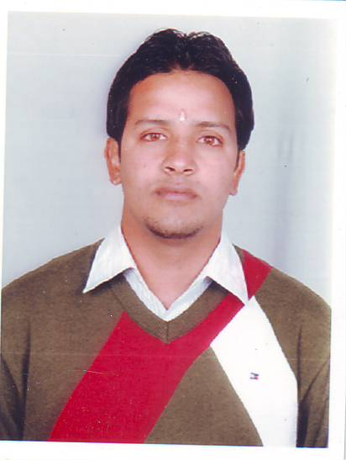
Gulfjobseeker.com CV No: 1404834
Mobile +971505905010 / +971504753686

To get contact details of this candidates
Submit request through Feedback Link
http://www.gulfjobseeker.com/feedback/submit_fb.php

B-PHARMACY

DATE OF BIRTH - 10 DEC 1988.

NATIONALITY - INDIAN

LANGUAGES KNOWN - HINDI, ENGLISH

STATUS - UNMARRIED

CAREER OBJECTIVE SELF MOTIVATED AND DETERMINED PHARMACY
GRADUATE WITH COMMUNITY PHARMACY
EXPERIENCE AND A PASSION FOR CUSTOMER
SERVICE SEEKS A FULL TIME POSITION WHERE I
CAN APPLY MY MEDICATION DISPENSING AND
MEDICAL COUNSELLING SKILLS TO PROVIDE
EXCEPTIONAL HEALTH SERVICES TO CUSTOMERS.

EDUCATIONAL QUALIFICATION -
- PASSED 12^{th(MEDICAL STREAM)}
FROM C.B.S.E. New Delhi.

2) DONE BACHELOR OF
PHARMACY WITH FIRST
DIVISION FROM SRI SAI
COLLEGE OF PHARMACY,
PUNJAB TECHNICAL
UNIVERSITY, JALANDHAR.

WORK EXPERIENCE - WORKED AS TRAINING SALES
OFFICER(TSO) IN ACME
PHARMACEUTICAL COMPANY
IN HIMACHAL PRADESH.

- WORKED FOR ARMY
ORGANISATION ‘ECHS’ ( EX-
SERVICE MAN CONTRIBUTORY
HEALTH SCHEME) POLYCLINIC
TYPE ‘A’ YOL CANTT,
w.e.f SEP 2011 TO OCT 2014,
AS A PHARMACIST.

RESPONSIBILTIES - DISPENSE DRUGS PRESCRIBED BY
PHYSICIANS AND OTHER HEALTH
PRACTITIONERS AND PROVIDE
INFORMATION TO PATIENTS
ABOUT MEDICATIONS AND THEIR
USE .MAY ADVISE PHYSICIANS
AND OTHER HEALTH
PRACTITIONERS ON THE
SELECTION, DOSAGE
INTERACTIONS AND SIDE
EFFECTS OF MEDICINES.

TECHNICAL SKILLS - 1) ABILITY TO WORK IN A
DETAILED ORIENTED MANNER.

2) WORKING KNOWLEDGE OF THE
PROCEDURES AND STANDARDS
USED IN DISPENSING OF
MEDICINES.

3) HANDS ON EXPERIENCE IN USING
SYRINGES AND OTHER
COMPOUND ACTIVITIES.

CO – CURRICULAR ACTIVITIES - 1) PARTICIPATED IN FOOTBALL
COMPETITION IN THE
REGIONAL SPORTS MEET AT
CHANDIGARH REGION HELD
AT CHANDIMANDIR.

2) PARTICIPATED IN K.V.S.
REGIONAL SPORTS MEET OF
CHANDIGARH REGION IN
BASKET BALL HELD AT
CHANDIMANDIR

3) WORKED AS NSS MEMBER IN
SRI SAI COLLEGE OF
PHARMACY, PATHANKOT.

