CURRICULUM VITAE
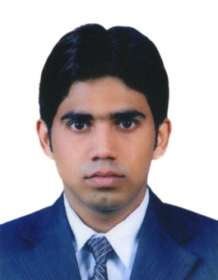
Gulfjobseeker.com CV No: 1405422
Mobile +971505905010 / +971504753686

To get contact details of this candidates
Submit request through Feedback Link
http://www.gulfjobseeker.com/feedback/submit_fb.php

Career Objective

To be part a successful, well established company where I can be given the opportunity to utilize my talent and skills to grow and expand my experience and knowledge with both hard work and dedication.

Professional Experience

AHLAN Services – Airport Guest Service Agent
Dubai International Airport
Dubai International Hotel
03 October 2010 - Present

- Provides quality escort service to the passenger on departing & arriving.
- Assist passengers to the immigration formalities on a fast track, all the way to their respective transport service.
- Ensures all baggage are accurate and properly handed over the passengers.
- Bids goodbye and thank them as well as envite them again next time for future business with them.
- Reports to the office every time the service has been completed.\

Sales Experience

- Working as Sales Man & Cashier 2006 to 2009 at Nishat Medical Store in Hyderabad AP India.
- Working as Sales Man & Cashier 2009 to 2010 at Mega Pharmacy in Hyderabad AP India.

Educational Qualification

- Intermediate (Twelve Classes)

Personal Details

Date of Birth : 04/08/1989
Nationality : Indian
Marital Status : Single
Sex : Male
Visa Status : Employment Visa (Changeable)

Languages Known

- English, Hindi, & Urdu

Declaration:

I hereby declare that the above mentioned statement is correct & true to the best of my knowledge and belief.

