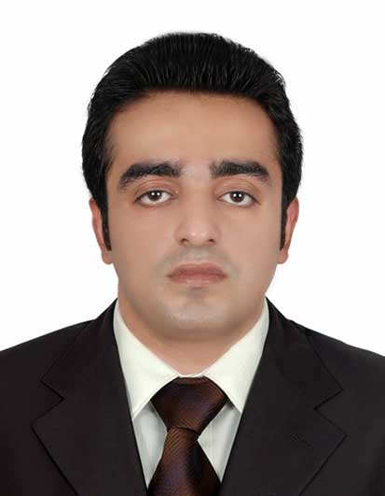**ZUBAIR**

[**zubair.234545@2freemail.com**](mailto:zubair.234545@2freemail.com)



**CAREER OBJECTIVE**

To get associated with a reputed organization that utilizes my skills effectively and helps in developing my knowledge while offering professional growth and learning in a challenging environment.



**EDUCATIONAL QUALIFICATIONS**

|  |  |  |  |
| --- | --- | --- | --- |
| **Year** | **Academic Qualification** | **Institute/University** | **Percentage/GPA** |
| 2013 | B.Tech Computer Engineering | Jamia Millia Islamia,  New Delhi | 6.9 CPI |
| 2008 | XII (CBSE Board) | The Heritage School,  New Delhi | 70% |
| 2006 | X (CBSE Board) | International Indian School  Jeddah, Saudi Arabia | 83% |

**SKILLS**

**Technical Skills:**

* Programming languages : C, Java, XML, PHP
* Database query language : MySQL
* Tools and Applications : Android Studio IDE, Eclipse IDE, Matlab, Blender
* Operating systems : WINDOWS 95 onwards, LINUX, MAC OS X

**Language Skills:**Fluent in English, Hindi, Urdu and working knowledge of Arabic.

**ACADEMIC PROJECTS**

* **MAJOR PROJECT : ACOUSTIC FINGERPRINTING SYSTEM**

**Project Description :** In this project we present an audio fingerprinting system, which can be used to identify an audio sample in an audio database. By using the fingerprint of an unknown audio clip as a query on a fingerprint database, which contains the fingerprints of a large library of songs,

the audio clip can be identified.  
**Tools & Languages used :** Matlab, MySql

* **MINOR PROJECT : IMAGE AUTHENTICATION AND INTEGRITY**

**Project Description :** The aim of this project is to present a technique to achieve image integrity and authenticity by using compression and encryption techniques. In this project, we use discrete cosine transformation technique for image compression and bit-xor encryption technique. **Tools & Languages used :** Matlab

**OTHER PROJECTS**

* **COMPANY FEEDBACK FORM ANDROID APPLICATION**

**Tools & Languages used :** Java, XML, Android Studio

* **ONLINE RAILWAY TICKET RESERVATION SYSTEM**

**Tools & Languages used :** Java, MySql, Java database connectivity (JDBC)

**EXTRA CURRICULAR ACTIVITIES AND ACHIEVEMENTS**

* Achieved **99.84** percentile in **Management Aptitude Test (MAT)** held in February 2013.
* Secured an **All India Rank** o**f 4** in Maths Olympiad in School held at National level.
* Worked as **Director** for the **Student** **Interact Club** in School.
* Memberof Computer Society of India Student Chapter Jamia Millia Islamia.
* **Coordinator** of event *Who Dares Win* at **ALGO*RHYTHM*’12**.
* Participated in **ETHICAL HACKING** workshops held by KYRION technologies.

