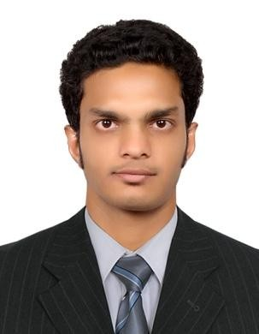SYED ABDUL REHMAN QUADRI

Address: Dubai
Email Address: rehmanquadri@gmail.com Visit Visa Valid Till: 1st JULY 2015

OBJECTIVE

I would like to be professional towards the organization and work where my skills will be usefull, active to accept all challenges and hard towards achieving goals of the organization with new techniques and resulting organizational growth as well as individual development.

Academic Qualification
- Year: B.TECH 2012 (ELECTRICAL & ELECTRONICS ENGINEERING) (HYDERABAD, INDIA)

Technical Qualification

  - AUTO CAD 2D DESIGNS.
  - MECHANICAL ELECTRICAL PLUMBING(MEP).
  - HEATING VENTILATION & AIR CONDITIONING(HVAC)

EXPERIENCE

Name of Company: PRINCE BUILDERS & PLANNERS Designation: AUTO CAD DESIGNER AND SITE ENGINEER
Duration: 2012-2014
Place: (HYDERABAD, INDIA)

Responsibilities:

- Handling of electrical loads as per requirements.
- To provide proper preventive maintenance of machines.
- Maintenance of boiler (8MT,12MT & 20MT).
- Daily maintaining of power consumption report.
- To check the entire work as according to approved drawings.

Name of Company: PRINCE BUILDERS & PLANNERS Designation: AUTO CAD DESIGNER AND SITE ENGINEER
Duration: 2012-2014
Place: (HYDERABAD, INDIA)

Responsibilities:

- Handling of electrical loads as per requirements.
- To provide proper preventive maintenance of machines.
- Maintenance of boiler (8MT,12MT & 20MT).
- Daily maintaining of power consumption report.
- To check the entire work as according to approved drawings.

Achievements

- My achievements in this system is high current darlington arrauys.
- In each open collector darlingtons paired with emitters.
- Ensured that the base plans are in accordance with the client requirement. Embedded system relays DC motors and displays filament lambs.

LANGUAGES
English, Urdu and Hindi

PERSONAL
Father’s Name : SYED ATHER HUSSAIN QUADRI
Date of Birth : 29-10-1989

Place of Birth : HYDERABAD, INDIA

I hereby certified that the above statements are true and correct with all my knowledge.

COMPLETE NAME:

SYED ABDUL REHMAN QUADRI

