Curriculum Vitae

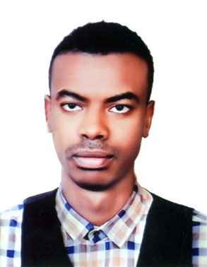 | Ahmed  Ahmed.234585@2freemail.com

Objective  education  Languages  EXPERIENCE  other skills  personal information | To find a challenging position to meet my competencies, capabilities, skills, & education  - HSE –Safety officer (occupational safety and health administration) Charisma Workforce Development - Completed training program( OSHA )Compliance In Constructions Industry  - University of Khartoum - Auto Cad 2D basic applications  - University of Khartoum – Primavera  - Jelecom Cairo – Auto Desk – Auto Cad 2D  - Charisma Workforce Development - Completed training program OASHA Compliance In Constructions Industry  - Istanbul Aydin University – Turkish language teaching, research and application centre  - Two years in Omdurman Ahlia University faculty of Interior Design(2008-2010)  - Sudanese high secondary school certificate (March,2004)  - Secondary stage, Kosti – Sudan (2001-2003)  - Basic stage, Kosti – Sudan (1992-2000)  - Arabic – Native  - English - Fluent (writing – reading – speaking)  - Turkish – Fluent (speaking)  - Worked as an accountant for 6 months in sama company sudan – kosti  - Excellent computer skills (Ms. Office & internet applications)  - Valid Driving license  - Ahmed Hashim Hamd Mohamed  - Sudanese  - Muslim  - Kosti in 16/03/1987  - Male  - Single

