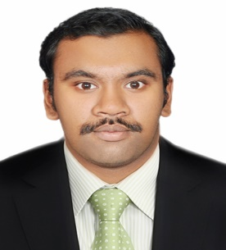  Personal Data  Date of Birth :25-05-92  Birth Place :R.A.K, U.A.E  Gender :Male  Nationality :Indian  Marital Status :Single  Languages Known :English,  Malayalam,  Hindi,  Tamil | Sajeem  Sajeem.234694@2freemail.com  Objective  Intended to work in the progressive environment that uses my technical and analytical skills and provides the opportunity to enhance my skills which helps for the good productivity.  Work Experience  I have worked in Kerala as an “Auto CAD draughtsman” at “MADATHIL ENGINEERS AND BUILDERS” from 10/09/2014 to 25/03/2015  Education  2014-BBA, from Dr. C. V. Raman University , Chattisgarh  2010- HSE( XII), from Sabarigiri Higher Secondary School, Anchal, Kollam  2008- SSLC, from The New Indian Higher Secondary School ,  Ras-Al-Khaimah,U.A.E  Technical skills  - Designing Tools : AutoCAD,REVIT,PPM,Primavera  - Office Tools : Microsoft Office,PowerPoint  Certification  - PPM  - Auto CAD  - REVIT Architecture  - Primavera  Key Strengths  - Dedication and Commitment  - Interest to learn new technologies  - Hard Working  - Enthusiastic  - Ability to adapt to changes  Declaration  I here by declare that the above written particulars are true to the best of my knowledge.  Date:  Place
Declaration

I here by declare that the above written particulars are true to the best of my knowledge.

Date:
Place: Sajeem

