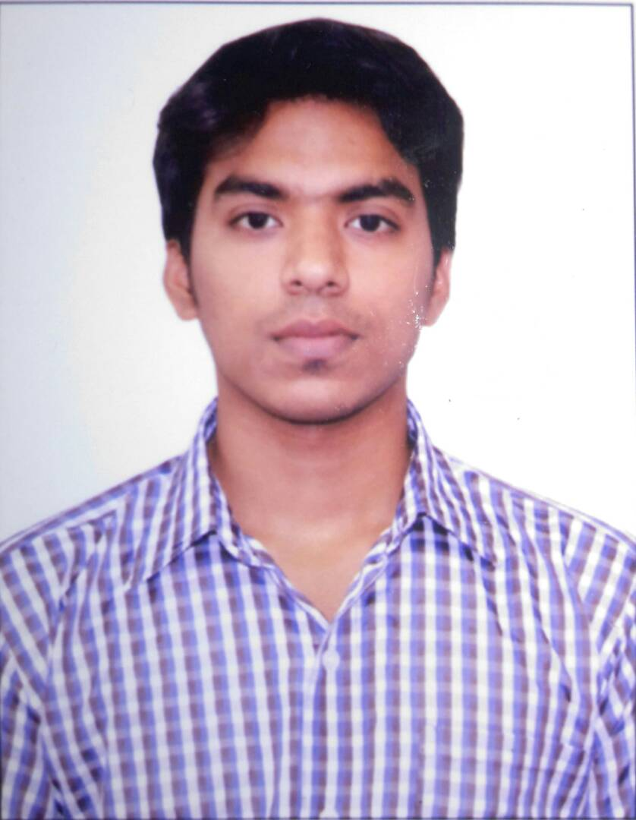
Nouman
Nouman.234729@2freemail.com
Process associate
First American (India)
Location: Dubai, United Arab Emirates
Education: Bachelor's degree, B.Sc (MPCs)
Experience: 1 year, 11 Months
__________________________________________________________________________________________
Contact:

Country: Dubai, United Arab Emirates
Career Objective:
To work hard for the organization I am into and learn new things from my Superiors which helps me grow and handling day to day pressure of duty by applying the best of me and achieving the goals and targets of the company by appointing the experience of my past and the knowledge I gained from the past and will help the people who are under me with the best I have. Instead of being just an employee I want to always focus on the things which bringthe growth for my Organization which simultaneously help me grow and brings me a respectful position which I always dreamed of.
Experience (1 Year, 11 Months):
- Process Associate at First American (India)
Sep 2016- Sep 2017
Location: India
Job Role: Process Associate
- Working on Review Title Company.
- Working on Formatting Rules Project.
- Monitor all data entry operations and ensure compliance to timeframe.
- Monitor all transactions and ensure compliance to quality regulations and maintain effective relationships with clients.
- To maintain good quality and high production numbers.
- Ensure and maintain effective professional relationships with staff.
- To meet Service Level Agreement and productivity targets.
- Responsible for maintaining daily production logs.
- Adaptable to learn new processes, concepts and skills.
- Responsible for keeping commitments in a timely manner and resolving issues promptly.
- Monitor data entry operations and ensure compliance to provided timelines.
- Assemble, disassemble, operate and maintain production equipment and tools.
- Report any questionable activity to the process specialist immediately.
- Maintain work areas to meet the cleanliness and sanitation standards of the company.
- Perform regular and preventative maintenance on equipment.
- Make sure that produced items are properly stored.
- Create reports for each completed production process and punch in information into the company database.
- Sales Executive at Faizul’s Communication:
March 2015- February 2016
Location: India
Job Role: Sales Executive
- Listen to customer requirements and present appropriate mobile to make a sale
- Maintain and develop relationships with existing customers in person and via telephone calls and emails
- Replenishment of the store on daily basis
- Respond to incoming email and phone enquiries
- Act as a contact between a company and its existing and potential markets
- Negotiate the terms of an agreement and close sales
- Gather market and customer information
- Challenge any objections with a view to getting the customer to buy
- Advise on forthcoming product developments and discuss special promotions
- Check the quantities of goods on display and in stock
- Make accurate, rapid cost calculations and providing customers with quotations.

Education:
Bachelor's Degree: B.Sc. (MPCs)
From St. Joseph's Degree & PG college
Location: Hyderabad, India
Completion Date: April 2016
Grade: 71 out of 100
Intermediate: MPC
From Sri Chandra Junior College
Location: Hyderabad, India
Completion Date: April 2013
Grade: 68 out of 100
Schooling: SSC
From Dwaraka High School
Location: Hyderabad, India
Completion Date: April 2011
Grade: 65 out of 100
Technical skills:
Windows XP, 7, 8, 10
Customer Support (Voice & Non-Voice)
Microsoft Excel
Microsoft Word
Microsoft PowerPoint
Microsoft Outlook
SQL
JAVA
Networking and Hardware
Operating System
PCB designing

Certifications:
PCB designing
Training Institute: St. Joseph's Degree & PG College.
JAVA
Training Institute: Solo learn.
SQL
Training Institute: Solo learn.
Major Proje ct:
Online student portal.
LINGUISTIC ABILITY:
Able to read & speak fluently: English, Urdu and Hindi.
Personal Information:
Birth Date: 31st December 1995(21 years)
Gender: Male
Residence Country: Dubai, United Arab Emirates
Nationality: India
Visa Status: Visit (03rd of Feb 2017)
Marital Status: Single

