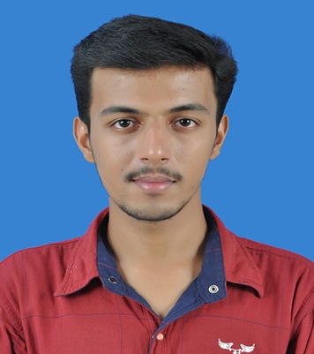
RESUME
Gulfjobseeker.com CV No: 1410258
Mobile +971505905010 / +971504753686

To get contact details of this candidates
Submit request through Feedback Link
http://www.gulfjobseeker.com/feedback/submit_fb.php

Career objective
Seeking a position in your organization where I can display my technical abilities and knowledge to contribute for the growth of the organization simultaneously helping me to fulfill my carrier objectives and widen my knowledge in this rapid changing field.
Academic details
Qualification | School/  college | Board/  university | Year of passing | Percentage  Of mark
S.S.L.C | NSS HSS  MANICKAMANGALAM  KERALA | BOARD OF KERALA EDUCATION | 2010 | 80
HIGHER SECONDARY | DEPAUL INSTITUTE AND MANAGEMENT | BOARD OF KERALA EDUCATION | 2012 | 75
BACHELOR OF DEGREE IN B.COM | INDIRAGANDHI COLLEGE OF ARTS AND SCIENCE,KERALA | MG UNIVERSITY | 2015 | 60

STRENGTH
- HARD WORKING
- HONESTY
- ABLE TO WORK IN ANY SITUATION
- GOOD COMMUNICATION SKILL
- GOOD CUSTOMER RELATIONSHIP

HOBBIES
1. READING BOOKS
2. LISTENING MUSIC
3. SURFING INTERNET
PERSONAL DOSSIER
DATE OF BIRTH : 21/12/1993
GENDER : MALE
MARITAL STATUS : SINGLE
LANGUAGE KNOWN: ENGLISH, MALAYALAM, TAMIL
SOFT SKILL : MICRO-SOFT OFFICE, TYPING , TALLY ERP SOLUTION 9.0

EXPIRENCE
- ONE YEAR WORKING EXPIRENCE AS A CASHIER IN PVR CINEMAS IN LULU MALL COCHIN,
- ONE YEAR WORKING EXPIRENCE IN BILLING AT PRIVATE TEXTILE SHOP
DECLARATION
I hereby declare that above mentioned information is true to the best of my knowledge and belief and I bear the responsibility of the correctness of the above mentioned particulars.

DATE :

