CURRICULUM VITAE
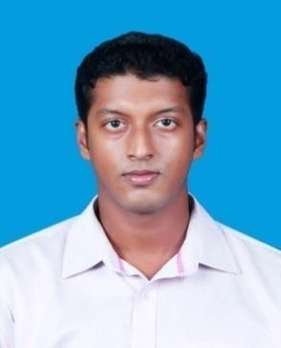

Name Joel Jossy

Address: C/o Cicy Thomas; P.O Box: 12386, Dubai.

Email : joeljossy755@gmail.com

Educational Qualifications:

- B. Tech in Mechanical Engineering- Mahatma Gandhi University (2009-2013)

Objective:

Seeking a position as Mechanical Engineer in the field of Engineering in a company of immense repute where my potentials and acquired knowledge can be utilized at optimum level in terms of analytical, organizational and communication skills. To deliver my best to ensure timely, safe and cost effective design and implementation during the life cycle of projects from conception till completion.

Professional Experience:

Mechanical Maintenance Supervisor –at Bombay High South (BHS) offshore oil/gas platform owned by ONGC India. June 2013-February 2015 (About 2 years).

- Undertaking scheduled, preventive, breakdown maintenance activities of static mechanical machines in oil and gas (process/production) platforms.

- Apply permits for regular jobs as well as break down jobs as a permit applicant.

- Having knowledge about permit to work (PTW), equipment isolation, lock out/ tag out procedure, job safety analysis (JSA), near miss, near hit, incident report, on job safety & off job safety.

- Have hands-on experience in Maintenance works of heat exchangers, Hydro cyclones, Surge Tanks and vessels & pipeline maintenance.

- Able to handle fabrication jobs at hazardous sites in extreme safety.

- Controlling & monitoring of projects, Preparation of isometric drawings for fabrication.

- Fabrication of spools & pipe supports within design standards & its installation.

- Valve type selection for piping systems, its installation and maintenance.

- Preparation of statistical and financial record for the works carried out. Reporting it directly to maintenance engineer.

Training:

- STCW-95 at YAK Institute of Marine & Management, Navi Mumbai. o HUET : Helicopter Under Water escape

o PST; Proficiency in Survival Techniques

o PSSR: Proficiency in Personal Safety And Social Responsibilities o EFA: Elementary First Aid

o FPFF: Fire Prevention And Fire Fighting

- Health Safety Environment (HSE) training, ONGC India, Sion, Mumbai.

- Confined Space Entry trained at ONGC India BHS platform.

Technical Skills:

- Fabrication & erection of pipelines.

- Exposure in Auto Cad, ProE, Piping Design Management System (PDMS) and Primavera.

- Skilled in analysis & implementation of Technical drawings.

- Knowledge of various international Codes & Standards such as ASME, API etc.

- Well versed with MS Office, Windows OS and Linux OS.

- Quality assessment & Quality Control (QA, QC) and NDT techniques.

- Knowledge in Conventional & Computer Aided Manufacturing techniques

Personal Skills:

- Self-motivated and productive.

- Able to accomplish time bound tasks.

- Quick learning, willingness to learn and team facilitator.

- Attention to details.

- Possesses highly analytical skills, good verbal and written skills, as well as good personnel-relations management skills.

- Planning and organizing.

- Ability to work in a fast paced environment on multiple tasks simultaneously.

Co-Curricular Activities:

- Participated in inter college project presentation held at ST. Josephs College & won special jury award for project ‘Pneumatic Rubber Tree Tapping Machine’.

- Worked as team lead for the project ‘Kinematic Walking Robot’ as a part of technical fest SYNOSURE 2011.

- Coordinator (kinematics section) of technical fest SYNOSURE 2012 at St. Joseph College of Engineering & Technology.

- Participated in inter-school Cricket championship in 2006 & 2007.

Personal Details:

• | Nationality: | Indian
• | Gender: | Male

- Date of Birth, Age: 16th October 1991
- Languages known: English, Hindi, Malayalam

• Visa Status: Visit Visa

Declaration:

I’m a very ambitious, hardworking and determined professional as far as work is concerned. I’ve passion for construction and petrochemical industries. I assure you the best output from my end. I confirm that the information provided by me is true.
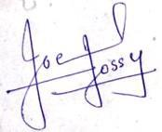

JOEL JOSSY

