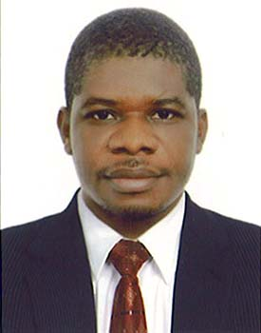
UBA
UBA.235235@2freemail.com
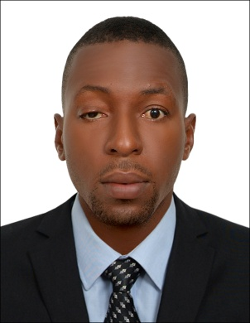
DISH WASHER /KITCHEN ASSISTANT

Profile Summary:

pro-active and result oriented with broad experience in all aspects of operating and handling automatic dish-washing equipment In depth knowledge of safe use of detergents and cleaning chemicals Profound understanding of health and safety regulations Strong team builder and facilitator, fosters an atmosphere that encourages highly talented Ascertains needs and goal, streamlines existing operations, turns around unprofitable functions, envisions new concepts and future trends, and follows through with development direction, and accomplishment. Effectively communicates direction, commits people to action, and conveys complex information in easily understood format, computer literate,
STRENGTHS:
- Professional in handling automatic dish washing machine
- Profound understanding of health and safety regulations
- Ability to work with little or no supervision
- Handle Pressure with Ease & Efficiency
- Hard working
- Ability to learn fast

Career Snapshot:

Zodiac hotel & suites - Lagos Nigeria dish washer 2013 -2014

Chinese restaurant - Lagos Nigeria
Kitchen assistant 2011 – 2013

First bank plc
Cleaner 2010-2011

Proven Job Role:

Dish washer, zodiac hotel &suites
- Clean, wash and store pots, pans and dishes
- Empty trash and recycle bins
- operate trash compactor and dishwasher
- stock supplies such as utensils in serving stations and cupboards
- Receive and store food supplies
- Assist janitorial staff in routine cleaning procedures
- Maintained cleanliness of all food service areas and equipment
- Cleaned, washed and stored all eating and drinking utensils
- Sanitized kitchen surfaces
- Maintained clean dish washing area
- Kept garbage compactor clean and neat
- Kitchen Assistant, Chinese restaurant

- preparation of basic food
- unloading deliveries from suppliers
- organizing the storeroom
- Washing kitchen appliances, work surfaces, floors and walls.
- Help chefs get ready for serving food to customers.
- washing, peeling and trimming food items to make them ready for cooking
- Using a variety of kitchen equipment such as automatic mixers, chipping machines and special knives and cutters etc.
- Sorting, storing and distributing ingredients

First bank plc Lagos Nigeria, cleaner
- Clean rugs, carpets, upholstered furniture, and/or draperies, using vacuum cleaners and/or shampooers.
- Empty wastebaskets, empty and clean ashtrays, and transport other trash and waste to disposal areas.
- Sweep, scrub, wax, and/or polish floors, using brooms, mops, and/or powered scrubbing and waxing machines.
- Dust and polish furniture and equipment.
- Keep storage areas and carts well-stocked, clean, and tidy.
- Polish silver accessories and metalwork such as fixtures and fittings.
- Remove debris from driveways, garages, and swimming pool areas.
- Replace light bulbs.
- Replenish supplies such as drinking glasses, linens, writing supplies, and bathroom items.
- Sort clothing and other articles, load washing machines, and iron and fold dried items.
- Sort, count, and mark clean linens, and store them in linen closets.
- Wash windows, walls, ceilings, and woodwork, waxing and polishing as necessary

Educational Attainment:
Institute of skills and computer learning – diploma in computer studies
Caro-Favored College Lagos Nigeria – senior secondary certificate
Bishop Onyeabo primary school – first school leaving certificate

Personal Details:

Nationality: Nigerian Date of Birth: 17th September, 1984 Marital Status: single
Sex: Male Visa – tourist visa Language: English

