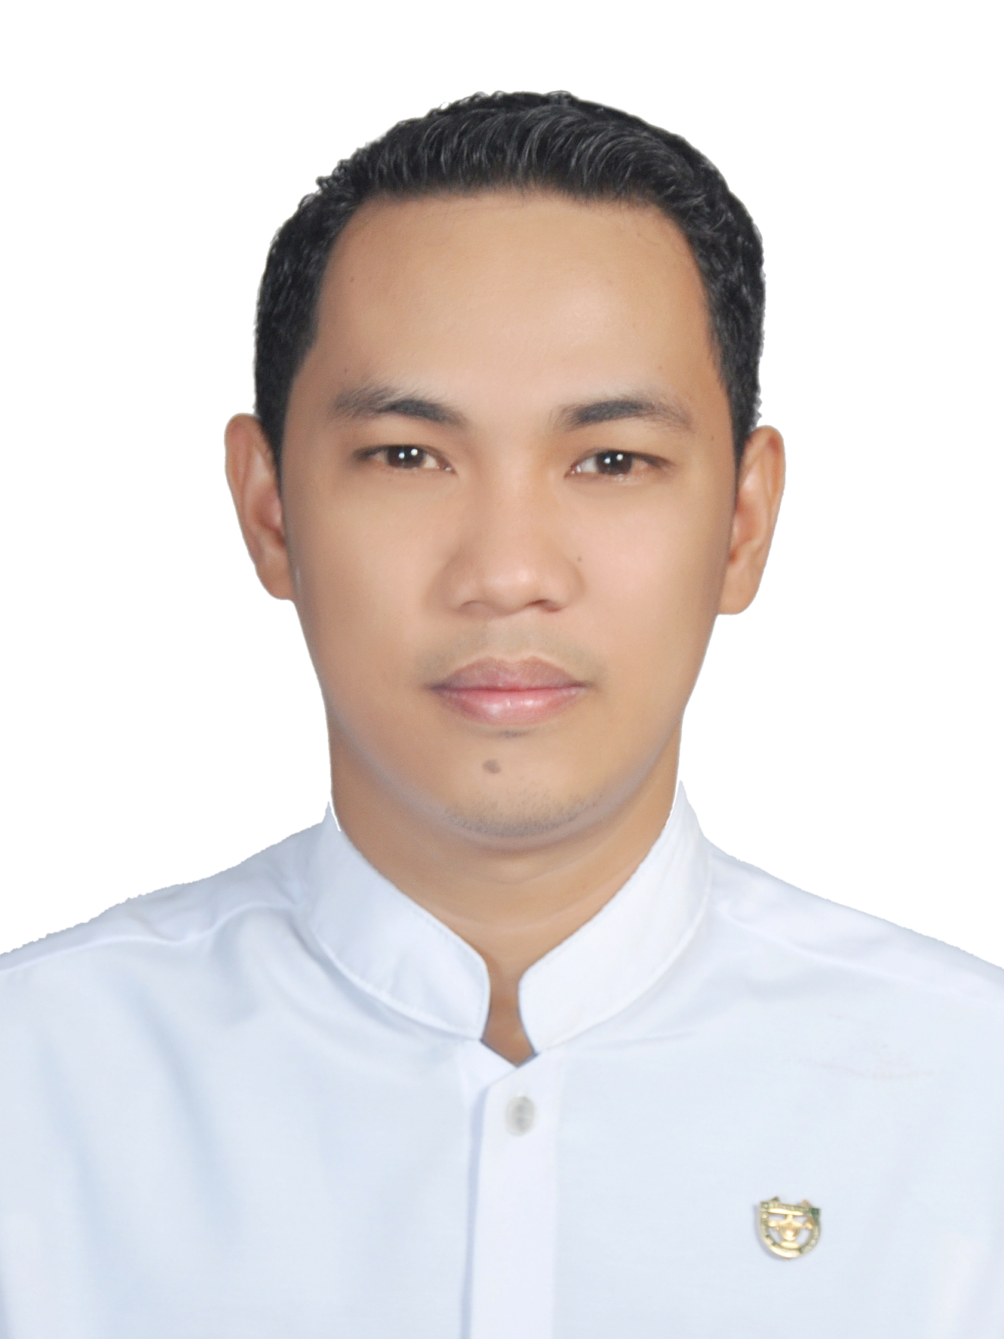
Gulfjobseeker.com

CV Number: 1411956
Mobile +971505905010 / +971504753686
E-mail: cvdatabase @ gulfjobseekers.com

To get contact details of this or many other candidates
Submit request on this link by writing all the short listed CV Numbers.
http://www.gulfjobseeker.com/feedback/submit_fb.php
CAREER OBJECTIVES:
Seeking an opportunity to expand my knowledge and experience and to assist in the continued development of the institute.

LICENSURES AND EXAMINATIONS
PHILIPPNE BOARD OF NURSING
Date Taken : November 29-30, 2009
Place Taken : Davao City, Philippines
Birthday : 09/07/1988

DUBAI HEALTH AUTHORITY
Date Taken : December 1, 2014
Place Taken : Cebu City, Philippines

SPECIAL SKILLS
- Computer literate MS Windows.
- Knowledgeable in MS Office (MS Word, Excel, Power Point, Internet browsing).
- Does typing, filing, data encoding proficiently.

PERSONAL ATTRIBUTES
- Hardworking, innovative, team player, excellent communication skills, highly motivated and can work under pressure with minimum supervision and delivers required work within schedule.
- Honest, reliable, fast-learner, responsible and persistent.
- Capacity to learn quickly and apply that knowledge effectively.
- Professional and dedicated to tasks assigned.

PROFESSIONAL EXPERIENCE:

Position : Senior Staff Nurse
Unit Assigned : Medical-Surgical Ward, Operating and Emergency Room
Period : 5 years
DUTIES AND RESPONSIBILITIES
Medical-Surgical Ward:
- Relay and receive endorsement in every shift.
- Conduct assessment in every patient.
- Carry out Physician’s order.
- Coordinates with health care team members.
- Prepares and administer prescribed medications.
- Conduct health teachings to patient and family members.
- Assist physician during examination and treatment of patient.
- Explain surgical procedure to patient.
- Responds to life-saving situations.
- Making discharge summary to patients.
Emergency Room:
- Ensure patients safety thru assisting patient to lay on stretcher, wheelchair and etc.
- Conduct assessment, obtaining patients’ vital signs.
- Obtain/Collect necessary patients personal data.
- Collect current symptoms, as well as detailed patient history and then consults and coordinates with health care team members.
- Do appropriate first aid.
- Perform triage.
- Manages basic life support needs.
- Carry out orders from resident physician on duty, assisting them during examinations and treatments.
- Prepares and administers prescribed medications.
- Cleans and bandages wounds.
- Records all information.
Operating Room:
- Conduct health teachings, pre and post-operative.
- Takes and monitor patients’ vital signs.
- Prepares Operating room for patient/procedures.
- Observes and enforces strict standards asepsis.
- Ensure patients’ safety thru assisting patients to lay on wheelchair, stretcher and OR table.
- Prepares and administers prescribed medications.
- Responds to life-saving situations based on nursing standards and protocol.
- Handles patients’ documentation.
- Selects and handles instruments and supplies used for the operation, passing them to surgeon.
- Delivers direct surgical care by assisting physician.
- Records all care information.
TRAININGS AND SEMINARS
Title : First Aid and Basic Life Support for Health Care Provider CPR
Based on the current International Liaison Committee on Resuscitation (ILCOR) and
American Heart Association (AHA) Guidelines
Sponsor : Accredited Training Center of Emergency Care & Safety (ECSI) U.S.A
Date : December 13, 2013
Venue : Lax Hotel Conference Room, Koronadal City, Philippines

Title : Basic ECG Interpretation and Advance Airway Management
Sponsor : Accredited Training Center of Emergency Care & Safety (ECSI) U.S.A
Date : December 14, 2013
Venue : Lax Hotel Conference Room, Koronadal City, Philippines

EDUCATIONAL ATTAINMENT:

2005-2009 BACHELOR OF SCIENCE IN NURSING

BROKENSHIRE COLLEGE SOCSKSARGEN INC., PHILIPPINES

2001-2005 HIGH SCHOOL GRADUATE

NOTRE DAME OF TACURONG COLLEGE, PHILIPPINES

1995-2001 GRADE SCHOOL GRADUATE

TACURONG PILOT ELEMENTARY SCHOOL, PHILIPPINES

PERSONAL INFORMATION:
Age : 26 years old
Date of Birth : September 7, 1988
Citizenship : Filipino
Marital Status : Married
Visa Status : Tourist Visa
Dialect/Languages can speak/write: Filipino and English

