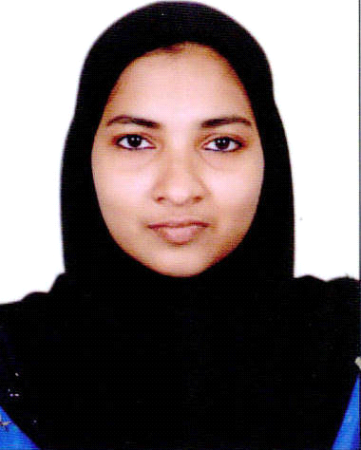
CURRICULAM VITAE
Gulfjobseeker.com CV No: 1412388
Mobile +971505905010 / +971504753686

To get contact details of this candidates
Submit request through Feedback Link
http://www.gulfjobseeker.com/feedback/submit_fb.php

CAREER OBJECTIVE:
A challenging position in a reputed firm where I can contribute my skills for the growth of the organization as well as getting a challenging career and professional growth while being resourceful, innovative and flexible.

EDUCATION:

Graduation Bachelors in Commerce – 2005

Calicut University, Kerala, India
AREAS OF EXPERTISE:
• Data Management & Documentation • Handling Petty cash
• Pay Rolling & Attendance • Passing Accounting Entries
• Shortlisting candidates • Making Purchase requisitions
• Scheduling Interview • Sending enquiries to the suppliers
• Travel arrangement • Placing purchase order
• Handling Accounts Payable/Receivable & Cheque issuing

PROFESSIONAL EXPERIENCE:
- Maico Gulf LLC - Ras Al Khaimah, UAE (Dec 2013 – till date)
Position: HR cum Accounts
Key Responsibilities:-
- Performing various HR functions.
- Screening the applicant (CV) and shortlisting as per the company’s requirements.
- Leading initial interview and arranging interview with the respective mangers.
- Collecting and maintaining the required document of new employees and forwarding it for their visa processing.
- Joining formalities – induction and training.
- Maintaining Employee attendance and other Records.
- Setting up and maintaining employee’s personnel files.
- Passing all HR related Accounting entries.
- Booking travel tickets for employees Annual Leave, Business trips etc.
- Record keeping and filing of documents.
- Maintaining ISO documents.

- Maxell Industries LLC - Dubai, UAE (October 2011-November 2013)
Position: Purchase cum Accounts
Key Responsibilities:-
- Handle all purchase related process, like raising purchase request, purchase order & other documentation.
- Invite quotations from the short listed vendors.
- Make comparison of Quotations from minimum 3 suppliers.
- Negotiate with vendor and place order.
- Follow up with the suppliers for the material.
- GRN checking and Bill booking.

- Tony & Tony Kerala, India (March 2009 - March 2011)
Position: Accounts Assistant
Key Responsibilities:-
- Posting of purchase bill and sale bill.
- Creating ledger.
- Passing journal entries.
- Filing monthly returns.
- Uploading of sales and purchase.

- ICICI Prudential Insurance Company, Kerala, India (July 2006 to July 2010)
Position: Financial Advisor
Key Responsibilities:-
- Buying and selling securities on behalf of the clients.
- Guide clients in the gathering of information, such as insurance records, returns, income tax etc.
- Interview the client to determine their current income, insurance coverage and Tax status.
- Research and investigate available investment opportunities to determine whether the fit into financial plans.

- Royal Regency, Kerala, India. (January '08– November ’08 Part Time)
Position: Customer care Executive
Key Responsibilities:-
- Ensured Customer Care to the Optimum, by analyzing their issues, solving it in the first stage and take further steps to not to happen in future
- Active link between customer to various departments and maintained the good business relation to customers.
- Developing good working environment and inter personal contacts.

PROFESSIONAL QUALIFICATION:
Insurance Regulatory and Development Authority (IRDA)
COMPUTER SKILLS:
- Peach Tree, Tally.
- MS Excel, MS Word, MS PowerPoint, DTP
- ERP – Orion, Facts.
LANGUAGES KNOWN:
- English, Hindi & Malayalam – Speak, Read and Write
- Arabic – Read & Write
- Tamil – Speak

PERSONAL DETAILS:
- Date of Birth 14, May 1983.
- Nationality / Citizen Indian.
- Civil Status Married.
- Visa Status Company Visa.

Declaration

I hereby declare that the above furnished information’s are true and correct to best of my knowledge and belief.

