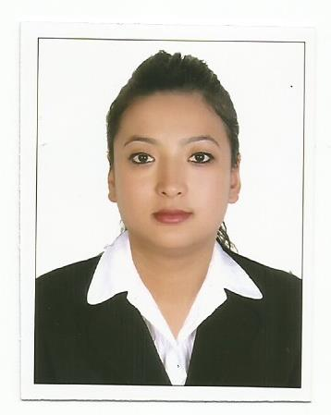
CIRRICULUM VITAE
Career Objective
To obtain a suitable position where I can utilize my skills to meet organizational and individual goals with exemplary work and a sense of professionalism that reflects foresight, flexibility, consistency and progressiveness.

Personal Details
Name : Nirjana Shrestha
Father’s Name : Nilkantha Shrestha
Address : Jumeriah 1, Dubai, U.A.E
Date of Birth : 1989/06/26
Nationality : Nepalese
Sex : Female
Religion : Hindu
Marital Status : Married
Email : stha.nirjana@yahoo.com
Language Known : English, Hindi

Passport Details

Issued Date : 21/12/2011
Valid Till : 20/12/2021
Issues Place : MOFA, Central Passport Office
Visa Status : Under husband’s visa
Educational Qualification

Board | Degree | School/University | Year | Division
TU | BBS | Bluebird College | Under Graduate
HSEB | Intermediate | Caribbean College | 2066 | 2nd
Nepal Government | SLC | Magus English School | 2063 | 1st

Work Experience
Hart Bernstien Marketing Management Al Garhoud, Dubai (September 2015 to till date)
- Worked as a sales promoter for various products like Scholl, Harpic, Veet, Lindt, Prill, etc.
- Greet customers with the most cheerful and pleasant.
- Demonstrate and provide information on promoted products.
- Create a positive image and lead consumers to use it.
- Distribute product samples, brochures, flyers etc. to source new sales opportunities.
- Identify interest and understand customer needs and requirements.
- Set up booths or promotional stands and stock products.

Ace Development Bank Limited Kirtipur Branch, Kathmandu
- Trainee Assistant since 18th Oct. 2014 to 4th April 2015.
- As a contract staff for 18 months in Customer Service and Cash Teller.
- As an intern for 18 months in Customer Service Desk.
- Handling the telephone calls.
- Dealing with customers.
- Handling the cash counter and remittances like Himal, Prabhu, Western Union, etc.
- Transferring cash within the branch & head office and other banks.
- Handling the bank assets file and other files.

Sales Girl in Big Bazar (July 1st 2011 to November 15th 2011)
- Greet customers with the most cheerful and pleasant.
- Give answers to customer’s questions or concerns related to the product.
- Communicate and assist customers in any way possible and as the customers may require.
- Deal with customer’s complaints professionally and with restraint.
- Bag products for the customers (if there’s no other assigned to that).
- Report sales accurately.
National Population Census, Kathmandu (1st June 2011 to 31st June 2011)
- Collecting data door to door.
IT Skills

- Basic Computer Skills including Microsoft Office Package.
- Pumori Plus IV
- Email, Internet
- Adobe Package

Volunteer Experience

- Has been working as a volunteer for various programs held by Kirtipur Volunteer Society.

Reference will be provided upon request.

