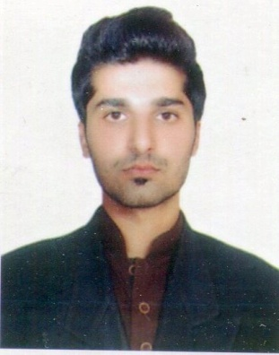
Job Focus: Office Administration And Clerical, Assistant, Secretary, Document controller, Electronics Technical
Gulfjobseeker.com CV No: 1415898

Mobile +971505905010 / +971504753686

To get contact details of this candidates
Submit request through Feedback Link
http://www.gulfjobseeker.com/feedback/submit_fb.php

Professional Objective
To contribute towards the growth and development of a dynamic organization where there are ample opportunities to grow both professionally and personally and where I can utilize my skills, professional expertise, sound knowledge and experience in an efficient and effective manner.

Professional Overview

- Hardworking, reliable and enthusiastic, holds professionally esteemed qualification of DAE(in Electronics technology) and having 1 years of vast& diversified work experience in Pakistan.
- Strategic thinker with a track record of handling tasks and resources with systematic approach.
- Can effectively set priorities, lead, multitask & work in challenging & pressure driven work environment.
Educational Background

Degree / Professional Qualification Grade Awarding Year

D.A,E In Electronics(Equal to Fsc) B 2008
Lahore Board ( Punjab University)

Secondary School Certification (Matric) A 2005 BISE Rawalpindi, Pakistan

Certification/Training | Duration | Institution
Computer diploma | 6 Months | Taibah Computer Academy
Graphic Designer | 6 Month’s | AGT Institute Of Technical & Professional Education Rawalpindi
English language course & Cabin Crew | 1 Month | Skill Development Council  (Islamabad) Qanzak Global Rawalpindi
Certification and Training

IT Proficiency

IT Software Languages / Application | Skill Rating Level
Computer application, Operating system, | Professional
Network essentials | Professional
Graphic designing, | Professional
Microsoft Office – All Versions (Word, Excel, PowerPoint, Access) | Professional User

Key Skills

Office Management  Skills: | -- MS office 2013 with typing 40 wpm | --Presentation skill | --Team head of conflicts resolution  --Office Management
Software Skills: | --Windows(Xp,7,8.98) | --Urdu Inpage--  --Adobe Photoshop | --Corel Draw

Language Skills
- English
  - Speaking – Fluent
  - Listening - Excellent
  - Reading - Excellent
  - Writing - Professional
- Hindi
  - Native
Personal Dossier

Date of Birth: January 16, 1990

Marital Status: Single

Gender: Male

Nationality: Pakistani

**********

