CURRICULUM VITAE

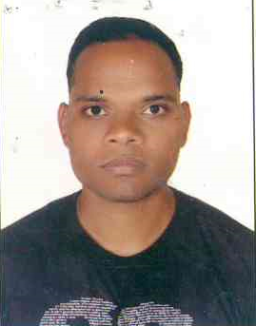
NARENDRA
Narendra.236067@2freemail.com
Post Applied For: Customer Care/ Service Agent

Qualification:
- HSSC: Passed through Goa board India
- SSC : Passed through Goa board India
- Completed the Computer Basic Course in MICE Goa India
- Completed the Hardware and Networking course in Jetking Goa India
- Completed the DPS training in Dubai Police Academy Dubai (UAE)
Work Experience:
- Worked as a Security Officer in Cops Security in India Goa for 30 Months
- Worked as a Office Executive In Goa correspondence College for 18 months
- Worked as a Security Guard in Afghanistan in a US Army Base for 12 months
- Currently Working as Front Desk Security in Emrill Services LLC Dubai (UAE)
Job Knowledge
- To provide a welcome service to our business passengers at check in and at other customer service touch points and to assist in smoothing the customer journey through the Airport
- To take service recovery measures when appropriate to protect the customer experience .
- Patrolling the common areas and the Parking area.
- Checking the gate passes and Access controlling
- Worked in high risk areas like in Afghanistan
- Knowledge of all the fire fighting Extinguishers
- Worked in busy areas like in Hotels and Malls.
- Knowledge of the Safety Equipments

Interest/Activities
Listening Music, working out, playing Cricket, volley ball

Language Known
English, Hindi, Marathi, Konkani
DECLARATION
I hereby declare that all the above information is true to best of my knowledge and belief and I bear the responsibilities for the correctness of the above mentioned particulars.

