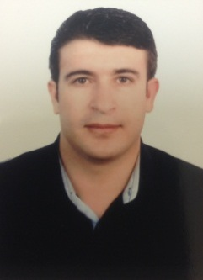
Gulfjobseeker.com CV No: 1417116
Mobile +971505905010 / +971504753686

To get contact details of this candidates
Submit request through Feedback Link
http://www.gulfjobseeker.com/feedback/submit_fb.php

CAREER AIM I am a looking for a medical job; wherein I can practice my profession, continue to learn from it and to develop my skills in rendering health care service.

PERSONAL PROFILE:

Date of Birth: October 18, 1981

Nationality: Syrian

Marital Status: Married

Religion: Moslem

Language: Arabic, English

QUALIFICATIONS:

- Master degree in internal medicine April 2011 Aleppo university Syria
- Medical Doctor (MD) July 2005 Aleppo University ( Faculty of Medicine)

RESIDENCY:

- Internal medicine Resident (October,2005- October 2009)- Aleppo University Hospital-Ministry of High Education, Aleppo, Syria
Teaching experience:

- Internal medicine lessons for medical students during residency period.
- Supervising & Teaching junior residents.

EMPLOYMENT SREVICE

Institution Position Date

Private Hospital (KSA) internal medicine doctor july2010-Present
(Prince fahad bin sultan hospital)
Private clinic(Syria) internal medicine doctor 06/2009- 3/2010

Clinical Experience:

- Cardiology,ccu (10 months)
- neurology (6 months)
- nephrology (6 months)
- pulomonology (6 months)
- endocrinology (3 months)
- GIT,hepatology (6 months)
- Hematology, oncology (3 months)
- emergency (8 months)

Skills :

- Computer skills: good user for (Windows – Office – Internet).

Self-Appraisal:

-Efficient, Diplomatic, Adaptable, Self motivated, Confidently and ability to handle work smoothly under any circumstance even Loaded pressure..
- Ready to Allocating

