Sohail
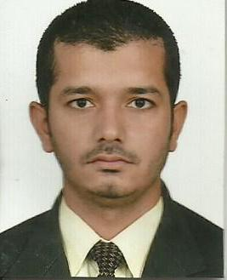
Sohail.236684@2freemail.com

Objective:

Looking for a bright and long-term career in a reputed organization to
Refresh my previous experience and to do something valuable to the
Organization.
Qualification:

- (Matriculation) from Board of Karachi.
- (Intermediate) from Board of Intermediate Karachi.
- (Under Graduation) from University of Karachi.

Job Experience:

- Two Years Experience as a “Office Boy” from 2008 to 2010, With,
- (Karachi international Container Terminal.)

- Two Years Experience as a “ Office Boy Messenger” from,2012 to 2014 with,
- (Construction Company)
- Abu Dhabi (U.A.E)

Computer Skills:

- Microsoft Office Course from (K.M.A) Institute of Information
- Technology Karachi.
- Microsoft Word
- Microsoft Excel
- Microsoft Power Point and Internet Email etc.

Personal information:

Date of Birth : 27.07.1987
Marital Status : Single
Nationality : Pakistani
Religion : Islam

Languages:

English, Hindi, Arabic, Urdu,

Visa Status:

On Visit Visa

Reference:

Will be furnished upon request.

