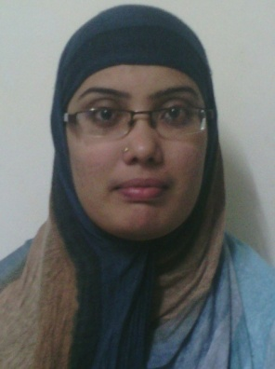 CURRICULUM VITAE

HASEEN
Haseen.236836@2freemail.com

CAREER OBJECTIVES :

To seek a challenging job to integrate my technical, analytical and imagination skills which provide an avenue for the organisation as well as my professional growth. For my professional growth I am ready to work hard for this concern.

SKILLS :

- English, Hindi and Tamil (Writing, Reading, and Speaking).

- Ability to work independently with minimal supervision and ability to prioritize task effectively.

- Strong communication and interpersonal skills.

- Fully competent in using Microsoft Office application (Excel, Word and Internet Outlook.)

- Ability to work under pressure.

WORK EXPERIENCE :

- Worked as a CO-ORDINATOR in AKSHAYA AGENCY(INDIA) from 2011 -2015 (four years).
- Customer care service
- Updating customer balance
- Stock checking
- Purchase & Sales invoices clearing
- Applying claims
EDUCATIONAL QUALIFICATION :

- B.C.A (Bachelor of Computer Application)completed, from Periyar University(India)2008-2011
- Higher Secondary completed in the year(2006-2008)

TECHNICAL SKILLS :

- DCA (Diploma in Computer Application ) (Micro Soft WORD , EXCEL, POWER POINT)

- Micro Soft Word
- Excel
- Power point

DECLARATION :

I hereby declare that the above information and facts are true to the best of my knowledge and belief. Thanking you in anticipation and looking forward to your kind favourable reply at the earliest.

