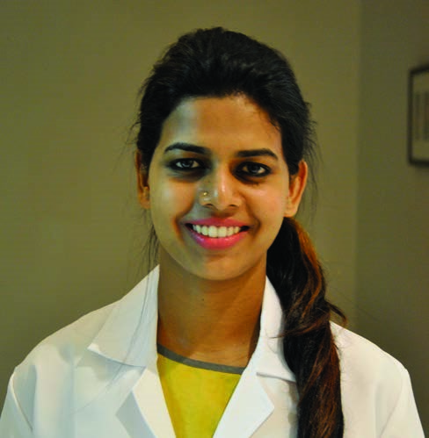
PERSONAL DETAILS
Aswathi
Aswathi.236874@2freemail.com
DOB: 22/05/1990
Marital Status: Married
Nationality: Indian
Visa: UAE Residence
Husband’s Visa
AREAS OF EXPERTISE
Diagnostic Audiology
Hearing Aid Trial
PROFESSIONAL
RCI registered
DHA CERTIFIED
Unique Id : DHA-P-
Aswathi
Audiologist

PERSONAL SUMMARY
A confident communicator who can relate well to patients with communicative disorder. Effective skills in establishing and maintaining relationships with disabled individuals. An optimistic healthcare professional experienced in successfully diagnosing and rehabilitating patients. Ability to work co-operatively with Neurologist, ENT Specialists, Pediatrician, Audiologist, Psychologist, Physiotherapist, Occupational Therapist, etc.
Looking to work as an Audiologist with a forward thinking and highly regarded organization.
WORK EXPERIENCE - 2+ years
Cedars - Jebel Ali International Hospital - Dubai, UAE
AUDIOLOGIST 11 Months

All India Institute of Speech and Hearing – Mysore, India AUDIOLOGIST 1 Year AWH Special College - Calicut, India
AUDIOLOGIST 1 Year
Duties:
Calibration of instruments (subjective & objective)
Dealing with routine appointments
Evaluation, diagnosis and treatment of inpatients, outpatients, adults, children with hearing impairments and variety of communication disorders.
Prescribing, programming, fine tuning, fitting, trouble shooting of hearing aids.
Updating patients medical records.
Reassuring anxious patients and clearly explaining procedures to them.
Providing apt recommendation and follow up.
Issuance of hearing disability certificates
Preparing weekly presentations and delivering talks on specific and new topics in the field of Audiology.

CLINICAL EXPERIENCE 6.6 Years
All India Institute of Speech and Hearing 1 year
Mysore, Karnataka
Designation: Audiologist
All India Institute of Speech and Hearing 2 years
Mysore, Karnataka
Designation: Student Clinician
Modern ENT Super Speciality Institute 1 month
Pottammal, Calicut, Kerala
Designation: Internee
Madras ENT Research Foundation  Mandavelipakkam, Chennai Designation: Internee  Kasturba Medical College Mangalore, Karnataka.  Designation: Internee | 1 month  1 month
Manipal College Of Allied Health Sciences 1 month
(MCOAHS), Mahe, Manipal, Karnataka
Designation: Internee
St Johns Hospital, Koramangala 1 month
Bangalore, Karnataka.
Designation: Internee
AWH AL-Badar Special College
3
years
contd....(2)
Payyannur, Kannur, Kerala
Designation: Student Clinician
1
PERSONAL SKILLS
Able to concentrate for long periods
Attention to detail
Communication skills
KEY SKILLS AND COMPETENCIES
Well presented and articulate.
Excellent listening, communication and interpersonal skills.
Able to diagnose a variety of hearing conditions.
FAMILIAR INSTRUMENTS & EQUIPMENTS

Puretone Audiometry
Double channel audiometer - GSI-61, GSI-16, madson itera, orbiter 922. Single channel audiometer- GSI-68 and 67, Elkon, Maico
Middle Ear Analyser
GSI tympstar, GSI autotymp
OAE
Diagnostic DPOAE, SOAE and TEOAE

BSERA
Intelligent Hearing System, Bio Logic-Navigator

Programing of Digital Hearing Aids
Phonak, Oticon, Bernafon, Starkey, Audioservice

CONFERNECES AND SEMINARS ATTENDED
40th national conference of Indian speech and hearing association held at Mangalore, Karnataka, February 2008
42nd national conference of speech and hearing association held at Bangalore, Karnataka. January 2010
Attented National Seminar on Cortical Auditory Evoked Potentials and Its Applications conducted by dept of Audiology in All India Institute Of Speech & Hearing
ACADEMIC QUALIFICATIONS

Msc Audiology 2011 - 2013
All India Institute of Speech and Hearing Mysore, Karnataka, India

BASLP 2007 - 2011
AWH Al-Badar Special College
Payannur, Kannur - Kerala, India

St. Joseph's Anglo Indians Girls Higher Secondary School
Kozhikode, Kerala - India
I declare that the above information provided is correct and true to my knowledge.

2

