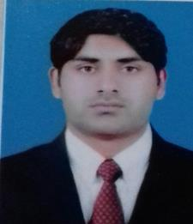
KHALIL

Email: khalil.236990@2freemail.com
Address: Dubai UAE.

Objective:
Seek as opportunity with an organization of repute my experience as a

SECURITY GUARD, FABRICATION FITTER, DRIVER to the best advantage of the organization and which opportunities exist for career growth and diversified responsibilities.

Work Experience:

- Worked as a SECURITY GUARD 2 years in SUFI BANASPATI COMPANY PAKISTAN.

- Worked as a security guard in TIME SECURITY from Feb 2012 to Feb 2014.

- Worked as a FABRICATION FITTER from FEB 2014 to till to date in ROLLAT AL MADINAH SHARJAH U.A.E.

- Worked as a MAINTENANCE AND CLEANER SUPERVISOR 2 years in CARREFOUR HYPERSTAR LAHORE.

Job Responsibilities:
- SECURITY GUARD, FABRICATION FITTER, LTV DRIVER.

Academic Qualification:
- GRADUATION.
- CIT 3 MONTHS COMPUTER DIPLOMA.

- SPOKEN ENGLISH 3 MONTHS DIPLOMA.
- PIPE FABRICATION DIPLOMA.

Personal Profile:

Date of Birth: 03 Apr 1991
Nationality Pakistan

Religion: Islam
Marital Status: Married

Languages:
- URDU, ENGLISH, PUNJABI.

Passport Detail:
Passport Issue | 03/10/2016
Passport Expiry | 02/10/2021

Strengths:
- Hard working and quick learner
- Willingness to work in any part of world

Declaration:

- I hereby certify that all the above information is true and correct to the best of my knowledge and belief.

